Abstract
Multidimensional energy poverty remains a critical barrier to sustainable human development in Bangladesh. While national electrification metrics have improved rapidly, aggregate grid coverage often masks persistent deprivations in clean cooking energy, modern lighting, and household energy efficiency. This thesis establishes an integrated empirical framework that evaluates household energy poverty using the Multidimensional Energy Poverty Index (MEPI), leveraging nationally representative data from the 2022 Bangladesh Demographic and Health Survey (BDHS 2022) comprising N = 12,758 households across 674 Primary Sampling Units (PSUs). To overcome the rigid parametric assumptions of traditional statistical models while preserving full econometric interpretability, this study employs a hybrid ML-Guided Discovery-and-Refit procedure. First, non-parametric machine learning classifiers (Random Forest, XGBoost, and a Tabular Multilayer Perceptron with Entity Embeddings) are benchmarked to extract non-linear functional shapes and high-order interaction structures via TreeSHAP attributions. Second, discovered non-linearities (evaluated via natural cubic splines) and feature interactions are formally integrated into parametric Multilevel Logistic Models (MLM) accounting for administrative clustering (Division, District, and PSU levels). Out-of-sample evaluations and controlled simulation experiments confirm that the ML-Guided MLM matches the predictive accuracy of black-box ML models while providing exact, hypothesis-tested odds ratios and intra-cluster correlation coefficients (ICC). The findings provide key actionable guidance for targeted energy subsidies, regional infrastructure development, and policy interventions in Bangladesh.

Contents
Abstract 1
Contents 2
List of Figures 6
List of Tables 7
Multidimensional Energy Poverty Index (MEPI) Targeting Pipeline 8
Chapter 1. Introduction 9
1.1 Motivation and Research Objectives 9
1.1.1 Background and Motivation 9
1.1.2 Statement of the Problem 10
1.1.3 Research Objectives 10
1.2 Literature Review 10
1.2.1 Conceptualizing and Measuring Energy Poverty 10
1.2.2 Determinants of Energy Poverty 11
1.2.3 Econometric Approaches to Modeling Poverty 11
1.2.4 Machine Learning as an Alternative: Prediction versus Inference 12
1.2.5 Explainable AI and the Bridge Between Paradigms 12
1.2.6 Research Gap 12
Chapter 2. Data and Variables 14
2.1 Data Source 14
2.2 Variables and Indicators 15
Chapter 3. Methodology 21
3.1 Bivariate Association Tests: Pearson's Chi-Square ($\chi^2$) and Cramér's $V$ 21
3.1.1 Theoretical Foundations and Non-Parametric Advantages 21
3.1.2 Methodological Assumptions and Cochran's Expected Frequency Rule 22
3.1.3 Expected Frequencies, Pearson Statistic, and Cell Contribution Analysis 23
3.1.4 Quantifying Strength of Association: Cramér's $V$ 24
3.1.5 Location Shift Tests for Continuous Predictors (Wilcoxon-Mann-Whitney) 25
3.2 Multilevel Logistic Regression and Parameter Estimation 25
3.2.1 Model Specification 25
3.2.2 Parameter Estimation Procedure 26
3.3 Machine Learning Architectures 27
3.3.1 Random Forest (RF) 27
3.3.2 Extreme Gradient Boosting (XGBoost) 28
3.3.3 Tabular Multilayer Perceptron (MLP) with Entity Embeddings 29
3.4 Model Evaluation and Explainability Framework 32
3.4.1 Evaluation Diagnostics (Minimal Summary) 32
3.4.2 TreeSHAP Explainability and Interaction Tensors 32
3.5 Household Archetype Discovery and Spatial Autocorrelation 35
3.6 The ML-Guided Discovery-and-Refit Procedure 35
Step 1: Leakage-Free Data Partitioning 37
Step 2: Non-Linearity Screening via Spline Regression 37
Step 3: Interaction Candidate Discovery & Parent Aggregation 37
Step 4: Parametric MLM Augmentation & Likelihood Ratio Test (LRT) Safety Net 37
Chapter 4. Result and Discussion 39
4.1 Univariate Descriptive Statistics 39
4.2 Bivariate Analysis 45
4.2.1 Categorical Predictors 45
4.2.2 Continuous Predictors 49
4.3 Multivariate Results 52
4.3.1 Model Fit and Variance Decomposition 53
4.3.2 Fixed-Effects Parameter Estimates (Odds Ratios) 55
4.3.3 Summary of Section 4.3 Results 60
4.4 Machine Learning Results and the ML-Guided Multilevel Model Enhancement 61
4.4.1 Machine Learning Models 62
4.4.2 Predictive Performance on the Standard Test Split 62
4.4.3 Spatial Generalizability: Unseen PSUs 65
4.4.4 Decoding the Black Box: TreeSHAP and Household Archetypes 67
4.4.5 The ML-Guided Multilevel Model Pipeline 71
Chapter 5. Simulation Validation Study 78
5.1 The Simulation Framework 80
5.1.1 Geographic Nesting and Random Effects 80
5.1.2 Covariate Generation 80
5.1.3 The True Data-Generating Process 80
5.1.4 Calibration to Real-World Prevalence 81
5.2 The Blind Discovery-and-Refit Algorithm 82
5.3 Results 83
5.3.1 Non-Linearity Recovery 83
5.3.2 Interaction Recovery 86
5.3.3 Predictive Performance and Gap Closure 88
5.3.4 Coefficient Stability Audit 89
5.4 Specificity Check: Does the Pipeline Stay Quiet When There Is Nothing to Find? 90
5.4.1 A Second Synthetic Dataset: The Null DGP 90
5.4.2 Non-Linearity Detection Correctly Stays Quiet 91
5.4.3 Interaction Ranking Under the Null: A Persistent False Signal 92
5.4.4 The Refit Safety Net Is Not Fully Reliable: A Quantified False-Positive Rate 92
5.5 Discussion 93
5.5.1 What This Recovery Demonstrates 93
5.5.2 A Known Limitation: The Variance-Mediated Interaction-Detection Blind Spot 94
5.5.3 Implications for the HIES 2022 Findings 95
5.6 Chapter Summary 97
Chapter 6. Conclusion 100
6.1 Summary and Key Findings 100
6.2 Answering the Central Question: Scenario A vs. Scenario B 101
6.3 Contributions 101
6.4 Limitations and Scope 102
6.5 Policy Implications 102
6.6 Recommendations for Future Research and Concluding Remarks 103
References 104

List of Figures
Figure 3.1: Architecture of the Tabular Multilayer Perceptron with Entity Embeddings 24
Figure 3.2: Flowchart of the two-stage ML-Guided Discovery-and-Refit Procedure 26
Figure 4.1: Distribution of Energy Poverty Percentage District-wise 69
Figure 4.2: Distribution of Raw Monthly Income and Log-Transformed Monthly Income 70
Figure 4.3: Strength of Association Between Categorical Predictors and Energy Poverty 71
Figure 4.4: Average Monthly Income and Energy Expenditure by Energy Poverty Status 72
Figure 4.5: ROC curves, standard test split 73
Figure 4.6: Calibration curves (10-quantile bins) 73
Figure 4.7: Decision Curve Analysis 74
Figure 4.8: ROC curves, unseen-PSU audit 75
Figure 4.9: Global SHAP beeswarm, top 15 features 76
Figure 4.10: SHAP-cluster vs. raw-cluster agreement 77
Figure 4.11: R² explaining SHAP values: linear fit vs. 3-DF spline fit 78
Figure 4.12: SHAP dependence plot for age with fitted natural cubic spline 79
Figure 4.13: SHAP dependence for energy expenditure fit separately by wall material 80
Figure 4.14: SHAP dependence plot for income with fitted natural cubic spline 81
Figure 5.1: True DGP hinge effect versus natural spline partial effect 85
Figure 5.2: True DGP quadratic effect versus natural spline partial effect 86

List of Tables
Table 4.1: Descriptive Statistics of Categorical Variables 59
Table 4.2: Descriptive Statistics of Continuous Variables 60
Table 4.3: Chi-Square Tests of Independence and Effect Sizes 63
Table 4.4: Wilcoxon Mann-Whitney Rank-Sum Tests and Group Descriptives 64
Table 4.5: Model Comparison and Variance Decomposition 68
Table 4.6: Fixed-Effects Parameter Estimates in Odds Ratios 69
Table 4.7: Test-set performance, standard 80/20 split 74
Table 4.8: Spatial generalizability audit on unseen PSUs 75
Table 4.9: Socioeconomic profile of the three SHAP-derived household archetypes 77
Table 4.10: Non-linearity detection (training-split-only diagnostic metrics) 78
Table 4.11: ML-Guided MLM predictive performance 81
Table 5.1: Non-linearity detection results: R²-gain test against ground truth 85
Table 5.2: TreeSHAP parent-feature interaction ranking, top 10 of 55 pairs 86
Table 5.3: Test-set AUC-ROC comparison across four benchmark models 87
Table 5.4: Discovered spline and interaction coefficients, ML-Guided MLM 88
Table 5.5: Maximum R² gain across all four continuous features, null DGP 89
Table 5.6: Rank of income-energy pair among candidate pairs, null DGP 90
Table 5.7: Real data top interaction strength compared against pure noise range 91
Table 5.8: Discovery stability across five independent folds and main split 92

Chapter 1. Introduction

1.1 Motivation and Research Objectives

1.1.1 Background and Motivation
Modern energy access underpins household wellbeing, yet hundreds of millions worldwide still lack reliable electricity and rely on polluting solid fuels for cooking, a shortfall the United Nations' Sustainable Development Goal 7 commits to closing. Bangladesh illustrates the limits of a narrowly defined success: grid electrification has expanded rapidly, yet formal connection alone does not guarantee clean, sufficient energy services. Reducing “energy poverty” to a single indicator risks declaring victory over a problem that persists as inadequate lighting, indoor air pollution, and missing energy-dependent assets [1], [2]. This Study measures energy poverty via a Multidimensional Energy Poverty Index (MEPI), following the Alkire-Foster [3] dual-cutoff counting methodology adapted to energy deprivation by Nussbaumer et al. [4], applied to N = 12,759 households from the Bangladesh Household Income and Expenditure Survey (HIES) 2022.
A second, methodological motivation follows. Prior Bangladesh research typically fits a single linear, or at best multilevel linear, regression, implicitly assuming every household experiences deprivation through one homogeneous pathway, with only intercepts, not slopes, varying by geography [5]. If the process is instead heterogeneous, for instance if wall quality protecting more strongly in rural than urban areas, or income's effect saturating above a threshold then a linear model can pass every diagnostic check while leaving predictive signal on the table. Machine learning models recover non-linear and interaction effects automatically and have outperformed conventional models on prediction tasks in development research [6], [7], but superior accuracy is of limited use to a policymaker who cannot recover an interpretable coefficient from it.

1.1.2 Statement of the Problem
This is a genuine tension: multilevel models offer inferential transparency but risk under-fitting non-linear structure; machine learning models capture that structure but return no reportable parameter. TreeSHAP-based Shapley decompositions [8], [9] make it possible to open a trained model and read off exactly where, and how much, non-linear flexibility it has learned that a linear model has not. Whether this can be fed back into a multilevel model without importing spurious structure is untested in the Bangladesh energy poverty literature, and rarely validated against a known ground truth more broadly.

1.1.3 Research Objectives
This study aims to: (1) Construct a household-level MEPI for HIES 2022; (2) Compare an econometric baseline, plain and multilevel logistic regression against three machine learning models (Tabular MLP, Random Forest, XGBoost) on identical splits, including a spatial audit on unseen villages; (3) Use TreeSHAP to decompose the best model, test whether households cluster into archetypes with heterogeneous drivers rather than one pathway, and build a discovery-and-refit procedure reintroducing mined non-linearities and interactions into the multilevel regression; and (4) Validate this procedure against a synthetic dataset with a known data-generating process, quantifying its false-positive rate.

1.2 Literature Review

1.2.1 Conceptualizing and Measuring Energy Poverty
Early research operationalized deprivation through a single threshold, the “10 percent rule,” under which a household spending more than a tenth of income on energy was fuel poor [1]. “This ratio conflates efficiency with unaffordability”, the energy-ladder problem documented in Hosier and Dowd's Zimbabwean fuel-choice study [10]. Subsequent work moved toward multidimensional counting measures evaluating several indicators simultaneously. Nussbaumer et al. [4] proposed the MEPI, applying the dual-cutoff counting methodology of Alkire and Foster [3]: a household is deprived on an indicator below an indicator-specific threshold, and multidimensionally poor only if its weighted deprivation count exceeds a second, cross-indicator cutoff. Charlier and Legendre [2] confirm no single fuel-poverty definition has achieved consensus, but that counting approaches are preferred precisely because they need not assume which deprivation matters most. This study follows the Nussbaumer/Alkire-Foster tradition, building an eight-indicator MEPI spanning energy services and energy-dependent assets.

1.2.2 Determinants of Energy Poverty
A consistent finding across countries is that income, housing quality, and geography jointly determine energy poverty risk. In Bangladesh, Haq et al. [11] find rural-urban residence and housing are strong, independent determinants of clean energy adoption net of income, while Hasanujzaman and Omar [5] fit a multilevel logistic model nationally and find Division- and District-level random intercepts explain variance beyond household covariates which confirms geography structures risk rather than merely needing to be controlled away. Analogous multilevel studies in rural China [12], [13] similarly find spatial clustering biases household-level estimates if ignored. A separate strand links human capital to energy poverty: quasi-experimental evidence from schooling reforms in China [14], Zimbabwe [15], and a Chinese-university comparison [16] each find education causally reduces energy poverty risk, consistent with this thesis's inclusion of household head education.

1.2.3 Econometric Approaches to Modeling Poverty
The workhorse model for a binary poverty outcome is logistic regression, tracing to Cox's [17] analysis of binary sequences and formalized as a generalized linear model by McCullagh and Nelder [18]; McFadden's [19] conditional logit analysis remains the standard justification for reading its coefficients as a resource-allocation process. Because households nest within villages, districts, and divisions, a plain logistic regression that ignores this clustering understates standard errors which is the motivation for the multilevel extension of Gelman and Hill [20], estimated here via lme4 [21]. Multilevel logistic regression is now standard in the literature above [5], [12], [13], but still assumes linear, additive covariate effects unless a non-linear form is specified in advance, an assumption this thesis tests directly.

1.2.4 Machine Learning as an Alternative: Prediction versus Inference
Mullainathan and Spiess [7] frame the distinction sharply: econometrics estimates a structural parameter with a valid standard error, while machine learning maximizes out-of-sample accuracy. Ensemble tree methods like Random Forest [22] and XGBoost [23] recovers non-linear thresholds and interactions automatically and out-predicts linear benchmarks in applied poverty settings, most visibly in Jean et al.'s [6] demonstration that a convolutional network on satellite imagery predicted village consumption competitively with household surveys across five African countries.

1.2.5 Explainable AI and the Bridge Between Paradigms
A predictive gap raises an immediate question: is it genuine non-linear structure, or overfitting of sampling noise? Shapley additive explanations [8] and their tree-specific implementation, TreeSHAP [9], decompose each prediction into per-feature contributions, testing whether a predictor's relationship is genuinely non-linear. By regressing its SHAP values against a flexible spline and whether two features interact, without specifying the functional form in advance. This is the bridge between the two paradigms above: a machine learning model as an instrument for finding where the interpretable model's linear specification is misspecified, not a replacement for it.

1.2.6 Research Gap
Traditionally, applied econometricians testing for non-linear responses or interaction effects have relied on conventional specification diagnostics. Non-linear associations are often explored using polynomial expansions ($X^{2},X^{3}$), Box-Tidwell power transformations [24], or Generalized Additive Models (GAMs) [25]. Similarly, interaction terms are typically specified via manual pairwise product terms ($β_{ij}X_{i}X_{j}$) or automated stepwise selection routines [26]. While foundational, these conventional methods present well-documented practical constraints: polynomial terms impose rigid global functional forms sensitive to boundary values, GAMs can become computationally demanding to estimate when nested within high-dimensional spatial hierarchies, and stepwise interaction selection risks degree-of-freedom depletion, collinearity, and inflated false-discovery rates [27, 28].
Conversely, while modern machine learning algorithms automatically capture non-linearities and high-order interaction surfaces, they function as black-box predictors that lack formal statistical parameter inference (e.g., odds ratios and p-values). In the Bangladesh energy poverty literature, existing multilevel studies [5] achieve interpretability without testing whether their linear specifications leave predictive information on the table; existing machine learning applications to poverty [6] achieve accuracy but discard structural interpretability entirely. No study has benchmarked machine learning against a multilevel baseline on a common, spatially-audited split, or evaluated whether tree-based explainable AI (TreeSHAP) can serve as a non-parametric screening tool to inform and modestly enhance the specification of interpretable multilevel logistic models. This thesis addresses this gap by exploring a hybrid, two-stage discovery-and-refit approach—testing whether TreeSHAP non-linearity and interaction screening can inform statistical MLMs while maintaining strict statistical gating and parametric inference.

Chapter 2. Data and Variables
This section covers a brief introduction about the source of data and a detailed description of relevant variables.

2.1 Data Source
This study utilizes secondary data extracted from the Household Income and Expenditure Survey (HIES) 2022, the 17th round of BBS's national household survey program [29]. HIES 2022 is the most comprehensive source of micro-level socioeconomic information available in Bangladesh, covering household consumption, expenditure, income, housing conditions, health, and education. A major design feature of the survey is its fieldwork window: data collection ran continuously from January 1 to December 31, 2022, spanning a full calendar year and thereby minimizing the influence of seasonal variation on consumption patterns, income streams, and labor market behavior [29].
The survey employed a two-stage stratified cluster sampling design to ensure representativeness at both national and subnational levels, covering rural and urban domains [29]. In the first stage, BBS drew the sampling frame from the second zonal operation of the 2022 Population and Housing Census and selected 720 Enumeration Areas (EAs) as Primary Sampling Units (PSUs) through systematic random sampling with Probability Proportional to Size (PPS). Each EA contains roughly 100 households. The stratification structure comprised 24 strata formed by crossing the 8 administrative divisions with 3 locality types: rural areas, urban municipalities, and city corporations. In the second stage, a complete household listing was conducted within each selected PSU, from which 20 households were drawn by systematic random sampling, producing a final nationally representative sample of 14,400 households [29].
For the purposes of this study, the raw sample was filtered down to an analytic sample of 12,759 households a reduction of approximately 11.4%. This attrition arose from merging several Stata data sections covering household rosters, housing conditions, landholdings, economic activities, asset ownership, and fuel expenditures, with listwise deletion applied to resolve incompatibilities across sections. Households were excluded if they had missing, incomplete, or implausible values on relevant key variables. This cleaning protocol was deliberately conservative, prioritizing a leakage-free analytic sample over sample size, and guarding against bias in both the econometric and machine learning components of the analysis.

2.2 Variables and Indicators
Multidimensional Energy Poverty Index (MEPI)
Energy access in Bangladesh is far too complex to be captured by a single metric. This study therefore constructs a household-level Multidimensional Energy Poverty Index (MEPI) by adapting the framework of Nussbaumer et al. [4] within the dual-cutoff methodology of Alkire and Foster [3]. Unlike conventional energy poverty measures that reduce the problem to a single dimension household income, energy expenditure, or grid connectivity the MEPI evaluates deprivation simultaneously across multiple dimensions of energy services and asset ownership, offering a more complete picture of household-level energy poverty [3], [4].
The index is built around eight indicators distributed across two dimensions, each carrying a specific weight. The first dimension, Energy Services (total weight: 0.55), captures direct access to energy utilities and indoor environmental quality through three indicators.
Modern Cooking Fuel (w₁ = 0.20): A household is considered deprived if it relies primarily on traditional solid fuels l firewood, charcoal, animal dung, straw, or agricultural residues rather than cleaner modern alternatives such as LPG, electricity, natural gas, or biogas [29], [4].
Main Lighting Source (w₂ = 0.20): Deprivation is assigned when a household's primary lighting comes from kerosene, paraffin, candles, or similar non-grid sources, reflecting the absence of grid electricity or a solar home system [29], [4].
Indoor Smoke Exposure (w₃ = 0.15): A household is deprived if cooking takes place inside the main living area without a separate kitchen or functional chimney, creating sustained exposure to harmful levels of indoor air pollution [29].
The second dimension, Household Assets (total weight: 0.45), reflects ownership of appliances that translate raw energy access into tangible improvements in living standards and economic participation [4]. It comprises five indicators:
Mobile Phone (w₄ = 0.15): Deprivation is recorded when no household member owns a functioning mobile handset, used here as a proxy for basic communication needs and digital financial inclusion [29], [4].
Refrigerator (w₅ = 0.10): A household lacking a refrigerator or freezer is considered deprived in food preservation and cold storage capacity [29].
Television (w₆ = 0.10): Absence of a television indicates deprivation in access to information and media [29], [4].
Cooling Fan or Air Conditioning (w₇ = 0.05): Households without an electric fan or air conditioning unit are considered deprived of basic thermal comfort a meaningful hardship in Bangladesh's tropical climate [29].
Computer (w₈ = 0.05): Absence of a desktop or laptop computer reflects deprivation in digital access and educational resources [29].
Formally, let $I_{ij}$denote the binary deprivation status of household $i$on indicator $j$, where $I_{ij}=1$if the household is deprived and $I_{ij}=0$otherwise. Each indicator carries weight $w_{j}$, with all weights summing to unity: $\sum_{j=1}^{8}{w_{j}}=1.00$. The weighted deprivation score for household $i$is then:
$$D_{i}=\sum_{j=1}^{8}{w_{j}}⋅I_{ij}$$
Energy poverty status is determined by applying a second cutoff of k = 0.35 [3]. A household is classified as multidimensionally energy poor if its deprivation score meets or exceeds this threshold:
$$Y_{i}=\left\{\begin{matrix}1 & \text{if }D_{i}≥0.35 \\ 0 & \text{if }D_{i}<0.35\end{matrix}\right.$$
The dual-cutoff design is deliberate. By requiring a household to accumulate deprivations across multiple indicators before being classified as energy poor, the approach guards against misclassification based on a single missing asset for instance, the absence of a computer or fan alone is insufficient for a poverty designation. Classification instead demands substantive, cross-dimensional deprivation spanning both energy services and energy-dependent assets [3], [4].
Covariates
To model and predict multidimensional energy poverty, this study draws on a broad set of socioeconomic, demographic, housing, and geographic covariates. These are organized into four substantive domains.
Demographic Characteristics
Area of Residence
A binary variable distinguishing rural from urban households: included to account for economic discrepancy between urban and rural areas.
A binary variable classifying households as "Small" (≤ 3 members) or "Large" (> 3 members). The study includes household size to control for its ability to shape domestic energy demand and influences how efficiently resources are distributed within the household.
Geographical Identifiers (Division and District):
Categorical spatial controls encoding Bangladesh's 8 administrative divisions and 64 districts. These variables account for regional disparities in infrastructure, physical access to clean energy networks, and localized economic conditions.
Household Head Profile
Gender of Household Head
A binary variable recording whether the household head is male or female, included to examine potential gender-based differences in decision-making authority and asset ownership patterns.

Age of Household Head
A continuous variable measuring the household head's age in years, serving as an indicator of experience, career stage, and accumulated wealth.
Marital Status of Household Head
A binary variable classifying the household head as Married or Unmarried. “Unmarried” covers single, widowed, divorced, and separated heads included to capture differences in household structure and social support.
Education Level of Household Head
An ordered categorical variable recording the highest education level completed by the household head: "No Education" (no formal schooling), "Primary" (Grades 1–5), "Secondary" (Grades 6–10), and "Higher" (Grade 11 and above, including university and vocational qualifications). The study includes Education as a well-established correlate of socioeconomic status and technology adoption.
Socioeconomic Variables
Household Income
Monthly household income is constructed by aggregating income streams across five categories, drawn from seven sections of HIES 2022 [29], each standardized to a monthly rate:
- Employment and Labor Income: For daily wage workers, the monthly income is calculated as,
$$\left(Avg Daily Wage+Avg Daily In Kind Payments\right)×Avg Days Worked in a Month$$
For salaried workers the monthly income is calculated as,
$$\left(Monthly net take home salary+{Total yearly benefits}/{12}\right)$$
- Non-Agricultural Enterprise Profits: Monthly income from non-agricultural enterprise owners is computed as,
$$\frac{(Net Annual Revenue×Ownership share)}{12}$$
To prevent business losses from artificially suppressing the income proxy, net profits are floor-truncated at zero.
- Agricultural and Primary Sector Income: Aggregates monthly revenues from crop sales (Quantity Sold × Unit Price), livestock product sales, fish sales, and forestry product sales, all converted to a monthly basis.
- Remittances and Transfer Incomes: Covers both domestic remittances received from within Bangladesh and international remittances received from abroad, each divided by 12 to obtain a monthly figure.
- Asset and Financial Incomes: Calculated by summing monthly revenues from property rentals, agricultural land leasing, financial dividends, bank interest, and payouts from life, health, and general insurance policies.
All these incomes are added for each household to get an estimate of household income. In order to account for the possibility of missing out other income the variable is named as Income Proxy.
A logarithmic transformation is applied to address the pronounced right skew typical of household income distributions, stabilize variance, and reduce the influence of extreme high-income outliers.
$$\text{Log Transformed Income}=log⁡(\text{Monthly Income Proxy}+1)$$
As some households report zero monthly income, a value of one is added to the proxy before applying the transformation — ensuring the log function remains mathematically defined across the full sample.
Total Energy Expenditure:
A continuous variable representing the household's total monthly spending across all energy and fuel sources grid electricity, gas, LPG, kerosene, coal, and firewood. It reflects the household's actual financial commitment to meeting its energy needs and is standardized for model training. A logarithm transformation is applied here also to account for the possibility of skewness.

Financial Inclusion:
A binary indicator of whether any household member holds a formal financial account, including commercial bank accounts, savings cooperatives, or Mobile Financial Services such as bKash, Nagad, or Rocket. Financial inclusion is treated here as a signal of liquidity, credit access, and the capacity to invest in modern energy appliance.
Active Earners:
A continuous variable counting the number of earning members within the household, scaled for modeling. This variable reflects the household's dependency ratio and overall economic stability.
Chronic Illness:
A binary indicator flagging whether any household member experienced a chronic illness or long-term disability in the 12 months preceding the survey. Chronic illness is included since generates sustained disease burden and reduces labor productivity, both of which can divert resources away from energy access and appliance ownership.
Housing and Land Assets
Housing Structural Quality:
Categorical variables capturing the structural integrity of the dwelling through wall and roof construction materials. Both are coded into three classes: "Flimsy" (straw, bamboo, plastic, or canvas), "Semi-Permanent" (tin or corrugated iron sheets, wood, mud, or unburnt bricks), and "Permanent" (brick and cement). Structurally weak dwellings tend to be thermally inefficient, which can increase household energy demand.
Operating Land Category:
A categorical variable classifying agricultural land operated by the household into four categories: "Marginal/Landless" (< 0.05 acres), "Small" (0.05–2.50 acres), "Medium" (2.50–7.50 acres), and "Large" (≥ 7.50 acres). In agrarian economies like Bangladesh, land holdings are a primary indicator of household asset wealth.

Chapter 3. Methodology
This chapter details the analytical and empirical framework employed to predict household-level multidimensional energy poverty and evaluate policy targeting utility. The primary focus of the methodology is centered on four core pillars: (1) nested spatial Multilevel Logistic Models (MLM) and their parameter estimation procedures, (2) non-parametric Machine Learning classifiers (Random Forest, XGBoost, and Tabular MLP with Entity Embeddings), (3) Shapley Additive Explanations (TreeSHAP), and (4) a novel, two-stage ML-Guided Discovery-and-Refit Procedure. Baseline bivariate tests and diagnostic metrics are presented minimalistically.

3.1 Bivariate Association Tests: Pearson's Chi-Square ($χ^{2}$) and Cramér's V
Bivariate statistical testing provides the initial empirical screening of underlying relationships between potential socioeconomic predictors and household energy poverty status ($Y∈\{0,1\}$). For categorical independent variables, hypothesis testing was conducted using Pearson's chi-square ($χ^{2}$) test of independence, coupled with Cramér's $V$ statistic to quantify effect size and strength of association [24].

3.1.1 Theoretical Foundations and Non-Parametric Advantages
Pearson's $χ^{2}$ test of independence is a fundamental non-parametric (distribution-free) statistical tool designed to evaluate group differences and association structure when variables are measured at nominal or ordinal levels [24]. Unlike parametric counterparts (such as independent-samples $t$-tests or analysis of variance / ANOVA), the $χ^{2}$ test does not require assumptions of normality in underlying populations, nor does it mandate homoscedasticity (equality of variances across study groups) [24].
Furthermore, non-parametric tests are particularly robust for multi-stage national sample surveys where subgroup sample sizes are inherently unequal and data distributions for economic indicators exhibit severe positive skewness or kurtosis [24]. A major methodological advantage of the $χ^{2}$ test over aggregate summary statistics is its informational richness: by comparing observed counts against expected counts across each individual cell of a contingency table, researchers can pinpoint precisely which specific categories account for observed omnibus differences [24].

3.1.2 Methodological Assumptions and Cochran's Expected Frequency Rule
To ensure valid inferential testing, six structural assumptions specified for the $χ^{2}$ test of independence were systematically verified across all survey cross-tabulations [24]:
1. Measurement Scale: The data in each cell represent raw frequencies or case counts rather than percentages, proportions, or transformed metrics [24].
2. Mutually Exclusive Categories: The categories of each variable are mutually exclusive, such that every household belongs to one and only one level per variable [24].
3. Observation Independence: Each subject contributes data to one and only one cell in the contingency table. Because the survey employs cross-sectional sampling without repeated-measures or longitudinal tracking, independence of observations is preserved [24].
4. Group Independence: The study groups being compared are independent (unpaired samples) [24].
5. Categorical Variable Structure: Both candidate predictors and outcome indicators are measured as categorical (nominal or collapsed ordinal) variables [24].
6. Cochran's Cell Expected Frequency Rule: The expected cell frequencies must be 5 or more in at least 80% of contingency table cells, and no cell should have an expected count of less than 1 [24]. This requirement is generally satisfied when the overall sample size satisfies $N≥5×K$ (where $K$ is the total number of cells) [24].
Violating the expected frequency assumption distorts the theoretical $χ^{2}$ sampling distribution, leading to inflated Type I error rates or substantial power loss [24]. In $2×2$ contingency tables where expected cell counts fall below 5, Fisher's Exact test is required; for larger $r×c$ contingency matrices violating cell minimums, the Maximum Likelihood Ratio $χ^{2}$ test serves as the appropriate non-parametric alternative [24]. Given our primary analytical sample size of $N=12,759$ households across 674 PSUs, Cochran's expected cell frequency rule was fully satisfied for all nominal indicators evaluated in Chapter 4.

3.1.3 Expected Frequencies, Pearson Statistic, and Cell Contribution Analysis
For a bivariate contingency table with $r$ rows and $c$ columns cross-classifying a categorical predictor $X$ against binary energy poverty status $Y$, the expected cell frequency $E_{ij}$ under the null hypothesis of independence ($H_{0}:XandYareindependent$) is computed as:
$$E_{ij}=\frac{R_{i}×C_{j}}{N}$$
where $R_{i}=\sum_{j=1}^{c}{O_{ij}}$ represents the row marginal total for category $i$, $C_{j}=\sum_{i=1}^{r}{O_{ij}}$ represents the column marginal total for outcome level $j$, $O_{ij}$ is the observed cell frequency, and $N=\sum_{i=1}^{r}{\sum_{j=1}^{c}{O_{ij}}}$ is the total sample size [24].
The omnibus Pearson $χ^{2}$ test statistic is formulated as the weighted sum of squared standardized cell deviations:
$$χ^{2}=\sum_{i=1}^{r}{\sum_{j=1}^{c}{\frac{{\left(O_{ij}-E_{ij}\right)}^{2}}{E_{ij}}}}$$
Under $H_{0}$, the test statistic asymptotically follows a chi-square distribution with degrees of freedom:
$$df=(r-1)(c-1)$$
To evaluate localized group dynamics, individual cell $χ^{2}$ contributions were examined:
$$χ_{ij}^{2}=\frac{{\left(O_{ij}-E_{ij}\right)}^{2}}{E_{ij}}$$
Cells displaying large $χ_{ij}^{2}$ values accompanied by positive residual deviations ($O_{ij}>E_{ij}$) indicate specific socioeconomic sub-groups experiencing disproportionately high rates of energy deprivation relative to random expectation [24].

3.1.4 Quantifying Strength of Association: Cramér's V
As highlighted by McHugh [24], finding a statistically significant $χ^{2}$ result ($p<0.05$) merely confirms that observed group differences are unlikely to stem from random sampling variation; it does not indicate the magnitude or practical importance of the association. In large sample sizes ($N>10,000$), minor group variations frequently attain extreme statistical significance ($p<0.001$), rendering $p$-values insufficient for prioritizing policy predictors [24].
To quantify the substantive strength of categorical relationships, Cramér's $V$ statistic—a standardized correlation measure bounded in $\left[0 , 1\right]$—was calculated alongside every $χ^{2}$ test [24]:
$$V=\sqrt{\frac{χ^{2}}{Nmin(r-1,c-1)}}$$
or in McHugh notation for a table with $k=min(r,c)$ categories:
$$V=\sqrt{\frac{χ^{2}}{N(k-1)}}$$
where $min(r-1,c-1)=k-1$ denotes the smaller table dimension minus one [24].
Cramér's $V$ is interpreted symmetrically to standard correlation coefficients, where values near 0 denote negligible association, values around 0.10–0.20 indicate weak-to-moderate strength, values of 0.20–0.40 reflect moderate-to-strong association, and values exceeding 0.50 indicate very strong structural dependency [24]. In social science and public health survey research, relatively modest $V$ values ($0.15-0.30$) frequently represent highly impactful relationships due to low baseline rates or complex multi-factorial determination of living conditions [24].

3.1.5 Location Shift Tests for Continuous Predictors (Wilcoxon-Mann-Whitney)
For continuous predictors (e.g., household monthly income, monthly energy expenditure, age of household head, earner count), severe non-normality and right-skewness precluded standard independent two-sample $t$-tests. Distributional shifts between poor ($Y=1$) and non-poor ($Y=0$) groups were evaluated using the non-parametric Wilcoxon-Mann-Whitney rank-sum test [33, 34]. All observations from both groups were pooled and jointly ranked, and the test statistic was calculated as the rank-sum ordering across combined observations:
$$W=R_{1},U=R_{1}-\frac{n_{1}(n_{1}+1)}{2}$$
where $R_{1}$is the sum of ranks assigned to Group 1 ($Y=1$) after pooling, and $n_{1}$, $n_{2}$are the respective group sizes. For moderate to large samples, the standardized statistic
$$Z=\frac{U-\frac{n_{1}n_{2}}{2}}{\sqrt{\frac{n_{1}n_{2}(n_{1}+n_{2}+1)}{12}}}∼N(0,1)$$
was used to test the null hypothesis of no location shift between groups, offering a robust non-parametric test of location difference without parametric distributional assumptions.

3.2 Multilevel Logistic Regression and Parameter Estimation

3.2.1 Model Specification
Because household survey data from multi-stage cluster sampling exhibit spatial clustering, single-level logistic regressions violate independent and identically distributed (i.i.d.) error assumptions [20, 30]. To capture administrative hierarchy, nested Multilevel Logistic Models (MLM) [20, 21] were fit with random intercepts specified at Division ($k$), District ($j$), and Primary Sampling Unit / PSU ($m$) levels.
For household $i$ ($i=1,…,n_{mjk}$) residing within Primary Sampling Unit $m$ ($m=1,…,M_{jk}$), within District $j$ ($j=1,…,J_{k}$), and Division $k$ ($k=1,…,K$), the full three-level nested random-intercept model is expressed as:
$$logit(p_{imjk})=ln\left(\frac{p_{imjk}}{1-p_{imjk}}\right)=β_{0}+\sum_{p=1}^{P}{β_{p}}X_{p,imjk}+u_{0k}+v_{0jk}+w_{0mjk}$$

where:
- $β_{0}+\sum_{p=1}^{P}{β_{p}}X_{p,imjk}$ represents the fixed-effects linear predictor across household covariates $X_{p,imjk}$.
- $u_{0k}\sim N(0,σ_{Division}^{2})$ is the random intercept for Division $k$.
- $v_{0jk}\sim N(0,σ_{District}^{2})$ is the nested random intercept for District $j$ within Division $k$.
- $w_{0mjk}\sim N(0,σ_{PSU}^{2})$ is the nested random intercept for Primary Sampling Unit (PSU) $m$ within District $j$ and Division $k$.
The unobserved random effects $\left(u_{0k} , v_{0jk} , w_{0mjk}\right)$ are assumed to be mutually independent and normally distributed with zero means and variance components $\left(σ_{Division}^{2} , σ_{District}^{2} , σ_{PSU}^{2}\right)$.
Spatial clustering magnitude was quantified via the Intraclass Correlation Coefficient (ICC) using the latent variable approach [20], assuming standard logistic residual variance $σ_{e}^{2}=\frac{π^{2}}{3}≈3.29$:
$${ICC}_{PSU}=\frac{σ_{Division}^{2}+σ_{District}^{2}+σ_{PSU}^{2}}{σ_{Division}^{2}+σ_{District}^{2}+σ_{PSU}^{2}+\frac{π^{2}}{3}}$$
$${ICC}_{District}=\frac{σ_{Division}^{2}+σ_{District}^{2}}{σ_{Division}^{2}+σ_{District}^{2}+σ_{PSU}^{2}+\frac{π^{2}}{3}}$$
$${ICC}_{Division}=\frac{σ_{Division}^{2}}{σ_{Division}^{2}+σ_{District}^{2}+σ_{PSU}^{2}+\frac{π^{2}}{3}}$$

3.2.2 Parameter Estimation Procedure
Estimating parameters in multilevel logistic models is computationally challenging because unobserved random effects $\left(u_{0k} , v_{0jk} , w_{0mjk}\right)$ enter non-linearly through the logit link function. Consequently, the marginal likelihood cannot be integrated analytically in closed form.
The marginal log-likelihood $L(β,θ∣y)$ over fixed-effects parameters $β$ and variance-component parameters $θ=(σ_{Division}^{2},σ_{District}^{2},σ_{PSU}^{2})^{T}$ requires integrating out random effects $u$ over their multivariate normal distribution $g(u∣θ)$:
$$L(β,θ∣y)=∫\left[\prod_{i=1}^{N}{p_{i}}(u)^{y_{i}}(1-p_{i}(u))^{1-y_{i}}\right]g(u∣θ)du$$
In this thesis, parameter estimation was executed using Maximum Likelihood via Laplace Approximation (specifically specified with `nAGQ = 0` / `nAGQ = 1` using the BOBYQA numerical optimizer in `lme4::glmer`) [21].
Adaptive Gauss-Hermite Quadrature (AGHQ with `nAGQ > 1`) was not employed because AGHQ evaluates integrands over a multi-dimensional grid of quadrature points, which scales exponentially ($K^{q}$) with the dimension $q$ of the random effects vector. For complex, multi-level nested groupings (such as households nested within Districts and Divisions), AGHQ becomes computationally intractable and is not supported by standard mixed-model software (`lme4`) for multi-level nested random effects.
Under the Laplace Approximation, the log-integrand $h(u)=lnf(y∣u,β)+lng(u∣θ)$ is approximated via a second-order Taylor series expansion centered at its conditional mode $\hat{u}=\max_{u}h(u)$:
$$L(β,θ∣y)≈(2π)^{q/2}|H|^{-1/2}exp\left(h(\hat{u})\right)$$
where $H=-∇^{2}h(\hat{u})$ is the $q×q$ Hessian matrix of negative second derivatives evaluated at the conditional mode $\hat{u}$ [21].
The optimization routine proceeds in two alternating loops:
1. Inner Loop (Penalized Iteratively Reweighted Least Squares / PIRLS): For a given set of variance components $θ$, PIRLS determines the conditional modes $\hat{u}$ and updates the fixed-effects linear predictor $β$.
2. Outer Loop (Numerical Optimization): The marginal log-likelihood profile is maximized over variance parameters $θ$ using derivative-free bound optimization (BOBYQA optimizer with function evaluation limits set to $maxfun=2×{10}^{5}$).
Parameter significance for fixed-effects coefficients is evaluated using Wald $z$-tests ($z={\hat{β}}_{j}/SE({\hat{β}}_{j})$) and reported as exponentiated odds ratios ${OR}_{j}=exp({\hat{β}}_{j})$ with corresponding 95% profile confidence intervals.

3.3 Machine Learning Architectures

3.3.1 Random Forest (RF)
Random Forest [22] is a non-parametric ensemble learning method based on decision trees. The algorithm combines bootstrap sampling (bagging) and random feature selection to build a collection of uncorrelated decision trees, reducing variance without increasing bias.
The Random Forest architecture operates as follows:
1. Bootstrap Sampling: Given a dataset with $N$ observations and $P$ features, the algorithm draws $B$ bootstrap samples $D_{1},D_{2},…,D_{B}$ of size $N$ with replacement.
2. Tree Building & Feature Subsampling: For each bootstrap sample $D_{b}$, a decision tree $T_{b}$ is grown. At each node split, instead of searching over all $P$ features, a random subset of $m=|\sqrt{P}|$ features is chosen. The node split is selected by maximizing Gini Impurity reduction:
$$ΔG=G_{parent}-\left(\frac{N_{L}}{N}G_{left} + \frac{N_{R}}{N}G_{right}\right)$$
where Gini impurity $G$ for binary class proportions $p_{0},p_{1}$ is defined as $G=1-(p_{0}^{2}+p_{1}^{2})$.
3. Aggregation & Out-of-Bag (OOB) Prediction: The final ensemble probability prediction for household $x$ is computed by averaging predictions across all $B=300$ trees:
$$\hat{p}(x)=\frac{1}{B}\sum_{b=1}^{B}{T_{b}}(x)$$

3.3.2 Extreme Gradient Boosting (XGBoost)
Extreme Gradient Boosting [23, 32] is an advanced implementation of gradient-boosted decision trees that builds an ensemble sequentially in a greedy additive framework.
At iteration $t$, decision tree $f_{t}(x)$ is added to minimize a regularized objective function combining loss function $L$ and tree complexity penalization $Ω$:
$$L^{\left(t\right)}=\sum_{i=1}^{N}{L}\left(y_{i},{\hat{y}}_{i}^{\left(t − 1\right)}+f_{t}(x_{i})\right)+Ω(f_{t})$$
where regularization term $Ω(f)$ penalizes leaf count $T$ and leaf weights $w$:
$$Ω(f)=γT+\frac{1}{2}λ\sum_{j=1}^{T}{w_{j}^{2}}$$
Using a second-order Taylor expansion around previous prediction ${\hat{y}}_{i}^{\left(t − 1\right)}$, the objective simplifies to:
$${\overset{\sim }{L}}^{\left(t\right)}≈\sum_{i=1}^{N}{\left[g_{i}f_{t}(x_{i})+\frac{1}{2}h_{i}f_{t}^{2}(x_{i})\right]}+γT+\frac{1}{2}λ\sum_{j=1}^{T}{w_{j}^{2}}$$
where first-order gradient $g_{i}$ and second-order gradient $h_{i}$ are given by:
$$g_{i}=\frac{∂L(y_{i},{\hat{y}}^{\left(t − 1\right)})}{∂{\hat{y}}^{\left(t − 1\right)}},h_{i}=\frac{∂^{2}L(y_{i},{\hat{y}}^{\left(t − 1\right)})}{∂({\hat{y}}^{\left(t − 1\right)})^{2}}$$
For a fixed tree structure, the optimal weight $w_{j}^{*}$ for leaf node $j$ and the corresponding minimal objective are:
$$w_{j}^{*}=-\frac{\sum_{i∈I_{j}}{g_{i}}}{\sum_{i∈I_{j}}{h_{i}}+λ},{\overset{\sim }{L}}^{(t)*}=-\frac{1}{2}\sum_{j=1}^{T}{\frac{{\left(\sum_{i∈I_{j}}{g_{i}}\right)}^{2}}{\sum_{i∈I_{j}}{h_{i}}+λ}}+γT$$
The split gain score evaluated during node construction is:
$$Gain=\frac{1}{2}\left[\frac{{\left(\sum_{i∈I_{L}}{g_{i}}\right)}^{2}}{\sum_{i∈I_{L}}{h_{i}}+λ}+\frac{{\left(\sum_{i∈I_{R}}{g_{i}}\right)}^{2}}{\sum_{i∈I_{R}}{h_{i}}+λ}-\frac{{\left(\sum_{i∈I}{g_{i}}\right)}^{2}}{\sum_{i∈I}{h_{i}}+λ}\right]-γ$$
Models were fit using learning rate $η=0.05$, max tree depth $d=6$, subsample ratio $0.8$, and 300 boosting iterations.

3.3.3 Tabular Multilayer Perceptron (MLP) with Entity Embeddings
To extend neural network architectures to tabular survey data, a PyTorch deep neural network (`TabularMLP_EE`) was developed incorporating Artificial Neural Network (ANN) principles and Entity Embeddings [40, 41].
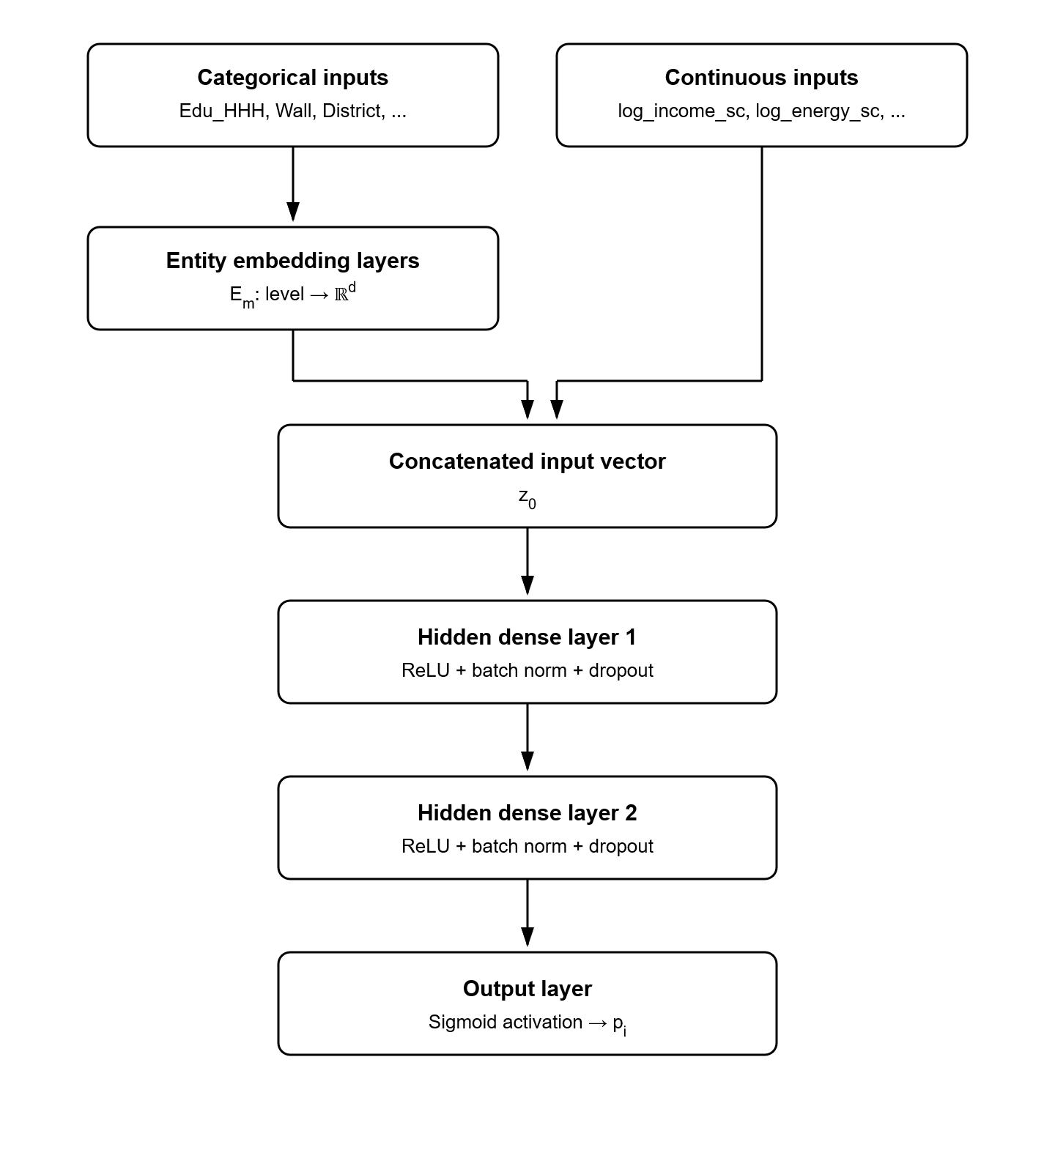
Figure 3.1: Architecture of the Tabular Multilayer Perceptron with Entity Embeddings.

A. Artificial Neural Network (ANN) Fundamentals
An ANN processes input vectors through layers of artificial neurons (nodes). For hidden layer $l$, node $j$ computes a linear combination of inputs from the preceding layer followed by a non-linear activation function:
$$z_{j}^{\left(l\right)}=f\left(\sum_{i}{w_{ji}^{\left(l\right)}}a_{i}^{\left(l − 1\right)} + b_{j}^{\left(l\right)}\right)$$
where $w_{ji}^{\left(l\right)}$ represents synaptic weight, $b_{j}^{\left(l\right)}$ is bias, and $f(·)$ is Rectified Linear Unit ($ReLU(z)=max(0,z)$). The final output node uses a sigmoidal activation $p_{i}=σ(z^{\left(L\right)})=(1+e^{-z^{\left(L\right)}})^{-1}$ to generate predicted energy poverty probabilities. Network parameters are updated via backpropagation [40] using AdamW optimizer [42, 43] to minimize binary cross-entropy loss:
$$L_{BCE}=-\frac{1}{N}\sum_{i=1}^{N}{\left[y_{i}lnp_{i}+(1-y_{i})ln(1-p_{i})\right]}$$

B. Entity Embedding Mechanism
High-cardinality categorical variables (e.g., District, Division, Wall Material, Education) present severe challenges for standard neural networks when one-hot encoded, causing extreme sparsity and dimensionality explosion. To resolve this, categorical features were mapped to continuous vector spaces via Entity Embeddings [41].
For categorical variable $m$ with $K_{m}$ distinct categories, an embedding lookup matrix $E_{m}∈R^{K_{m}×d_{m}}$ is instantiated, where embedding dimension $d_{m}$ follows rule-of-thumb:
$$d_{m}=min\left(50 , \left|\frac{K_{m}+1}{2}\right|\right)$$
When categorical index $k∈\{1,…,K_{m}\}$ is fed to the network, embedding layer $E_{m}(k)$ extracts the corresponding $d_{m}$-dimensional dense vector $e_{m}=E_{m,k,:}$. Dense embedding vectors across all $M$ categorical features are concatenated with scaled continuous variables $x_{num}$ to form the unified input vector:
$$z_{0}=\left[x_{num}|e_{1}|e_{2}|…|e_{M}\right]∈R^{P_{num}+∑d_{m}}$$
Dense embeddings were concatenated with scaled continuous features ($z_{0}$) and passed through two hidden dense layers of 128 and 64 units (`layers = c(128, 64)`). Each hidden layer incorporated Rectified Linear Unit ($ReLU$) activations, 1D Batch Normalization (`nnbatchnorm1d`), and a Dropout rate of $p=0.25$ (`nn_dropout(0.25)`) to prevent overfitting. The network was trained using the AdamW optimizer [42, 43] with a learning rate of $η=0.005$, weight decay of $0.01$, a mini-batch size of 128 (`trainingbatchsize = 128`), and 40 training epochs (`training_epochs = 40`) minimizing binary cross-entropy loss. Unlike static encodings (like dummy variables or PCA), embedding weights $E_{m}$ are parameters trained jointly with neural weights via backpropagation, organizing categories into low-dimensional continuous space where semantically similar factor levels cluster together naturally.

3.4 Model Evaluation and Explainability Framework

3.4.1 Evaluation Diagnostics (Minimal Summary)
Out-of-sample model performance was evaluated using:
- Discrimination: AUC-ROC and one-sided DeLong significance tests [44].
- Calibration: Brier Score [45] ($\frac{1}{N}∑(p_{i}-Y_{i})^{2}$) and Expected Calibration Error (ECE) [46].
- Policy Utility: Decision Curve Analysis (DCA) [40] calculating net benefit across risk thresholds.
- Validation: Stratified 5-Fold Cross-Validation [41] stratified by Division.

3.4.2 TreeSHAP Explainability and Interaction Tensors
While non-parametric decision tree ensembles (Random Forest and XGBoost) deliver superior predictive accuracy, their nested tree structures operate as non-linear black boxes, masking the exact marginal contribution of individual predictors. To restore full interpretability without sacrificing model complexity, Cooperative Game Theory Shapley additive explanations (SHAP) [8] and TreeSHAP [8, 9] were applied.

A. Foundations of Shapley Additive Explanations
For a model prediction $\hat{f}(x)$ on household $x=(x_{1},x_{2},…,x_{P})$, Shapley values calculate the unique additive attribution $ϕ_{j}(x)$ of each feature $j∈F=\{1,2,…,P\}$ toward the deviation of the prediction from the expected baseline outcome $E[\hat{f}(X)]$:
$$\hat{f}(x)=ϕ_{0}+\sum_{j=1}^{P}{ϕ_{j}}(x)$$
where $ϕ_{0}=E[\hat{f}(X)]$ is the expected baseline log-odds across the population. The local feature attribution $ϕ_{j}(x)$ for feature $j$ is uniquely determined by the weighted marginal contribution of feature $j$ across all possible feature sub-coalitions $S⊆F⧵\{j\}$:
$$ϕ_{j}(x)=\sum_{S⊆F⧵\{j\}}{\frac{|S|!(|F|-|S|-1)!}{|F|!}}\left[f_{x}(S∪\{j\})-f_{x}(S)\right]$$
where $f_{x}(S)=E[\hat{f}(X)∣X_{S}=x_{S}]$ represents the conditional expectation of the prediction given feature subset $S$. Shapley values are the only additive attribution method that simultaneously satisfies four fundamental theoretical axioms:
1. Efficiency: $\sum_{j=1}^{P}{ϕ_{j}}(x)=\hat{f}(x)-E[\hat{f}(X)]$ (attributions sum exactly to the prediction difference from baseline).
2. Symmetry: If two features $j$ and $k$ contribute identically to all coalitions ($f_{x}(S∪\{j\})=f_{x}(S∪\{k\})$ for all $S$), then $ϕ_{j}(x)=ϕ_{k}(x)$.
3. Dummy Player: If feature $j$ adds no marginal value to any coalition ($f_{x}(S∪\{j\})=f_{x}(S)$ for all $S$), then $ϕ_{j}(x)=0$.
4. Additivity: For an ensemble model $f(x)=g(x)+h(x)$, attributions add linearly: $ϕ_{j}^{f}(x)=ϕ_{j}^{g}(x)+ϕ_{j}^{h}(x)$.

B. TreeSHAP Computation & Polynomial Efficiency
While computing exact Shapley values across arbitrary model classes requires exponential time $O(2^{P})$, TreeSHAP [8, 9] exploits the conditional split geometry of decision trees to recursively compute exact feature attributions in low polynomial time $O(TLD^{2})$, where $T$ is the number of trees, $L$ is max leaves, and $D$ is max depth.

C. TreeSHAP Interaction Values: Mathematical Formulation
Standard main-effect Shapley values $ϕ_{j}(x)$ combine both the independent main effect of feature $j$ and its higher-order interaction effects with other features. To isolate pure multi-variable interactions, Lundberg et al. [9] extended TreeSHAP to compute pairwise Shapley Interaction Values based on Fujimoto’s game-theoretic interaction index.
The 3D TreeSHAP interaction tensor $Φ_{ij}(x)$ decomposes the prediction $\hat{f}(x)$ into main effects and pure joint interaction effects for every feature pair $\left(i , j\right)$:
$$\hat{f}(x)=Φ_{0}+\sum_{i=1}^{P}{Φ_{ii}}(x)+2\sum_{1≤i<j≤P}{Φ_{ij}}(x)$$
When $i=j$, $Φ_{ii}(x)$ represents the pure main effect of feature $i$ after removing all joint interactions with other features:
$$Φ_{ii}(x)=ϕ_{i}(x)-\sum_{j≠i}{Φ_{ij}}(x)$$
When $i≠j$, $Φ_{ij}(x)$ represents the pure joint interaction effect between feature $i$ and feature $j$, defined mathematically as:
$$Φ_{ij}(x)=\sum_{S⊆F⧵\{i,j\}}{\frac{|S|!(|F|-|S|-2)!}{2(|F|-1)!}}\left[f_{x}(S∪\{i,j\})-f_{x}(S∪\{i\})-f_{x}(S∪\{j\})+f_{x}(S)\right]$$
The bracketed term $Δ_{ij}(S)=f_{x}(S∪\{i,j\})-f_{x}(S∪\{i\})-f_{x}(S∪\{j\})+f_{x}(S)$ isolates the difference in predictive impact when features $i$ and $j$ are observed together versus when their individual marginal effects are evaluated independently. If features $i$ and $j$ act independently without synergistic or dampening effects, $Δ_{ij}(S)=0$ and $Φ_{ij}(x)=0$.

D. How TreeSHAP Interaction Values Interpret the Model
TreeSHAP interaction values provide three hierarchical levels of model interpretation:
1. Local Household-Level Interaction Analysis:
For any individual household $k$, $Φ_{ij}(x_{k})$ reveals whether the joint presence of two socioeconomic attributes (e.g., residing in a Rural area combined with Low Monthly Income) creates a non-additive penalty that pushes the predicted poverty probability higher than the sum of their individual risks.
2. Global Interaction Ranking Across the Population:
By taking the mean absolute interaction value across all $N$ households, the global interaction strength $I(i,j)$ between feature $i$ and feature $j$ is calculated:
$$I(i,j)=\frac{1}{N}\sum_{k=1}^{N}{|}Φ_{ij}(x_{k})|$$
This produces a rigorous, non-parametric ranking of which feature pairs exert the strongest interactive influence on model predictions nationwide.
3. Parent-Variable Dummy Aggregation for Econometric Integration:
Because categorical features are one-hot encoded during machine learning training (e.g., `WallMaterialCatFlimsy`, `WallMaterialCatSemiPermanent`), individual dummy interaction values $Φ_{m,n}$ are aggregated back to parent feature categories $A$ and $B$:
$$I_{Parent}(A,B)=\frac{1}{N_{sub}}\sum_{k=1}^{N_{sub}}{\sum_{m∈levels(A)}{\sum_{n∈levels(B)}{|}}}Φ_{m,n}(x_{k})|$$
This parent-level aggregation directly feeds into Step 3 of the ML-Guided Discovery-and-Refit Procedure (Section 3.6), identifying candidate parent interaction terms (e.g., `WallMaterialCat` $×$ `logincomesc`) to be tested and gated inside the parametric Multilevel Logistic Model (MLM).

3.5 Household Archetype Discovery and Spatial Autocorrelation
To discover socioeconomic sub-populations without manual pre-classification, K-Means clustering [43] was performed directly on the $N×P$ matrix of household-level SHAP values $Φ$. Cluster validity across solutions $k∈\{2,3,4,5\}$ was confirmed using the mean Silhouette Coefficient $S_{i}=\frac{b(i)-a(i)}{max(a(i),b(i))}$ [44] and Adjusted Rand Index (ARI) [45]. Model residual spatial independence $e_{i}=Y_{i}-{\hat{p}}_{i}$ was audited at the District level using Global Moran’s $I$ [46] ($I=\frac{N}{∑w_{ij}}·\frac{∑w_{ij}(e_{i}-\overline{e})(e_{j}-\overline{e})}{∑(e_{i}-\overline{e})^{2}}$).

3.6 The ML-Guided Discovery-and-Refit Procedure
The central methodological contribution of this thesis is an automated, two-stage framework designed to bridge machine learning pattern discovery with statistical parameter inference. The procedure uses TreeSHAP as a non-parametric screening tool to identify continuous non-linearities and candidate feature interactions on training data, which are subsequently refit and statistically gated inside a parametric Multilevel Logistic Model (MLM).
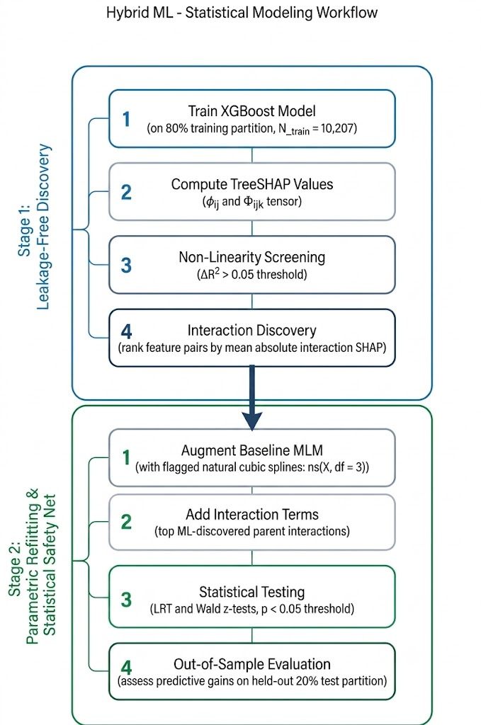
Figure 3.2: Flowchart of the two-stage ML-Guided Discovery-and-Refit Procedure.

Step 1: Leakage-Free Data Partitioning
To prevent data leakage into architecture selection, the discovery procedure runs exclusively on the 80% training partition ($N_{train}=10,207$).

Step 2: Non-Linearity Screening via Spline Regression
For each continuous covariate $X_{c}$ (e.g., log income, log energy expenditure, age, earners), two regression models are fit to predict the feature's main-effect TreeSHAP values $ϕ_{i,c}$:
$$LinearModel:ϕ_{i,c}=α_{0}+α_{1}X_{c,i}+ε_{i}$$
$$SplineModel:ϕ_{i,c}=α_{0}+ns(X_{c,i},df=3)α+ε_{i}$$
where $ns(X,df=3)$ denotes a natural cubic spline basis with 3 degrees of freedom. A feature is flagged for non-linear spline transformation in the MLM if the variance explained gain satisfies:
$$ΔR^{2}=R_{Spline}^{2}-R_{Linear}^{2}>0.05$$

Step 3: Interaction Candidate Discovery & Parent Aggregation
The 3D TreeSHAP interaction tensor $Φ_{i,j,k}$ is computed across training observations. For one-hot encoded dummy columns belonging to categorical parent variables $A$ and $B$, individual interaction SHAP values are aggregated back to parent feature pairs:
$$I_{Parent}(A,B)=\frac{1}{N_{sub}}\sum_{i=1}^{N_{sub}}{\sum_{j∈levels(A)}{\sum_{k∈levels(B)}{|}}}Φ_{i,j,k}|$$
Candidate interaction pairs are ranked by $I_{Parent}(A,B)$ to isolate the top multi-variable interactions.

Step 4: Parametric MLM Augmentation & Likelihood Ratio Test (LRT) Safety Net
The baseline nested Multilevel Logistic Model is augmented with the flagged spline transformations and top-ranked interaction pairs. To prevent overfitting and false-positive inclusions, candidate terms must pass a statistical safety net:
1. **Wald $z$-tests** ($p<0.05$) for individual interaction coefficients.
2. Likelihood Ratio Tests (LRT) comparing the augmented model against the baseline model:
$$D=-2\left(l_{Baseline} − l_{Augmented}\right)\sim χ^{2}(Δk)$$
Only candidate terms that yield a statistically significant reduction in deviance ($p<0.05$) are retained in the final ML-guided MLM specification:
$$logit(p_{imjk})=β_{0}+\sum_{p}{β_{p}}X_{p,imjk}+\sum_{c∈Flagged}{ns}(X_{c,imjk},3)θ_{c}+\sum_{(A,B)∈Passed}{(}X_{A,imjk}×X_{B,imjk})γ_{AB}+u_{0k}+v_{0jk}+w_{0mjk}$$
This two-stage strategy ensures that machine learning patterns responsibly inform—rather than replace—interpretable econometric models.

Chapter 4. Result and Discussion

4.1 Univariate Descriptive Statistics
This section presents the univariate descriptive statistics for the final cleaned sample drawn from the Bangladesh Household Income and Expenditure Survey (HIES) 2022. After cleaning, the analytical sample consists of 12,759 households with complete data across all indicators used in the study.
Household Head Characteristics
The household heads in the sample show the gender and marital patterns typically seen in Bangladesh. The large majority of households are male-headed (92.53%, n = 11,806), with female-headed households making up a much smaller share (7.47%, n = 953). Similarly, most household heads are married (92.30%, n = 11,776), while the remaining 7.70% (n = 983) are unmarried, a category that includes single, widowed, divorced, or separated individuals.
The average age of a household head is 46.70 years (SD = 13.20, median = 45), with ages ranging widely from 14 to 99 years. Education levels are fairly spread out across the sample: 30.27% (n = 3,862) of household heads have no formal education, 24.98% (n = 3,187) completed primary school, 27.69% (n = 3,533) reached secondary level, and only 17.06% (n = 2,177) went on to higher secondary or university education.
Household Size and Earners
Households average 4.45 members (SD = 1.74, median = 4), ranging from single-person households up to large, multi-generational homes with as many as 18 members. When grouped by size, 71.30% (n = 9,097) of households qualify as "large" (more than 3 members), while 28.70% (n = 3,662) are "small" (3 or fewer members).
On average, households have 1.48 active earners (SD = 0.74, median = 1). The fact that the median household relies on just a single earner points to a fairly high dependency burden across the sample, even though some households report as many as 8 earners.
Geographic Distribution
The sample is split almost perfectly evenly between rural (50.00%, n = 6,380) and urban (50.00%, n = 6,379) areas. Coverage across Bangladesh's eight administrative divisions is also fairly balanced, ranging from Rajshahi at the higher end (13.29%, n = 1,696) down to Chattogram at the lower end (11.40%, n = 1,455), with the remaining divisions falling in between.
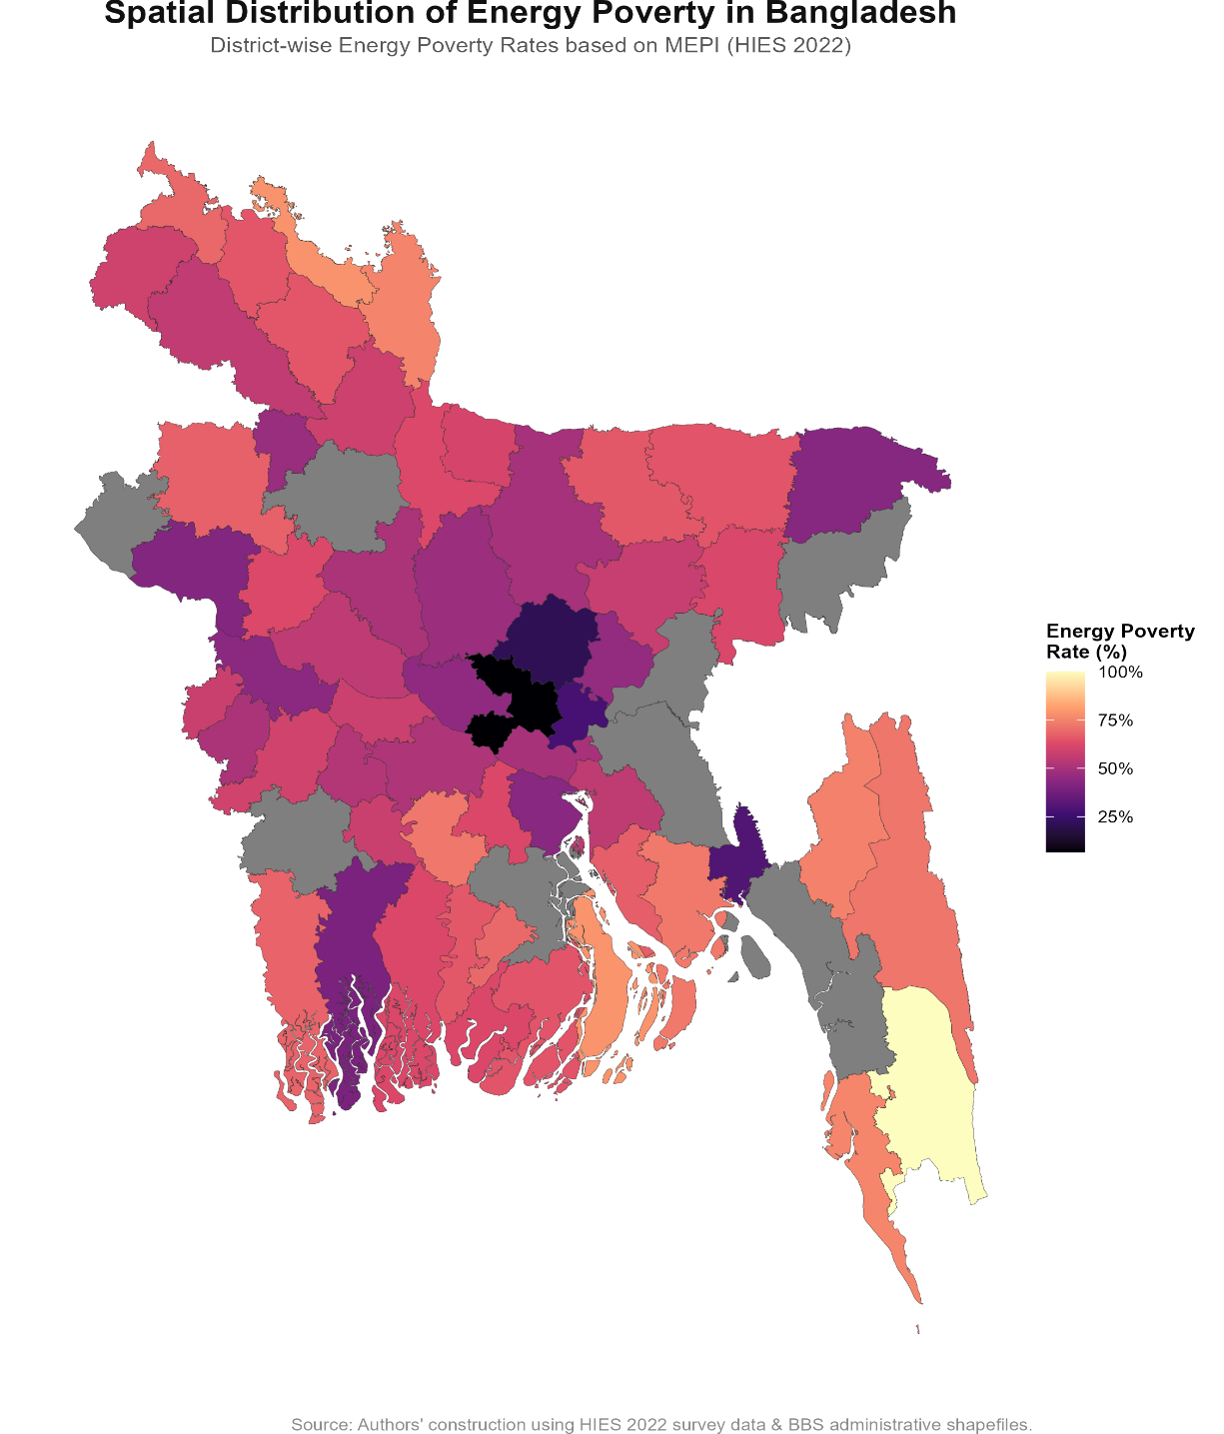
Figure 4.1: Distribution of Energy Poverty Percentage District-wise.
Economic and Financial Indicators
The mean monthly income proxy is BDT 27,726.72, but this figure is misleading on its own, since the distribution is heavily right-skewed (SD = BDT 66,429.81, median = BDT 16,950). The maximum recorded value, BDT 4,077,525, reflects a handful of extreme outliers pulling the mean well above the median. This skew is the reason a log transformation, log (Income + 1), was used for this variable in the regression models rather than the raw value.
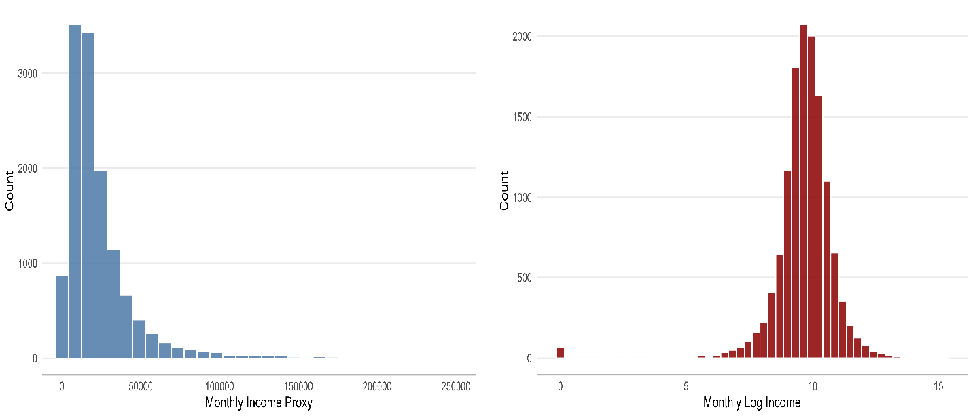
Figure 4.2: Distribution of Raw Monthly Income and Log-Transformed Monthly Income.
Households spend an average of BDT 1,498.23 per month on energy, covering gas, electricity, and solid fuels (SD = BDT 985.39, median = BDT 1,310). In terms of financial inclusion, 59.50% (n = 7,591) of households have at least one member with a bank account or mobile financial service, while 40.50% (n = 5,168) have no formal financial connection at all. Chronic illness is notably widespread in the sample, with 72.34% (n = 9,230) of households reporting that at least one member suffers from a chronic condition.
Housing Quality and Land Assets
Looking at housing infrastructure, wall materials are roughly split between permanent construction such as brick or concrete (51.16%, n = 6,528) and semi-permanent materials like tin sheets or wood (46.20%, n = 5,895), with flimsy walls made of mud, thatch, or bamboo making up a small remainder (2.41%, n = 308). Roofing tells a different story: semi-permanent roofing, mostly corrugated tin, dominates the sample at 77.69% (n = 9,913), while permanent concrete-slab roofs account for 21.73% (n = 2,773), and flimsy roofing is rare (0.51%, n = 65).
For land assets, the average operating land area is 0.62 acres (SD = 6.31, median = 0.09 acres), though this again is skewed by a few very large holdings reaching up to 630.17 acres. Using BBS's agricultural land classification, most households fall into the small landholder category of 0.05–2.50 acres (62.95%, n = 8,032), followed by marginal or landless households with less than 0.05 acres (33.26%, n = 4,244). Medium landholders (2.50–7.50 acres) and large landholders (7.50 acres or more) make up much smaller shares of the sample, at 3.17% (n = 405) and 0.61% (n = 78) respectively.
Dependent Variable: Multidimensional Energy Poverty Index (MEPI)
The outcome variable of interest, energy poverty status, was constructed using Alkire-Foster weights with a deprivation cutoff of k ≥ 0.35. Under this measure, 53.04% (n = 6,768) of households are classified as energy poor, while 46.96% (n = 5,991) are not. In other words, just over half of the sampled households in Bangladesh experience multidimensional energy poverty according to HIES 2022 data, underscoring the scale of the issue this thesis is built around.
Table 4.1. Descriptive Statistics of Categorical Variables (N = 12,759)
Variable / Category | Frequency (n) | Percentage (%)
Energy Poverty Status
No (0) | 5,991 | 46.96%
Yes (1) | 6,768 | 53.04%
Area of Residence
Rural | 6,380 | 50.00%
Urban | 6,379 | 50.00%
Administrative Division
Barishal | 1,611 | 12.63%
Chattogram | 1,455 | 11.40%
Dhaka | 1,512 | 11.85%
Khulna | 1,655 | 12.97%
Mymensingh | 1,610 | 12.62%
Rajshahi | 1,696 | 13.29%
Rangpur | 1,664 | 13.04%
Sylhet | 1,556 | 12.20%
Gender of HH Head
Male | 11,806 | 92.53%
Female | 953 | 7.47%
Marital Status of HH Head
Married | 11,776 | 92.30%
Unmarried | 983 | 7.70%
Family Size Category
Small (≤3 members) | 3,662 | 28.70%
Large (>3 members) | 9,097 | 71.30%
Education Level of HH Head
No Education | 3,862 | 30.27%
Primary | 3,187 | 24.98%
Secondary | 3,533 | 27.69%
Higher | 2,177 | 17.06%
Financial Inclusion
Not Included (0) | 5,168 | 40.50%
Included (1) | 7,591 | 59.50%
Chronic Illness Presence
Absent (0) | 3,529 | 27.66%
Present (1) | 9,230 | 72.34%
Wall Material Category
Permanent | 6,528 | 51.16%
Semi-Permanent | 5,895 | 46.20%
Flimsy | 308 | 2.41%
Other | 28 | 0.22%
Roof Material Category
Semi-Permanent | 9,913 | 77.69%
Permanent | 2,773 | 21.73%
Flimsy | 65 | 0.51%
Other | 8 | 0.06%
Operating Land Category
Marginal/Landless (<0.05 acres) | 4,244 | 33.26%
Small (0.05–2.50 acres) | 8,032 | 62.95%
Medium (2.50–7.50 acres) | 405 | 3.17%
Large (≥7.50 acres) | 78 | 0.61%
Variable / Category | Frequency (n) | Percentage (%)
Variable / Category | Frequency (n) | Percentage (%)

Table 4.2. Descriptive Statistics of Continuous Variables (N = 12,759)
Variable | Mean | SD | Median | Minimum | Maximum
Monthly Income (BDT) | 27,726.72 | 66,429.81 | 16,950.00 | 0.00 | 4,077,525.00
Monthly Energy Expenditure (BDT) | 1,498.23 | 985.39 | 1,310.00 | 20.00 | 15,200.00
Age of HH Head (Years) | 46.70 | 13.20 | 45.00 | 14.00 | 99.00
Number of Earners | 1.48 | 0.74 | 1.00 | 1.00 | 8.00
Household Size | 4.45 | 1.74 | 4.00 | 1.00 | 18.00
Operating Land Area (Acres) | 0.62 | 6.31 | 0.09 | 0.00 | 630.17
Variable | Mean | SD | Median | Minimum | Maximum
Variable | Mean | SD | Median | Minimum | Maximum

4.2 Bivariate Analysis
To establish a baseline understanding of the relationships between the hypothesized predictors and household multidimensional energy poverty status, this section presents the bivariate empirical results across the entire study sample (N = 12,759 households). The dependent variable, Energy Poverty Status, is a binary indicator where Yi = 1 denotes a household classified as multidimensionally energy-poor (deprivation score H ≥ 0.35 under the Alkire–Foster framework [3]) and Yi = 0 denotes an energy-secure household.
Bivariate tests allow for examination of the unadjusted, pairwise relationship between each independent predictor and the energy poverty outcome. This serves as a critical first step to identify potential associations, verify theoretical expectations, and establish descriptive profiles before moving to multivariate modeling.

4.2.1 Categorical Predictors
For the categorical variables, Pearson's Chi-Square (χ2) tests of independence determine whether a statistically significant association exists with energy poverty. To assess the practical strength of these associations on a standardized 0-to-1 scale, Cramér's V is reported.An audit of the expected cell count assumption revealed that all variables satisfied the requirement of having expected counts ≥ 5 in all cells, with the sole exception of Roof Material Category (RoofMaterialCat) due to a highly unequal distribution in a rare roof category. For Roof Material Category, simulated Monte Carlo p-values were calculated using 2,000 bootstrap replicates to ensure exact-like statistical validity.
Table 4.3 details the test statistics, degrees of freedom, p-values, and Cramér's V effect sizes, ordered from the strongest association to the weakest.
Categorical Predictor | χ² Statistic | df | p-value | Cramér's V | Expected Count Violated?
Wall Material | 2333.96 | 3 | < 0.001 | 0.428 | No
Education Level of Household Head | 2019.46 | 3 | < 0.001 | 0.398 | No
Roof Material | 1969.18 | 3 | < 0.001 | 0.393 | Yes (simulated p-value)
Residence | 1698.76 | 1 | < 0.001 | 0.365 | No
Financial Inclusion | 1066.25 | 1 | < 0.001 | 0.289 | No
Operating Land | 46.13 | 3 | < 0.001 | 0.060 | No
Family Size | 24.22 | 1 | < 0.001 | 0.044 | No
Marital Status of Household Head | 20.20 | 1 | < 0.001 | 0.040 | No
Gender of Household Head | 7.83 | 1 | 0.0051 | 0.025 | No
Chronic Illness | 4.43 | 1 | 0.0354 | 0.019 | No
Categorical Predictor | χ² Statistic | df | p-value | Cramér's V | Expected Count Violated?
Categorical Predictor | χ² Statistic | df | p-value | Cramér's V | Expected Count Violated?

Table 4.3 Chi-Square Tests of Independence and Effect Sizes
Categorical Predictor | χ² Statistic | df | p-value | Cramér's V | Expected Count Violated?
Wall Material | 2333.96 | 3 | < 0.001 | 0.428 | No
Education Level of Household Head | 2019.46 | 3 | < 0.001 | 0.398 | No
Roof Material | 1969.18 | 3 | < 0.001 | 0.393 | Yes (simulated p-value)
Residence | 1698.76 | 1 | < 0.001 | 0.365 | No
Financial Inclusion | 1066.25 | 1 | < 0.001 | 0.289 | No
Operating Land | 46.13 | 3 | < 0.001 | 0.060 | No
Family Size | 24.22 | 1 | < 0.001 | 0.044 | No
Marital Status of Household Head | 20.20 | 1 | < 0.001 | 0.040 | No
Gender of Household Head | 7.83 | 1 | 0.0051 | 0.025 | No
Chronic Illness | 4.43 | 1 | 0.0354 | 0.019 | No
Categorical Predictor | χ² Statistic | df | p-value | Cramér's V | Expected Count Violated?
Categorical Predictor | χ² Statistic | df | p-value | Cramér's V | Expected Count Violated?

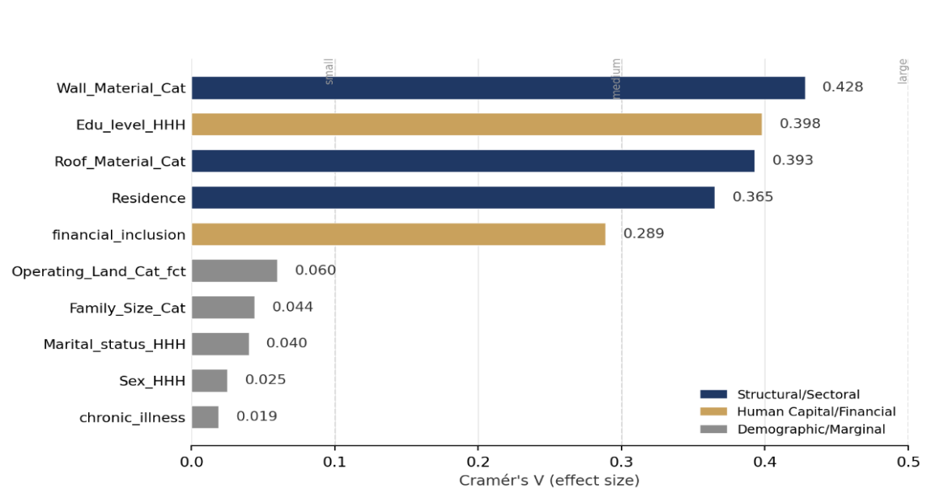
Figure 4.3: Strength of Association Between Categorical Predictors and Energy Poverty (Cramér's V)
The unadjusted categorical results reveal three distinct tiers of association strength.
Primary Structural and Sectoral Drivers (Cramér's V > 0.35)
Housing Materials (Wall Material and Roof Material). These exhibit the strongest bivariate associations with energy poverty. Wall material is the single most powerful categorical predictor (χ2(3) = 2333.96, V = 0.428, p < 0.001), followed closely by roof material (χ2(3) = 1969.18, V = 0.393, simulated p = 0.0005). This suggests that physical housing structure is a reliable indicator of energy poverty. Households living in dwellings constructed with flimsy, temporary, or low-quality materials (e.g., mud, bamboo, thatch, or low-grade corrugated iron sheets) are highly likely to be energy-poor. These materials are also associated with poor thermal insulation, increasing energy demand for basic comfort, while directly reflecting the household's inability to afford modern housing structures or formal utility connections [1].
Sectoral Disparities (Residence). Sector of residence (urban vs. rural) shows a highly significant association (χ2(1) = 1698.76, V = 0.365, p < 0.001). This represents a systemic gap in energy infrastructure access in Bangladesh. Rural communities face frequent power outages, lower grid density, and a near-complete lack of piped natural gas networks, forcing rural households to rely heavily on traditional biomass (wood, agricultural residues, dung) for cooking. Urban households, conversely, have much higher access to grid electricity and liquefied petroleum gas (LPG), explaining their much lower rate of multidimensional energy poverty [11].
Human Capital and Financial Mediators (Cramér's V ≈ 0.25–0.40)
Education of Household Head demonstrates a very strong association (χ2(3) = 2019.46, V = 0.398, p < 0.001). Educational attainment is a primary determinant of household head earning capacity, labor market mobility, and modern technology adoption. Households headed by individuals with no education face much higher energy poverty rates. Higher levels of education (primary, secondary, and higher) correspond to a linear drop in energy poverty risk, as educated heads are more likely to secure formal employment and adopt cleaner, more efficient cooking and lighting appliances [5].
Financial Inclusion (financial_inclusion). Exhibits a robust association (χ2(1) = 1066.25, V = 0.289, p < 0.001). Access to mobile financial services (e.g., bKash, Nagad) or traditional bank accounts plays a vital role. Financial inclusion facilitates cash transfers, reduces transaction costs for utility bill payments, and acts as a buffer against income shocks. It enables households to smooth their consumption and purchase modern fuels, such as LPG cylinders, that require upfront lump-sum payments.
Demographic and Marginal Covariates (Cramér's V < 0.10)
The remaining variables — land ownership (OperatingLandCatfct, V = 0.060), family size (FamilySizeCat, V = 0.044), household head marital status (MaritalstatusHHH, V = 0.040), head gender (SexHHH, V = 0.025), and chronic illness (chronic_illness, V = 0.019) — are all statistically significant at the 5% level. However, their Cramér's V values are exceptionally low. Given the large sample size (N = 12,759), even negligible effect sizes reach conventional statistical significance, so this pattern should not be read as evidence of meaningful practical association. It does, however, indicate that demographic characteristics carry a statistically detectable but practically marginal relationship with energy poverty in isolation, underscoring the necessity of multivariate models to isolate the conditional effects of these variables once economic controls are introduced.

4.2.2 Continuous Predictors
Because continuous variables such as household income and energy bills are heavily right-skewed and contain extreme outliers, their rank distributions were evaluated using non-parametric Wilcoxon Mann-Whitney rank-sum tests rather than parametric t-tests.
Table 4.4 summarizes the Wilcoxon W statistic, exact p-values, and group-specific descriptive statistics (means, medians, and standard deviations) for both the energy-poor and non-poor household groups.
Continuous Predictor | Wilcoxon W | p-value | Non-Poor Mean (Median) [SD] | Poor Mean (Median) [SD]
Monthly Energy Expenditure | 2.98 × 10⁷ | < 0.001 | 1,870.08 BDT (1,730.00) [862.4] | 1,169.07 BDT (1,010.00) [594.1]
Monthly Income | 2.95 × 10⁷ | < 0.001 | 37,144.94 BDT (23,083.33) [43,842.1] | 16,693.47 BDT (12,166.67) [15,108.6]
Age of HH Head | 2.04 × 10⁷ | 0.697 | 46.67 years (45.00) [12.92] | 46.74 years (45.00) [12.51]
Number of Earners | 2.04 × 10⁷ | 0.662 | 1.48 earners (1.00) [0.73] | 1.48 earners (1.00) [0.73]
Continuous Predictor | Wilcoxon W | p-value | Non-Poor Mean (Median) [SD] | Poor Mean (Median) [SD]
Continuous Predictor | Wilcoxon W | p-value | Non-Poor Mean (Median) [SD] | Poor Mean (Median) [SD]

Table 4.4 Wilcoxon Mann-Whitney Rank-Sum Tests and Group Descriptives
Continuous Predictor | Wilcoxon W | p-value | Non-Poor Mean (Median) [SD] | Poor Mean (Median) [SD]
Monthly Energy Expenditure | 2.98 × 10⁷ | < 0.001 | 1,870.08 BDT (1,730.00) [862.4] | 1,169.07 BDT (1,010.00) [594.1]
Monthly Income | 2.95 × 10⁷ | < 0.001 | 37,144.94 BDT (23,083.33) [43,842.1] | 16,693.47 BDT (12,166.67) [15,108.6]
Age of HH Head | 2.04 × 10⁷ | 0.697 | 46.67 years (45.00) [12.92] | 46.74 years (45.00) [12.51]
Number of Earners | 2.04 × 10⁷ | 0.662 | 1.48 earners (1.00) [0.73] | 1.48 earners (1.00) [0.73]
Continuous Predictor | Wilcoxon W | p-value | Non-Poor Mean (Median) [SD] | Poor Mean (Median) [SD]
Continuous Predictor | Wilcoxon W | p-value | Non-Poor Mean (Median) [SD] | Poor Mean (Median) [SD]

Note. SD = standard deviation. BDT = Bangladeshi Taka.
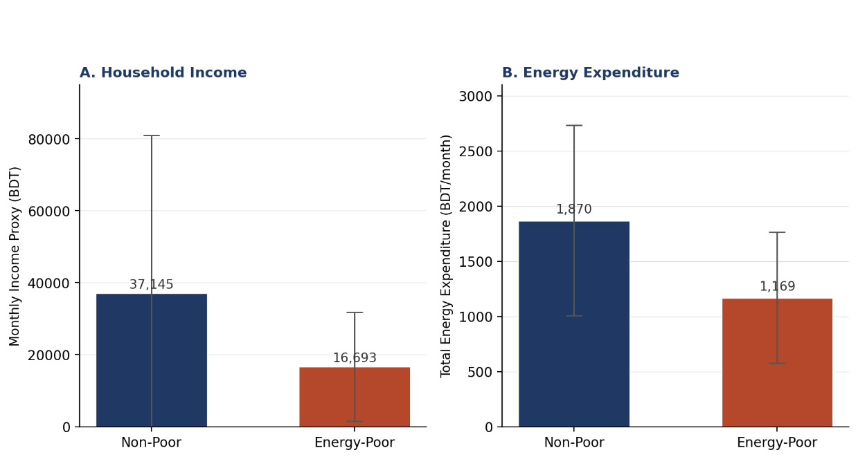
Figure 4.4: Average Monthly Income and Energy Expenditure by Energy Poverty Status.
The continuous bivariate results reveal a stark contrast between economic predictors and demographic indicators.
Stark Economic Disparities
Household Income Proxy (monthlyincomeproxy). Shows a highly significant difference in rank distributions between the poor and non-poor groups (W = 2.95 × 10⁷, p < 0.001). The median monthly income for non-poor households (23,083.33 BDT) is nearly double that of energy-poor households (12,166.67 BDT). This reinforces the theoretical link between income poverty and energy poverty: low-income households face severe budget constraints that force them to spend their limited resources on food and basic survival rather than investing in cleaner, more efficient, but more expensive energy options [10]. The high standard deviation in the non-poor group (43,842 BDT) reflects the wide income distribution among the energy-secure, whereas the poor group is tightly clustered at lower income levels.
Total Monthly Energy Expenditure (totalenergyexpenditure). Also highly significant (W = 2.98 × 10⁷, p < 0.001). Non-poor households spend a median of 1,730.00 BDT monthly, while energy-poor households spend a median of 1,010.00 BDT. This gap is a classic manifestation of suppressed energy demand: energy-poor households are unable to afford standard electrical appliances (refrigerators, fans, televisions) and rely heavily on free or cheaply gathered biomass instead of purchasing LPG cylinders. This lowers their absolute energy bills despite the high unit cost of the energy they do use, whereas non-poor households consume a wider array of modern energy services, leading to significantly higher absolute expenditures.
Identical Demographic Distributions
Age of Household Head (Age_HHH). Shows no statistically significant difference between energy-poor and non-poor households (W = 2.04 × 10⁷, p = 0.697). The median age in both groups is identical at 45.00 years, and the means are nearly indistinguishable (46.67 vs. 46.74 years). This suggests energy poverty is not a life-cycle issue that varies systematically with the household head's age.
Number of Earners (n_earners). Similarly non-significant (W = 2.04 × 10⁷, p = 0.662). Both groups exhibit an identical median of 1.00 earner and an identical mean of 1.48 earners, with identical standard deviations (0.73). This indicates that the absolute count of workers in a household does not protect against energy poverty; rather, it is the quality and productivity of those earners — which determines household income — that dictates energy security. A household with multiple low-productivity day-laborers remains at high risk, whereas a household with a single high-productivity formal employee is much more likely to be energy-secure.
Taken together, the bivariate results establish a clear preliminary hierarchy of association strength: structural housing quality and sectoral residence dominate, human capital and financial access mediate, and core demographic characteristics — age, family size, gender, marital status, chronic illness, and number of earners — contribute negligible standalone explanatory power. Continuous economic indicators (income and energy expenditure) sharply differentiate the two groups, while age and earner count do not differentiate them at all. These unadjusted patterns motivate the multivariate specification in the following section, which tests whether these associations persist once potential confounders and geographic clustering are controlled for.

4.3 Multivariate Results
To move from bivariate diagnostics to a proper multivariate framework, three models were fitted on the training set (N = 10,208 households).
The three specifications were:
Plain Logistic Regression (GLM): A standard binomial logistic model estimated by Maximum Likelihood, with no adjustment for geographic clustering.
2-Level Nested Multilevel Model (Division / District MLM): A generalized linear mixed model (GLMM) with nested random intercepts at the Division and District levels.
3-Level Nested Multilevel Model (Division / District / PSU MLM): A generalized linear mixed model (GLMM) with nested random intercepts at the Division, District and Primary Sampling Unit (PSU) levels, i.e., the village or block.
Comparing these three models makes it possible to see, layer by layer, how much geographic clustering is present at each level of Bangladesh’s administrative hierarchy, and which specification serves as the most suitable baseline model going forward.

4.3.1 Model Fit and Variance Decomposition
Table 4.5 reports the fit statistics, information criteria, and Intraclass Correlation Coefficients (ICC) for all three models.
Diagnostic Metric | Plain Logistic (GLM) | 2-Level MLM (Division/District) | 3-Level MLM (Division/District/PSU)
AIC | 9870.7 | 9330.6 | 8988.9
BIC | 10008.3 | 9511.4 | 9176.9
Log-Likelihood | −4911.4 | −4640.3 | −4468.5
Adjusted ICC | – | 0.126 (12.6%) | 0.296 (29.6%)
Unadjusted ICC | – | 0.067 (6.7%) | 0.160 (16.0%)
Random Effects Variance (σ²)
• Division | – | 0.2413 | 0.3319
• District (within Division) | – | 0.2341 | 0.1875
• PSU (within District & Division) | – | – | 0.8642
Diagnostic Metric | Plain Logistic (GLM) | 2-Level MLM (Division/District) | 3-Level MLM (Division/District/PSU)
Diagnostic Metric | Plain Logistic (GLM) | 2-Level MLM (Division/District) | 3-Level MLM (Division/District/PSU)

Table 4.5: Model Comparison and Variance Decomposition
Diagnostic Metric | Plain Logistic (GLM) | 2-Level MLM (Division/District) | 3-Level MLM (Division/District/PSU)
AIC | 9870.7 | 9330.6 | 8988.9
BIC | 10008.3 | 9511.4 | 9176.9
Log-Likelihood | −4911.4 | −4640.3 | −4468.5
Adjusted ICC | – | 0.126 (12.6%) | 0.296 (29.6%)
Unadjusted ICC | – | 0.067 (6.7%) | 0.160 (16.0%)
Random Effects Variance (σ²)
• Division | – | 0.2413 | 0.3319
• District (within Division) | – | 0.2341 | 0.1875
• PSU (within District & Division) | – | – | 0.8642
Diagnostic Metric | Plain Logistic (GLM) | 2-Level MLM (Division/District) | 3-Level MLM (Division/District/PSU)

–
–
–
–
–
–
Model fit improves steadily as geographic structure is added. AIC falls from 9870.7 for the plain GLM to 9330.6 for the 2-level MLM, and further to 8988.9 for the 3-level MLM. BIC follows the same pattern, moving from 10008.3 to 9511.4 to 9176.9. Log-likelihood also improves at each step, from −4911.4 (GLM) to −4640.3 (2-level MLM) to −4468.5 (3-level MLM). A Likelihood Ratio test confirms that each addition of structure is a statistically justified improvement: adding Division and District intercepts is significant at p < 0.001, and adding the PSU layer on top of that is significant again at p < 0.001. Taken together, these three metrics point in the same direction; the 3-level nested model is the best-fitting of the three specifications.
The adjusted ICC for the 3-level model is 0.296, meaning close to 30% of the variation in household energy poverty status can be attributed to clustering at the Division, District, and PSU levels combined. This is a substantial share for a household-level outcome.
Breaking the variance down by level in the 3-level model shows that the PSU-level random intercept variance (σ² = 0.8642) is more than double the combined Division (σ² = 0.3319) and District (σ² = 0.1875) variances. In other words, most of the geographic clustering captured by this model sits at the village/block level rather than at the broader Division or District level.
Because the residual variance structure differs so much across levels, a model that ignores this nesting; as the plain GLM does — violates the independence assumption and often underestimates standard errors, producing overly narrow confidence intervals and inflated Type I error [30]

4.3.2 Fixed-Effects Parameter Estimates (Odds Ratios)
Table 4.6 presents the fixed-effects estimates, expressed as odds ratios (OR) with 95% confidence intervals, for the Plain Logistic model (GLM) and the best-fitting 3-Level Nested MLM (Division/District/PSU).
Table 4.6. Fixed-Effects Parameter Estimates in Odds Ratios (GLM vs. 3-Level MLM)
Predictor Variable | GLM OR | GLM 95% CI | GLM p-value | MLM OR | MLM 95% CI | MLM p-value
(Intercept) | 18.083 | [7.091, 46.117] | <0.001*** | 25.494 | [8.196, 79.300] | <0.001***
Area of Residence (Ref: Rural)
Urban | 0.410 | [0.369, 0.455] | <0.001*** | 0.272 | [0.225, 0.329] | <0.001***
Education Level (Ref: No Education)
Primary | 0.731 | [0.640, 0.834] | <0.001*** | 0.664 | [0.570, 0.772] | <0.001***
Secondary | 0.482 | [0.421, 0.551] | <0.001*** | 0.453 | [0.388, 0.530] | <0.001***
Higher | 0.277 | [0.231, 0.332] | <0.001*** | 0.245 | [0.198, 0.303] | <0.001***
Financial Inclusion (Ref: No)
Yes | 0.639 | [0.576, 0.709] | <0.001*** | 0.572 | [0.506, 0.647] | <0.001***
Gender of HH Head (Ref: Female)
Male | 1.303 | [1.033, 1.643] | 0.026* | 1.234 | [0.949, 1.604] | 0.116
Marital Status (Ref: Married)
Unmarried | 1.325 | [1.053, 1.666] | 0.016* | 1.305 | [1.006, 1.691] | 0.045*
Family Size (Ref: Large >3)
Small (≤3 members) | 0.875 | [0.779, 0.983] | 0.024* | 0.979 | [0.857, 1.119] | 0.757
Log Income (Scaled) | 0.695 | [0.648, 0.745] | <0.001*** | 0.751 | [0.697, 0.809] | <0.001***
Log Energy Expenditure (Scaled) | 0.593 | [0.558, 0.630] | <0.001*** | 0.512 | [0.475, 0.553] | <0.001***
Age of Household Head (Scaled) | 0.973 | [0.922, 1.027] | 0.323 | 0.968 | [0.910, 1.030] | 0.305
Number of Earners (Scaled) | 1.025 | [0.973, 1.079] | 0.358 | 1.043 | [0.981, 1.109] | 0.180
Chronic Illness Presence (Ref: No)
Yes | 0.984 | [0.878, 1.102] | 0.780 | 0.864 | [0.756, 0.988] | 0.032*
Wall Material (Ref: Flimsy)
Permanent | 0.142 | [0.091, 0.223] | <0.001*** | 0.167 | [0.100, 0.281] | <0.001***
Semi-Permanent | 0.307 | [0.196, 0.482] | <0.001*** | 0.399 | [0.237, 0.672] | 0.001***
Other | 0.287 | [0.097, 0.851] | 0.024* | 0.336 | [0.100, 1.130] | 0.078†
Roof Material (Ref: Flimsy)
Permanent | 0.349 | [0.153, 0.794] | 0.012* | 0.412 | [0.163, 1.038] | 0.060†
Semi-Permanent | 0.877 | [0.389, 1.973] | 0.750 | 0.963 | [0.388, 2.393] | 0.936
Other | 1.206 | [0.134, 10.826] | 0.867 | 1.321 | [0.113, 15.385] | 0.824
Operating Land (Ref: Marginal)
Small (0.05–2.50 acres) | 1.172 | [1.047, 1.312] | 0.006** | 0.937 | [0.817, 1.075] | 0.353
Medium (2.50–7.50 acres) | 1.120 | [0.842, 1.489] | 0.436 | 0.731 | [0.526, 1.014] | 0.061†
Large (≥7.50 acres) | 1.480 | [0.801, 2.732] | 0.211 | 1.097 | [0.562, 2.141] | 0.786
Predictor Variable | GLM OR | GLM 95% CI | GLM p-value | MLM OR | MLM 95% CI | MLM p-value

Note. Significance codes: * p < 0.001, p < 0.01, * p < 0.05, † p < 0.1.
Residence: In the 3-level MLM, Urban residence carries an odds ratio of 0.272 (95% CI: [0.225, 0.329], p < 0.001). This means that, holding all other variables constant, urban households have about 72.8% lower odds of being energy-poor than rural households. This effect is stronger in the MLM than in the GLM, where the odds ratio is 0.410 (95% CI: [0.369, 0.455], p < 0.001, a 59.0% reduction in odds). The GLM therefore produces a noticeably smaller urban-rural gap than the model that accounts for geographic nesting, and the two confidence intervals do not overlap.
Education: The protective effect of education is consistent in direction and grows steadily stronger with each additional level, in both models:
Primary education: MLM OR = 0.664 (95% CI: [0.570, 0.772], p < 0.001), a 33.6% reduction in odds relative to no education. GLM: OR = 0.731 (95% CI: [0.640, 0.834], p < 0.001), a 26.9% reduction.
Secondary education: MLM OR = 0.453 (95% CI: [0.388, 0.530], p < 0.001), a 54.7% reduction. GLM: OR = 0.482 (95% CI: [0.421, 0.551], p < 0.001), a 51.8% reduction.
Higher education: MLM OR = 0.245 (95% CI: [0.198, 0.303], p < 0.001), a 75.5% reduction. GLM: OR = 0.277 (95% CI: [0.231, 0.332], p < 0.001), a 72.3% reduction.
In both models, each step up the education ladder produces a larger drop in the odds of energy poverty, and all six estimates (three per model) are significant at p < 0.001. This is quite evident with the mechanism that, education reduces energy poverty primarily by raising income and easing credit constraints with secondary contributions from efficient energy use behavior, better access to information and improved housing quality [1], [11], [5]
Financial Inclusion: This is significant in both models. In the 3-level MLM, OR = 0.572 (95% CI: [0.506, 0.647], p < 0.001), meaning a 42.8% reduction in the odds of energy poverty for financially included households. In the GLM, OR = 0.639 (95% CI: [0.576, 0.709], p < 0.001), a 36.1% reduction. As with residence, the effect is somewhat stronger in the MLM than in the GLM.
Several predictors behave differently across the two models — significant in the GLM, but not in the MLM (or vice versa):
Sex of Household Head (“Male”, Ref. “Female”): Significant in the GLM (OR = 1.303, 95% CI: [1.033, 1.643], p = 0.026) but not significant in the MLM (OR = 1.234, 95% CI: [0.949, 1.604], p = 0.116).
Family size (“Small”, Ref. “Large”): Significant in the GLM (OR = 0.875, 95% CI: [0.779, 0.983], p = 0.024) but not significant in the MLM (OR = 0.979, 95% CI: [0.857, 1.119], p = 0.757).
Operating Land (“Small”, Ref. “Marginal”): Significant in the GLM (OR = 1.172, 95% CI: [1.047, 1.312], p = 0.006) but not significant in the MLM (OR = 0.937, 95% CI: [0.817, 1.075], p = 0.353). The Medium category is not significant in either model, though it approaches the 10% threshold in the MLM (OR = 0.731, p = 0.061).
Chronic Illness: Not significant in the GLM (OR = 0.984, 95% CI: [0.878, 1.102], p = 0.780) but significant at the 5% level in the MLM (OR = 0.864, 95% CI: [0.756, 0.988], p = 0.032) a 13.6% reduction in odds. This is the reverse pattern: a predictor that becomes significant only after the nested structure is added.
Marital status (Ref: Married): Significant in both models, with a similar effect size (GLM: OR = 1.325, 95% CI: [1.053, 1.666], p = 0.016; MLM: OR = 1.305, 95% CI: [1.006, 1.691], p = 0.045).
This pattern is consistent with poverty and energy poverty research showing that single-level regressions can misattribute contextual, place-level variation to household-level predictors, since spatially clustered residuals often signal omitted geographic structure rather than genuine household effects [12], [13]. Notably, a Bangladesh energy poverty study using regional-level covariates still found several household predictors including income, age, and marital status remained significant even after accounting for regional context, suggesting the loss of significance for sex of household head, family size, and operating land here reflects genuine spatial confounding rather than a general breakdown of household-level effects [5].
Household consumption variables: Both Log Income (Scaled) and Log Energy Expenditure (Scaled) are significant at p < 0.001 in both models:
Log Income (Scaled): GLM OR = 0.695 (95% CI: [0.648, 0.745]); MLM OR = 0.751 (95% CI: [0.697, 0.809]).
Log Energy Expenditure (Scaled): GLM OR = 0.593 (95% CI: [0.558, 0.630]); MLM OR = 0.512 (95% CI: [0.475, 0.553]).
The income effect is somewhat weaker (closer to 1) in the MLM than in the GLM, while the energy expenditure effect is somewhat stronger (further from 1) in the MLM.
Age and Number of Earners. Neither Age HHH (Scaled) nor No. of Earners (Scaled) reaches statistical significance in either model (Age: GLM OR = 0.973, p = 0.323; MLM OR = 0.968, p = 0.305 | Earners: GLM OR = 1.025, p = 0.358; MLM OR = 1.043, p = 0.180).
Wall material. All three wall categories show odds ratios below 1 (protective) relative to Flimsy walls in both models:
Permanent: GLM OR = 0.142 (95% CI: [0.091, 0.223], p < 0.001); MLM OR = 0.167 (95% CI: [0.100, 0.281], p < 0.001).
Semi-Permanent: GLM OR = 0.307 (95% CI: [0.196, 0.482], p < 0.001); MLM OR = 0.399 (95% CI: [0.237, 0.672], p = 0.001).
Other: GLM OR = 0.287 (95% CI: [0.097, 0.851], p = 0.024); MLM OR = 0.336 (95% CI: [0.100, 1.130], p = 0.078, only marginal in the MLM, and its confidence interval crosses 1).
Roof material. Roof material shows a weaker and less consistent pattern than wall material:
Permanent: significant in the GLM (OR = 0.349, 95% CI: [0.153, 0.794], p = 0.012) but only marginal in the MLM (OR = 0.412, 95% CI: [0.163, 1.038], p = 0.060), with a confidence interval that just crosses 1.
Semi-Permanent and Other categories are not significant in either model, and both have very wide confidence intervals (e.g., Other in the MLM: [0.113, 15.385]).

4.3.3 Summary of Section 4.3 Results
The 3-level nested MLM is the best-fitting of the three models on all three information criteria (AIC, BIC, log-likelihood), with each nesting layer producing a statistically significant improvement (p < 0.001 at each step).
Nearly 30% (adjusted ICC = 0.296) of the unexplained variation in energy poverty sits at the Division, District, or PSU level, with the PSU (village/block) layer accounting for the largest single share of that geographic variance (σ² = 0.8642).
Residence, education, financial inclusion, income, energy expenditure, and wall material are significant predictors (95% CI excluding 1) in both the GLM and the 3-level MLM, though the odds ratios shift once geographic nesting is introduced — sometimes moving further from 1 (residence, financial inclusion), sometimes closer to 1 (income).
Sex of household head, family size, and operating land (small) lose significance once the nested structure is added (their MLM confidence intervals include 1), while chronic illness gains significance.
Age of household head, number of earners, and most roof material categories are not significant predictors in either model, and several of the smaller categories (e.g., roof “Other”) carry very wide confidence intervals reflecting limited sample size in those groups.

4.4 Machine Learning Results and the ML-Guided Multilevel Model Enhancement
The preceding chapter established the econometric baseline: a plain logistic regression and a nested multilevel logistic regression (Division/District random intercepts) fit to the Bangladesh Household Income and Expenditure Survey (HIES) 2022 sample (N = 12,759 households). This chapter asks whether flexible machine learning models out-predict that baseline, whether the source of any advantage can be identified and decomposed, and whether it can be folded back into an interpretable statistical model. Three machine learning models are benchmarked against the two econometric baselines: a Tabular Multilayer Perceptron with learned entity embeddings for geography (Tabular MLP), a Random Forest, and XGBoost [23], [38]. Performance is evaluated on a standard 80/20 split and on a stricter spatial generalizability split in which entire villages (PSUs) are held out, so no model can rely on a memorized village-level random intercept. TreeSHAP is then used to decode the best tree-based model, derive household archetypes, and test whether those archetypes carry genuine predictive information. The chapter closes with the ML-Guided Multilevel Model (MLM): a discovery-and-refit procedure that mines the machine learning model's learned non-linearities and interactions and reintroduces them into the multilevel logistic regression.

4.4.1 Machine Learning Models
Three models are reported, each using the encoding that performed best for that model class: XGBoost and Random Forest trained on one-hot encoded features, and the Tabular MLP trained with learned entity embeddings in place of a one-hot block for the 64-category District variable. All three share the same 14 socio-demographic, economic, and structural predictors, the same leakage-free 80/20 train/test partition (seed 2026), and the same 5-fold cross-validation folds used to generate out-of-fold predictions.
• Tabular MLP: a PyTorch feed-forward network with batch-normalized continuous inputs and a learned low-dimensional continuous embedding for District, trained with AdamW and binary cross-entropy loss.
• Random Forest: trained via the ranger package (a high-performance C++ implementation).
• XGBoost: gradient-boosted decision trees (300 rounds, learning rate 0.05, max depth 6, subsample and column-sample rates of 0.8).

4.4.2 Predictive Performance on the Standard Test Split
Table 4.7 reports test-set performance (N = 2,551) on AUC-ROC, Brier Score, Expected Calibration Error (ECE), Accuracy, Sensitivity, and Specificity.
Model | AUC-ROC | 95% CI | Brier | ECE | Accuracy | Sensitivity | Specificity
Tabular MLP (EE) | 0.8739 | [.861,.887] | 0.1434 | 0.0161 | 79.62% | 0.8046 | 0.7868
XGBoost (OHE) | 0.8718 | [.858,.885] | 0.1450 | 0.0195 | 79.58% | 0.8531 | 0.7322
MLM (Div/Dist RE) | 0.8670 | [.853,.881] | 0.1471 | 0.0153 | 78.91% | 0.8531 | 0.7182
Random Forest (OHE) | 0.8663 | [.853,.880] | 0.1493 | 0.0463 | 79.11% | 0.8479 | 0.7281
Plain Logistic | 0.8436 | [.829,.859] | 0.1592 | 0.0284 | 76.87% | 0.7897 | 0.7455
Model | AUC-ROC | 95% CI | Brier | ECE | Accuracy | Sensitivity | Specificity
Model | AUC-ROC | 95% CI | Brier | ECE | Accuracy | Sensitivity | Specificity

Table 4.7. Test-set performance, standard 80/20 split (N = 2,551).
Model | AUC-ROC | 95% CI | Brier | ECE | Accuracy | Sensitivity | Specificity
Tabular MLP (EE) | 0.8739 | [.861,.887] | 0.1434 | 0.0161 | 79.62% | 0.8046 | 0.7868
XGBoost (OHE) | 0.8718 | [.858,.885] | 0.1450 | 0.0195 | 79.58% | 0.8531 | 0.7322
MLM (Div/Dist RE) | 0.8670 | [.853,.881] | 0.1471 | 0.0153 | 78.91% | 0.8531 | 0.7182
Random Forest (OHE) | 0.8663 | [.853,.880] | 0.1493 | 0.0463 | 79.11% | 0.8479 | 0.7281
Plain Logistic | 0.8436 | [.829,.859] | 0.1592 | 0.0284 | 76.87% | 0.7897 | 0.7455
Model | AUC-ROC | 95% CI | Brier | ECE | Accuracy | Sensitivity | Specificity
Model | AUC-ROC | 95% CI | Brier | ECE | Accuracy | Sensitivity | Specificity

Tabular MLP and XGBoost are statistically tied for best (DeLong Z = 0.813, p = .208) [44], and both significantly beat Random Forest, Plain Logistic, and the MLM (p ≤ .012 in every case). The MLM's competitiveness with Random Forest (0.8670 vs. 0.8663) shows that modeling geographic clustering at all — not non-linear flexibility per se — closes much of the gap from Plain Logistic. XGBoost and the MLM favor sensitivity over specificity at their default thresholds (useful for a poverty-targeting tool where missing a poor household is usually costlier than over-inclusion), while Tabular MLP is the most balanced. Figures 4.4.1-4.4.3 show ROC, calibration, and Decision Curve Analysis (DCA); the latter confirms XGBoost and Tabular MLP dominate the other models' net policy benefit across nearly the entire realistic targeting-threshold range.
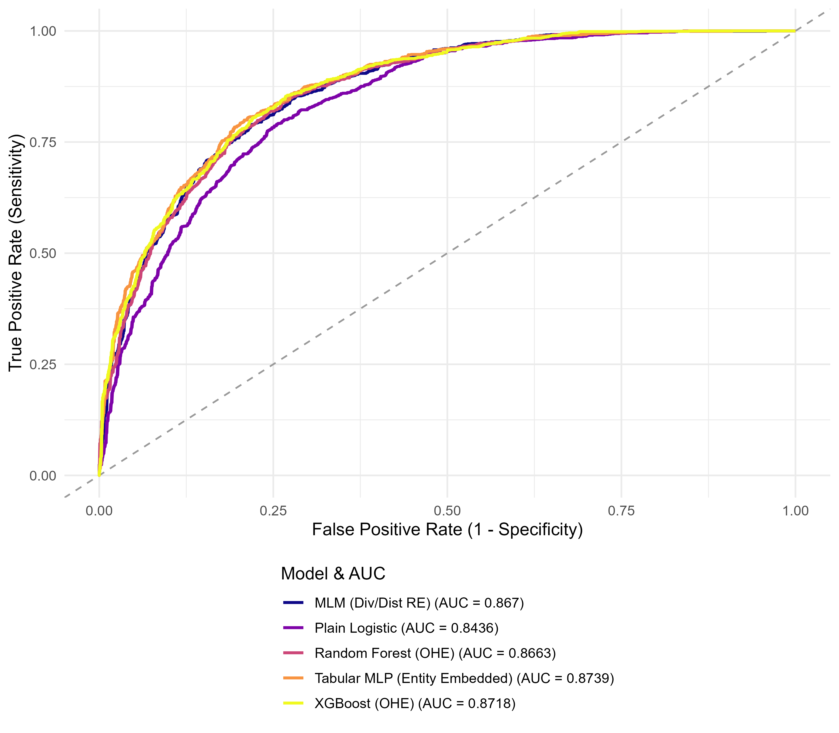
Figure 4.5: ROC curves, standard test split.
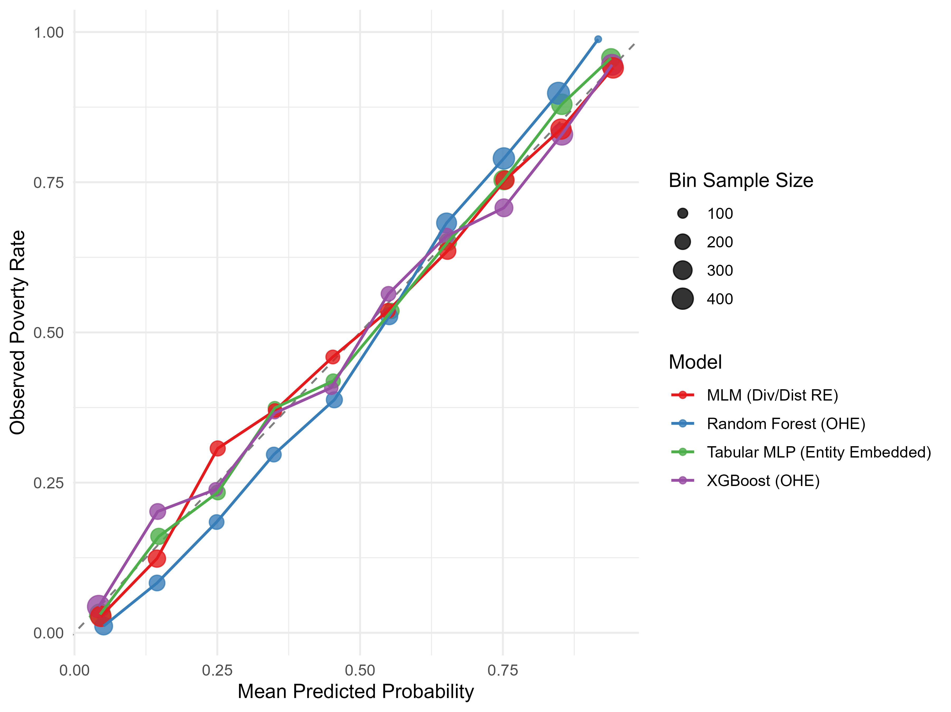
Figure 4.6: Calibration curves (10-quantile bins).
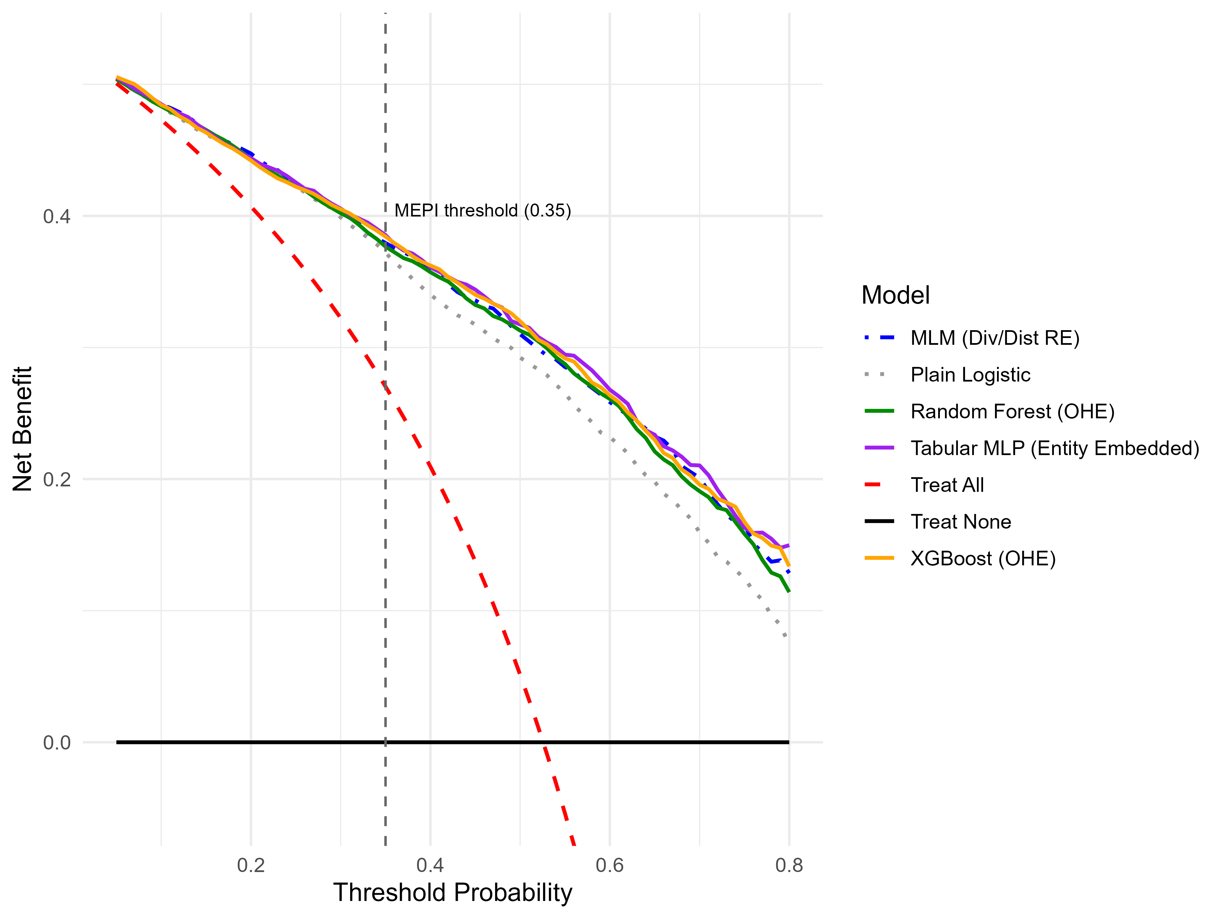
Figure 4.7: Decision Curve Analysis.

4.4.3 Spatial Generalizability: Unseen PSUs
The standard split evaluates models on villages (PSUs) also seen in training favorable to the MLM, which can partially memorize each PSU's deviation via its random intercept. To test a harder, policy-realistic setting, predicting energy poverty in PSUs never seen during training — the sample was repartitioned by whole PSU: 573 PSUs for training, the remainder held out entirely. This is the more decision-relevant test, since deployment to new, unsurveyed villages is exactly where a targeting tool is most needed.
Table 4.8. Spatial generalizability audit on unseen PSUs (N = 2,592).
Model | AUC-ROC | 95% CI | Brier | Accuracy | Sensitivity | Specificity
XGBoost (OHE) | 0.8838 | [.871,.896] | 0.1386 | 80.67% | 0.7885 | 0.8242
Random Forest (OHE) | 0.8761 | [.863,.889] | 0.1475 | 79.82% | 0.7987 | 0.7977
Tabular MLP (EE) | 0.8755 | [.862,.889] | 0.1433 | 79.98% | 0.8279 | 0.7728
MLM (Div/Dist RE) | 0.8751 | [.862,.888] | 0.1433 | 79.78% | 0.8153 | 0.7811
Model | AUC-ROC | 95% CI | Brier | Accuracy | Sensitivity | Specificity
Model | AUC-ROC | 95% CI | Brier | Accuracy | Sensitivity | Specificity

XGBoost is the clear leader here (AUC = 0.8838), significantly ahead of the MLM (Z = 2.938, p = .0017), Random Forest (Z = 2.994, p = .0014), and Tabular MLP (Z = 2.930, p = .0017). Once a village-level random intercept is unavailable, the MLM, Random Forest, and Tabular MLP converge to nearly identical performance (0.8751-0.8761), while XGBoost pulls ahead which indicates it captures transferable household-level structure rather than memorized local intercepts. Two robustness checks confirm this is not an artifact of chance: the Tabular MLP's 5-fold AUC is stable across four random seeds (range 0.8719-0.8732), and downsampling the training set to exact class balance changes validation AUC by only 0.0001 — the sample's near-53% prevalence is not a material confound.
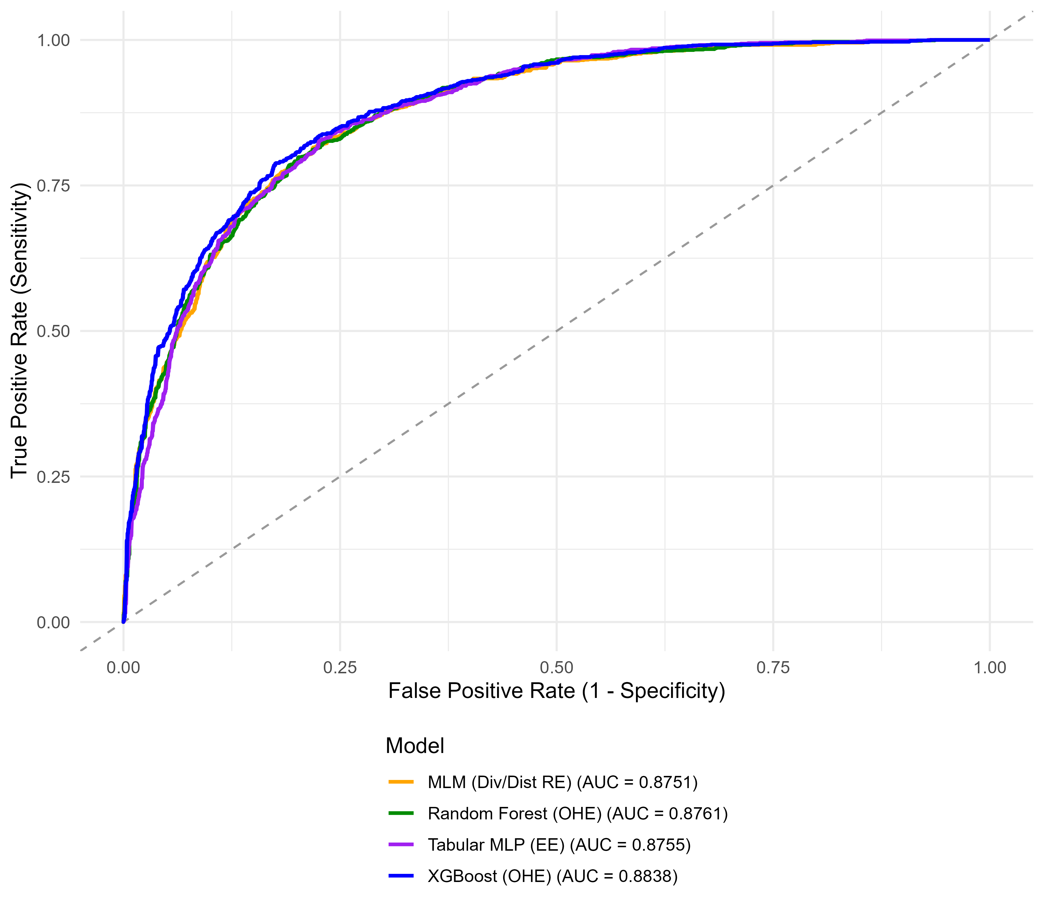
Figure 4.8: ROC curves, unseen-PSU audit.

4.4.4 Decoding the Black Box: TreeSHAP and Household Archetypes
Having established that XGBoost carries a genuine, spatially transferable advantage, this section opens the model with TreeSHAP [8], [9] to test the thesis's central claim: that households do not experience energy poverty through one homogeneous pathway (Scenario A) but cluster into distinct socioeconomic archetypes with different drivers (Scenario B).
Mean absolute SHAP value ranks structural housing quality, energy spending, urban residence, and income as the four most influential predictors (Figure 4.8) — consistent with the classic fuel-poverty framework of low income, high energy costs, and poor housing/insulation quality jointly driving deprivation [1]. A naive comparison of this ranking against the MLM's fixed-effect coefficient ranking yields weak agreement (Spearman ρ ≈ 0.37) — but this figure is distorted by District, which ranks first by SHAP importance in every archetype yet is forced to rank last in the MLM comparison because it enters as a random intercept, not a fixed effect with a comparable magnitude. Excluding District raises ρ to approximately 0.68-0.69 — moderate-to-strong agreement, not the near-total discordance the raw figure implies, though still short of the near-1.0 agreement Scenario A would predict.
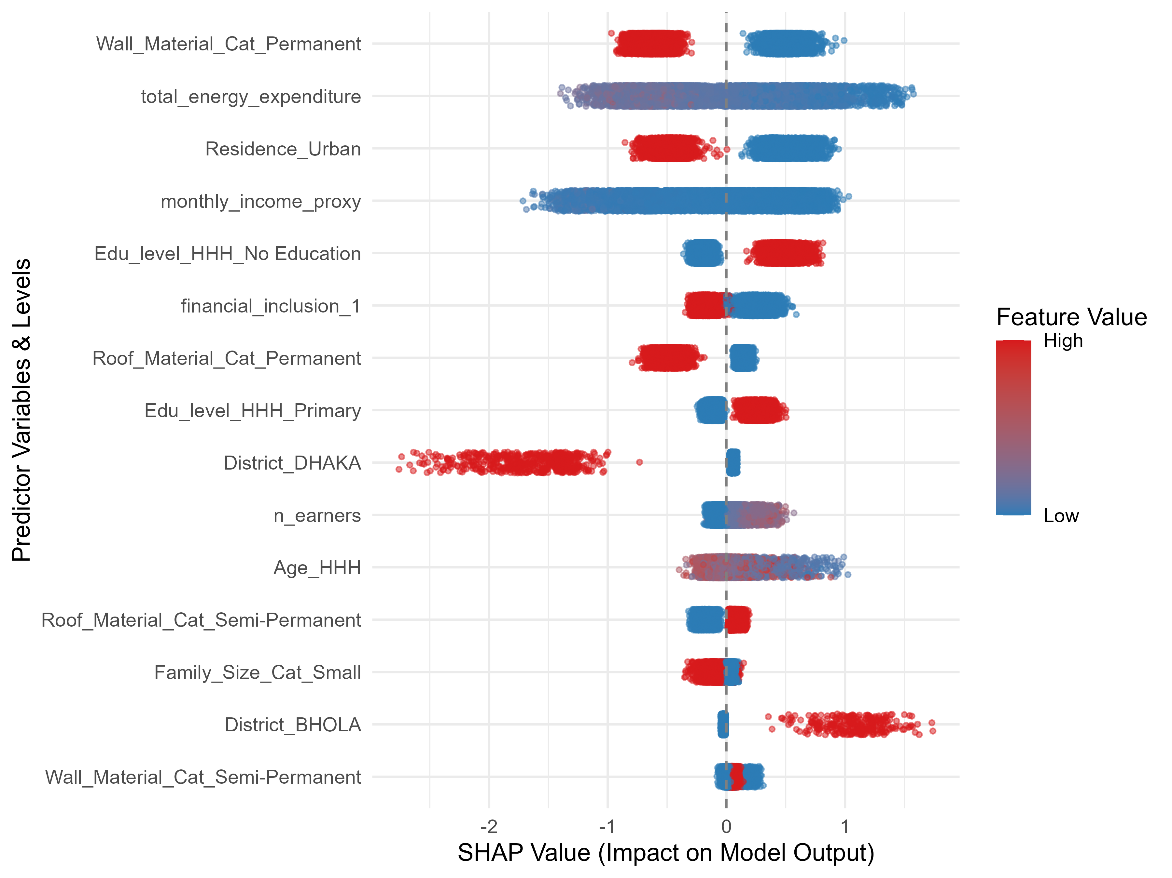
Figure 4.9: Global SHAP beeswarm, top 15 features.
K-means clustering of standardized per-household SHAP vectors (k = 3, chosen on substantive rather than purely statistical grounds — internal silhouette scores are highest at k=2 and decline thereafter) yields three archetypes with sharply different poverty rates (Table 4.9).
Archetype | N (%) | % Rural | Mean Income (BDT) | % No Education | Poverty Rate
Rural Poor | 6,617 (51.9%) | 70.4% | 17,489 | 43.0% | 78.16%
Urban Resilient | 2,652 (20.8%) | 19.7% | 48,605 | 9.4% | 12.59%
Urban Working-Class | 3,490 (27.3%) | 34.4% | 26,043 | 21.9% | 36.16%
Archetype | N (%) | % Rural | Mean Income (BDT) | % No Education | Poverty Rate

Table 4.9. Socioeconomic profile of the three SHAP-derived household archetypes.
Archetype | N (%) | % Rural | Mean Income (BDT) | % No Education | Poverty Rate
Rural Poor | 6,617 (51.9%) | 70.4% | 17,489 | 43.0% | 78.16%
Urban Resilient | 2,652 (20.8%) | 19.7% | 48,605 | 9.4% | 12.59%
Urban Working-Class | 3,490 (27.3%) | 34.4% | 26,043 | 21.9% | 36.16%
Archetype | N (%) | % Rural | Mean Income (BDT) | % No Education | Poverty Rate
Archetype | N (%) | % Rural | Mean Income (BDT) | % No Education | Poverty Rate

These archetypes are not an artifact of TreeSHAP: an independent K-means clustering run directly on raw demographic features recovers nearly the same partition (Adjusted Rand Index [47] = 0.759; the Urban Resilient archetype alone matches its raw-cluster counterpart in 2,650 of 2,652 households), externally validating the segmentation (Figure 4.9). The rural/urban and divisional stratification underlying these archetypes (Rural Poor concentrated in Barisal, Urban Resilient in Khulna) echoes prior national-level multilevel analyses of multidimensional energy poverty in Bangladesh, which likewise identify residence and division as key structuring factors [5]. Fitting separate local logistic regressions within each cluster, however, surfaces a caution: the Urban Resilient subgroup (only 334 poverty-positive households) shows textbook quasi-complete separation in an unregularized fit (the Permanent wall-material dummy (WallMaterialPermanent) estimate +12.0, SE 1,455); Ridge regularization stabilizes this (shrinking to +0.39) but leaves residual sign disagreement on housing-material coefficients in 3 of 19 and 2 of 20 compared terms for the two urban archetypes, suggesting genuine local heterogeneity rather than pure noise.
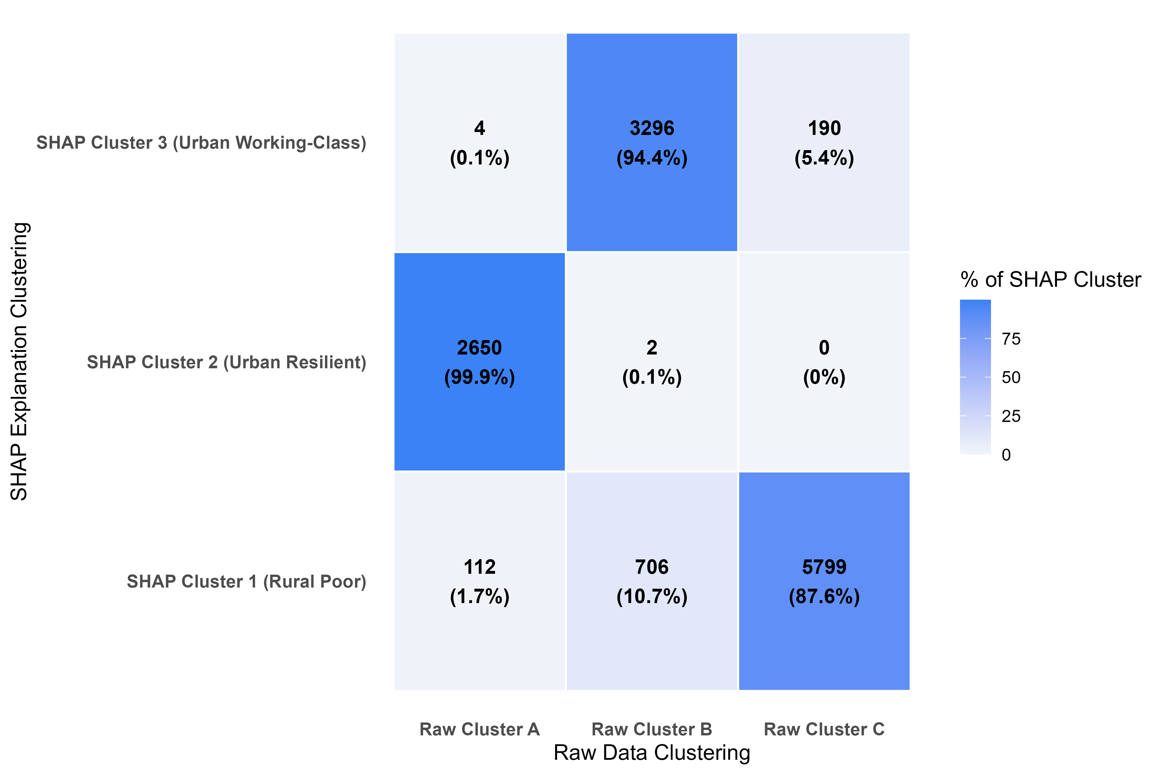
Figure 4.10: SHAP-cluster vs. raw-cluster agreement (ARI = 0.759).
Two further checks test whether this descriptive structure has independent predictive value or is simply a proxy for geography. First, a leakage-free 5-fold cross-validation (cluster assignment, TreeSHAP, and model fitting all confined to training folds) compared baseline, raw-cluster-interaction, and SHAP-cluster-interaction logistic specifications: none of the cluster-augmented models beat the baseline (Mean AUC 0.8421 vs. 0.8427 vs. 0.8404), and SHAP-cluster interactions perform significantly worse than raw-cluster interactions (Z = -2.088, p = .037). SHAP clustering's value here is descriptive and diagnostic, not predictive. Second, re-fitting the MLM with added district-level slope interactions for the top predictors closes only 10.07% of the MLM-to-XGBoost gap (0.8670 → 0.8675 vs. XGBoost's 0.8718) — ruling out a simple geographic-slope confound as the source of XGBoost's edge. Household-level prediction divergence (XGBoost minus MLM) differs significantly by archetype (Kruskal-Wallis χ² = 22.18, p = 1.5 × 10⁻⁵), further indicating the advantage is household-level, not geographic.

4.4.5 The ML-Guided Multilevel Model Pipeline
Rather than discard the interpretable MLM in favor of the black box, this section uses XGBoost/TreeSHAP purely as a diagnostic instrument: identifying where and how much non-linear flexibility the MLM is missing, and injecting only that much back in. This targets a middle ground between two extremes — XGBoost's high accuracy with no reportable coefficients, and the MLM's full interpretability with left-on-the-table accuracy — without defaulting to a fully automatic Generalized Additive Model (GAM), which would add a second, less transparent layer of smoothing-parameter selection on top of the TreeSHAP diagnostic step already performed. Fixing spline degrees of freedom at 3 in advance instead keeps the refit model a fully parametric GLMM, with the same standard errors and p-values as the baseline for every term [21], [37].
To decide which continuous features needed non-linear treatment, we first trained a diagnostic XGBoost model using only the training data, then examined the SHAP values it produced for each continuous feature. For each continuous feature x, we fit two auxiliary regressions predicting its SHAP values, SHAP(x), from the feature itself: one assuming a straight-line relationship, and one allowing a flexible natural spline with 3 degrees of freedom:
SHAP(x) = β₀ + β₁x + ε (linear fit → R²_linear)
SHAP(x) = f(ns(x, df=3)) + ε (spline fit → R²_spline)
The improvement in explanatory power from allowing the curve is the R² gain:
R²gain = R²spline − R²_linear
A feature is flagged for spline treatment in the refit model whenever R²_gain > 0.05. This test flagged three of the four continuous features — income, energy expenditure, and age — as genuinely non-linear, while the number of earners was left as a simple straight line (Table 4.10. Non-linearity detection (training-split-only diagnostic metrics).
Continuous Feature | Linear R² | Spline R² (df=3) | R² Gain (ΔR²) | Flagged for Spline Transformation?
Age of Household Head | 0.004 | 0.487 | 0.483 | Yes (Flagged)
Log Monthly Income Proxy | 0.312 | 0.727 | 0.415 | Yes (Flagged)
Log Monthly Energy Expenditure | 0.618 | 0.725 | 0.107 | Yes (Flagged)
Number of Earners | 0.421 | 0.471 | 0.050 | No (Not Flagged)
Continuous Feature | Linear R² | Spline R² (df=3) | R² Gain (ΔR²) | Flagged for Spline Transformation?
Continuous Feature | Linear R² | Spline R² (df=3) | R² Gain (ΔR²) | Flagged for Spline Transformation?

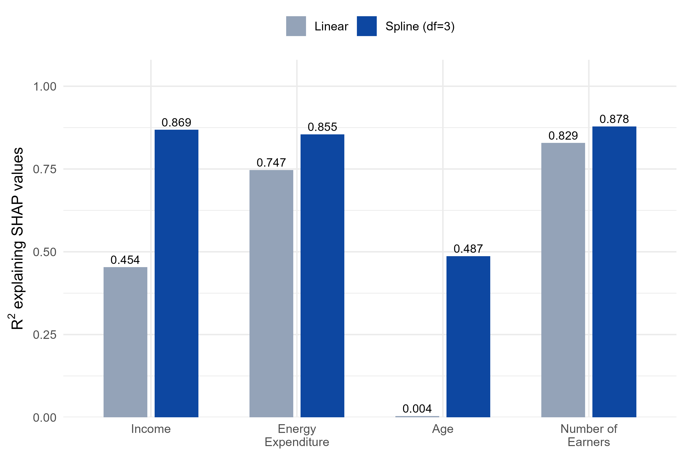
Figure 4.11: R² explaining SHAP values: linear fit vs. 3-DF spline fit, all four continuous features.
Age's R² gain is the most striking case: a straight line explains almost none of the pattern in its SHAP values (R² = 0.004), while the fitted spline recovers a clear U-shape (Figure 4.11) — risk is highest for the youngest and oldest household heads and lowest in middle age, consistent with a lifecycle-earnings pattern. Energy expenditure and number of earners, by contrast, show nearly identical linear and spline R² (Figure 4.10), which is exactly why the R²-gain test correctly leaves the latter untouched.
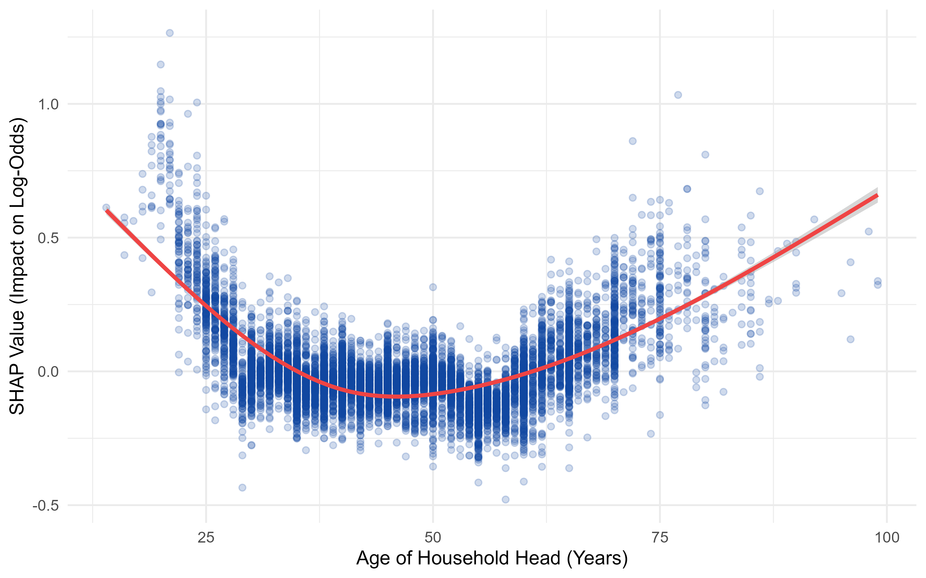
Figure 4.12: SHAP dependence plot for age with fitted natural spline (training-split-only).
The ranking metric itself is an aggregated TreeSHAP interaction strength: for parent features A and B, the average, across a training subsample of size N, of the summed absolute pairwise SHAP interaction values across every dummy-level combination belonging to A and B:
Strength(A, B) = (1/N) Σᵢ Σ{j∈A} Σ{k∈B} |Φᵢⱼₖ|
A companion robustness check is essential here: re-running discovery independently within each of five cross-validation folds gives each candidate pair a stability count how many of six runs (five folds plus the main split) selected it into the top three. Residence × wall-material was selected in all six runs, energy × wall-material in four of six, income × education in two of six, and income × energy expenditure the interaction actually selected into the final model — in only one.
A separate null-DGP test — applying the identical discovery procedure to synthetic data with no true interaction anywhere, across three seeds and two covariate-correlation conditions — shows this stability count cannot be trusted at face value: a known-fake pairing also reached 6-of-6 consistency purely by chance. Comparing raw magnitudes is sharper: the real data's top-ranked strength falls below the weakest value pure noise produced across six null trials:
Strengthreal (top-1) = 0.0512 < min[ Strengthnull (top-1) ] = 0.0538
Income × energy expenditure matches this documented artifact shape (two independently strong continuous predictors) and should be read as a likely false discovery. Its own refit coefficient tests this directly, under H₀: β = 0:
β̂ = 0.0165, SE = 0.0298, z = 0.55, p = .58 → fail to reject H₀
Residence × wall-material and energy × wall-material are more plausible on substantive and stability grounds but should still be treated as motivated hypotheses rather than confirmed findings absent a permutation-based significance test.
Figure 4.12 illustrates the more trustworthy of the two: energy expenditure's SHAP dependence, fit separately by wall-material category. The refit model represents this interaction by adding, on top of energy expenditure's main-effect slope β₁, a separate adjustment term for each wall category:
logit(P) = ⋯ + β₁·log(energy) + β₂·[log(energy)×1(Wall=Permanent)] + β₃·[log(energy)×1(Wall=Semi-Permanent)] + ⋯
with fitted values β₁ = −0.416, β₂ = −0.711, β₃ = −0.384 (all p < .001). Since the reference category (Flimsy) receives only β₁, each other category's actual slope is simple addition:
∂logit(P)/∂log(energy): Flimsy = β₁ = −0.416 Semi-Permanent = β₁+β₃ = −0.800 Permanent = β₁+β₂ = −1.127
That ordering — steepest for Permanent, shallowest for Flimsy — is exactly what Figure 4.12 shows visually: the three lines diverge rather than overlap, meaning an extra taka of energy spending lowers the log-odds of poverty roughly 2.7 times faster in a Permanent-wall home than a Flimsy one. Substantively, this means better-insulated housing makes energy spending more effective at reducing poverty risk, rather than simply reflecting income differences already captured elsewhere in the model.
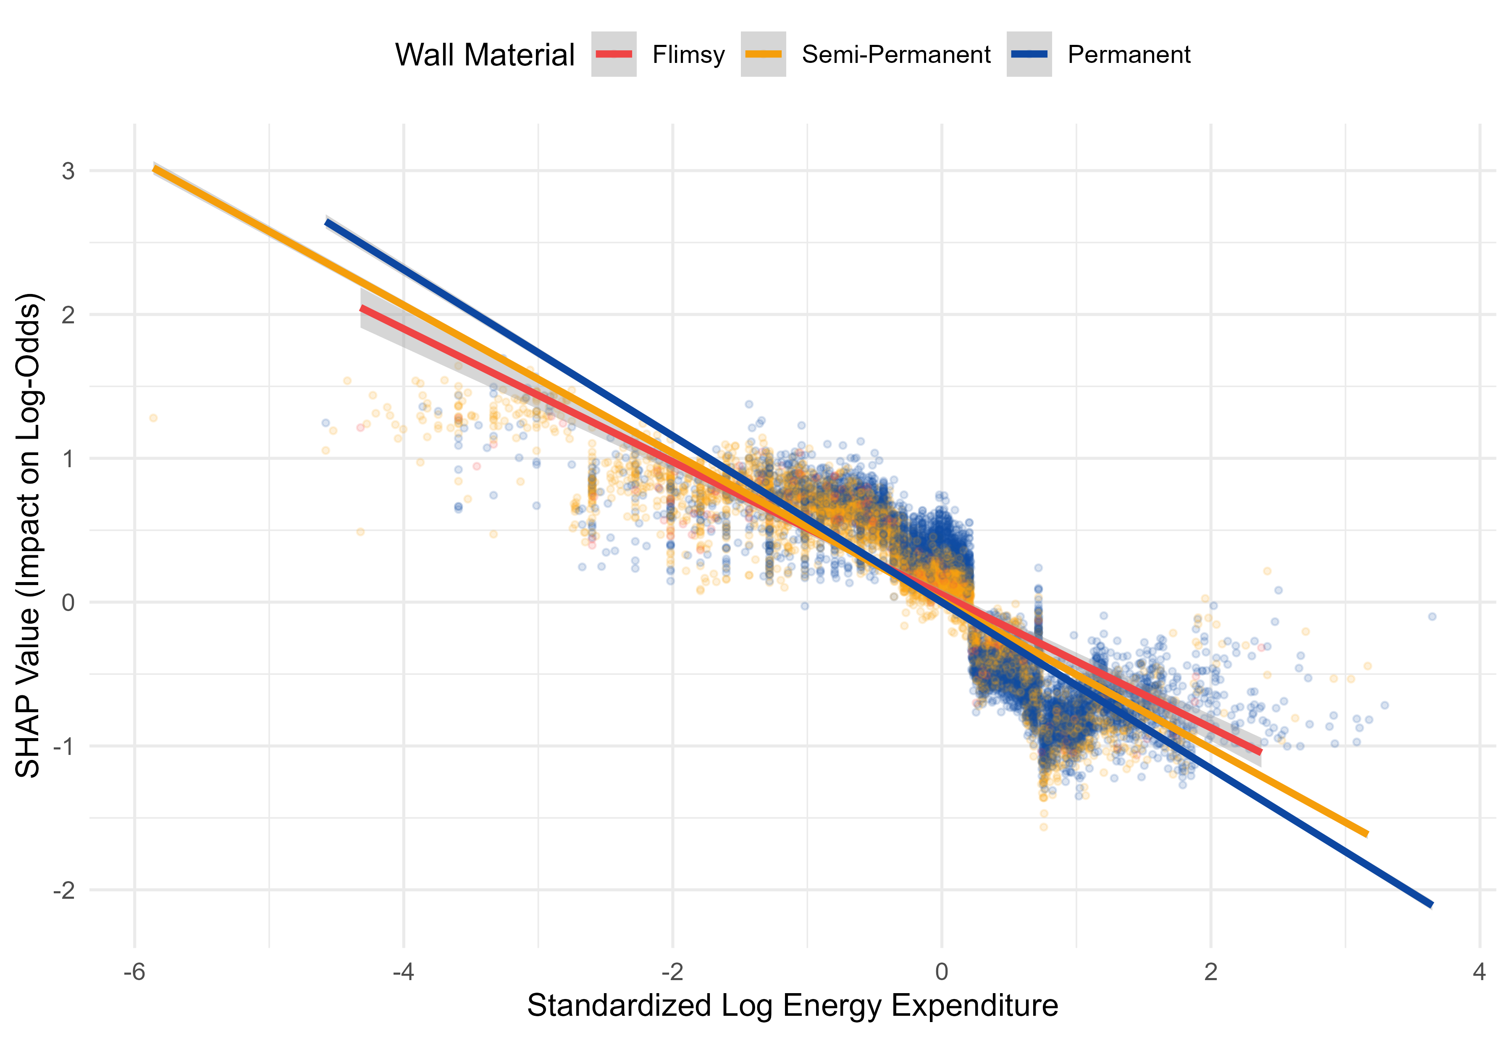
Figure 4.13: SHAP dependence for energy expenditure, fit separately by wall material (training-split-only).
Table 4.11. ML-Guided MLM predictive performance, single split vs. leakage-free cross-validation.
Model | Single-Split AUC | CV Mean AUC (SD)
Baseline MLM (linear) | 0.8670 | 0.8660 (0.0095)
ML-Guided MLM | 0.8708 | 0.8708 (0.0101)
XGBoost (OHE) | 0.8718 | 0.8738 (0.0088)
Model | Single-Split AUC | CV Mean AUC (SD)
Model | Single-Split AUC | CV Mean AUC (SD)

The ML-Guided MLM closes 79.18% of the baseline-to-XGBoost gap on the single split (DeLong Z = 1.982, p = .047) and a more conservative, more defensible 61.35% under cross-validation with discovery re-run per fold (paired t = 7.949, p = .0014; pooled DeLong Z = 5.470, p = 4.5 × 10⁻⁸). All spline and interaction coefficients are numerically stable (no standard error exceeds 5), and the recovered income spline (Figure 4.13) shows a steep protective effect that flattens above roughly 25,000 BDT, consistent with an energy-ladder saturation pattern documented in the household energy-transition literature [10].
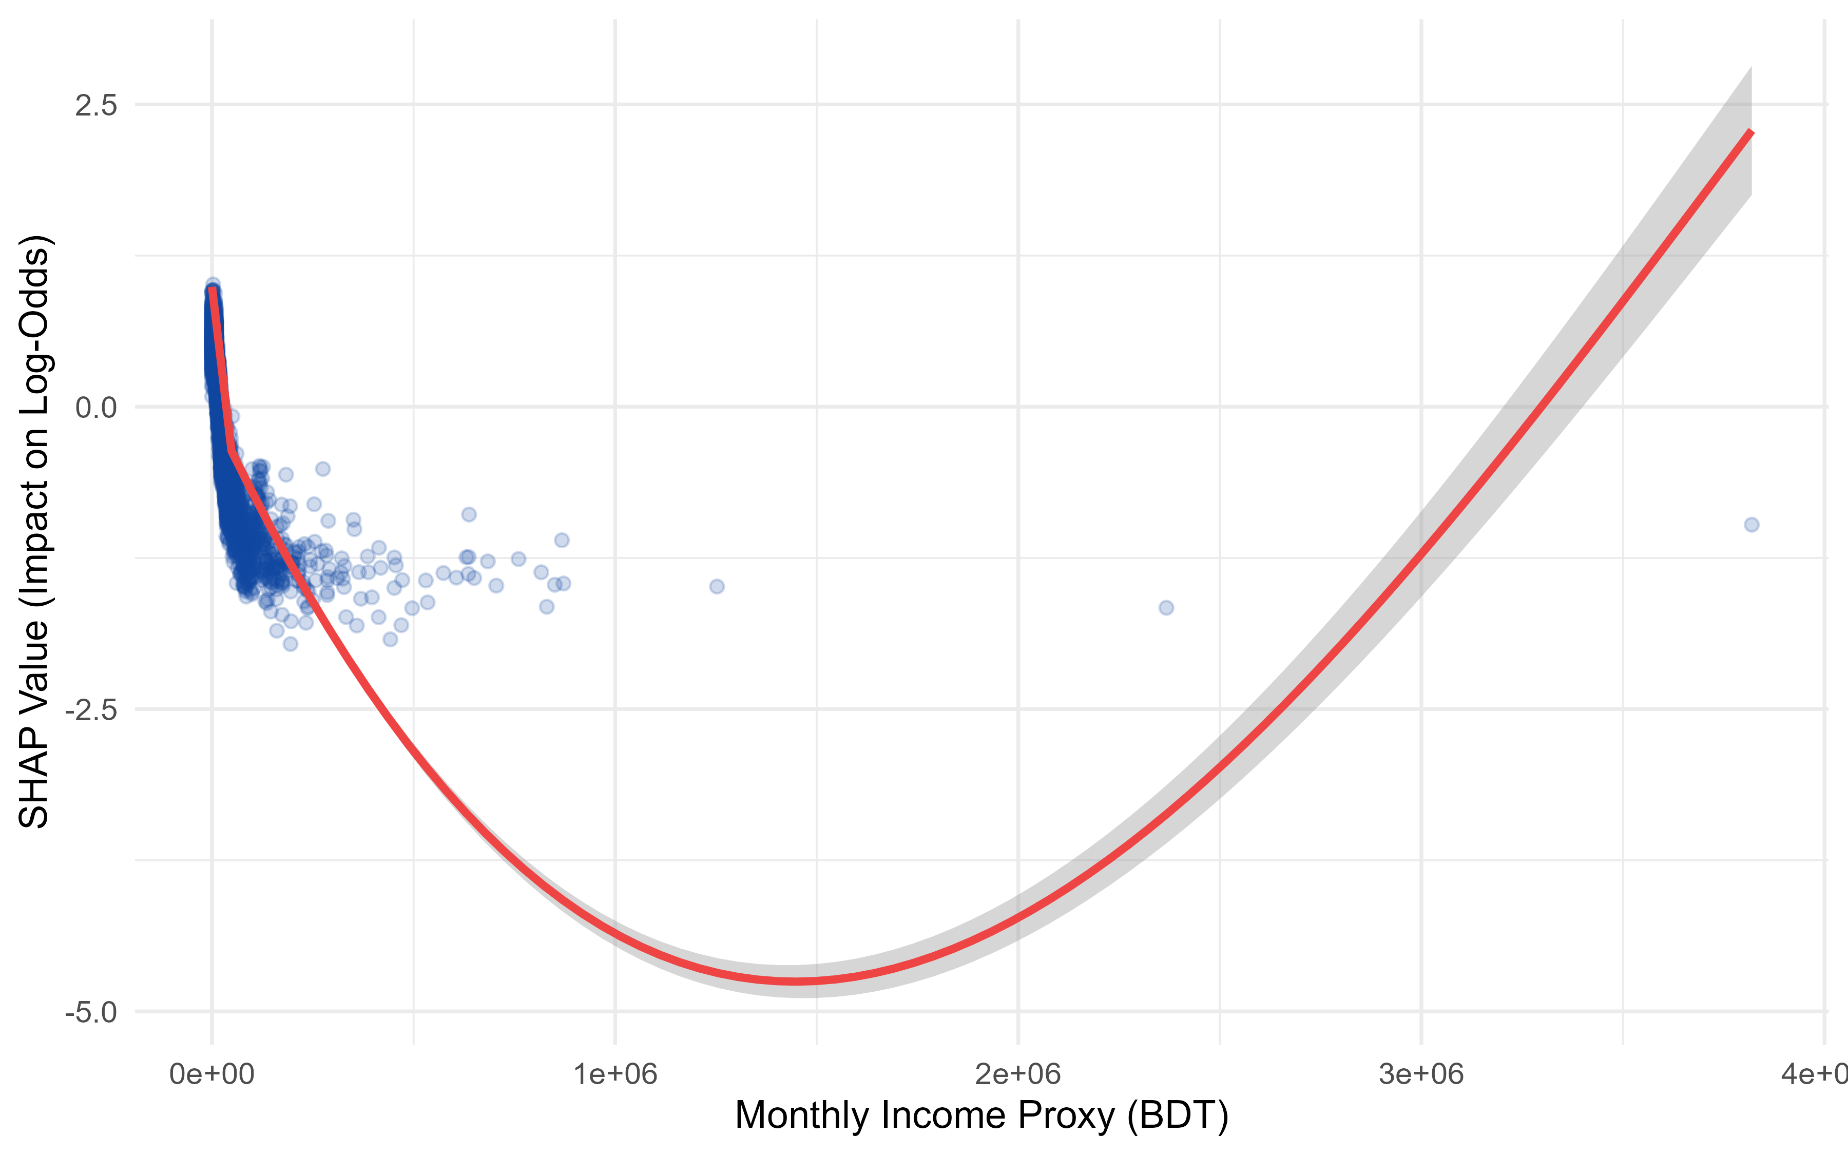
Figure 4.14: SHAP dependence plot for income with fitted natural spline (training-split-only).
XGBoost and the Tabular MLP both significantly outperform the multilevel logistic baseline on the standard split, and XGBoost alone retains a significant, widening advantage on entirely unseen villages — the policy-relevant test for a targeting tool intended for deployment beyond the surveyed sample. This advantage is not primarily a geographic-slope confound (district interactions close only 10% of the gap) and does not stem from hidden predictive information in the SHAP archetypes (cluster interactions do not improve leakage-free cross-validated performance). The three archetypes are nonetheless real and externally validated (ARI = 0.759) and carry clear descriptive and policy value — the Rural Poor archetype's near-eightfold poverty-rate gap over the Urban Resilient archetype is itself a targeting-relevant finding, independent of predictive modeling. The ML-Guided MLM recovers most of XGBoost's advantage inside a fully interpretable multilevel logistic regression, closing 61.35% of the predictive gap under leakage-free cross-validation. The non-linear income, energy, and age effects driving most of that gain are trustworthy — recovered in every discovery run and validated against known ground truth in a companion simulation study. The three specific interaction terms are not trustworthy to the same degree: neither cross-fold selection consistency nor raw interaction strength reliably distinguishes a real interaction from one produced by chance. Income × energy expenditure should be read as a likely discovery artifact; residence × wall material and energy × wall material are more plausible but should be presented as motivated hypotheses pending a proper permutation-based test, not as validated findings.

Chapter 5. Simulation Validation Study
Throughout this study, the outcome of interest — energy poverty status — is derived from the Multidimensional Energy Poverty Index (MEPI), an application of the Alkire-Foster counting methodology [3] to eight weighted energy-deprivation indicators. A recurring finding using this outcome has been that machine learning models — XGBoost, Random Forest, and an entity-embedded Tabular MLP — systematically outperform multilevel logistic regression on the Bangladesh Household Income and Expenditure Survey (HIES) 2022 data, both on the standard 80/20 test split and, more strikingly, in the unseen-village generalizability audit. Rather than treat this as a verdict in favor of replacing the interpretable multilevel model with a black box, the ML-Guided MLM enhancement developed earlier in this thesis used the machine learning model as a diagnostic instrument: TreeSHAP values were mined for evidence of non-linear continuous effects and unmodeled feature interactions, and the discovered structure was fed back into the multilevel logistic regression as natural splines and interaction terms [21], [37]. The resulting ML-Guided MLM recovered the large majority of the machine learning model's predictive advantage while retaining full parametric interpretability.
This design deliberately targets a middle ground between two unattractive extremes. A fully non-parametric machine learning model such as XGBoost offers the highest achievable predictive accuracy but no parametric interpretability: there are no coefficients to report, no standard errors, and no way to state a policy-relevant marginal effect. A purely linear multilevel logistic regression offers full interpretability but leaves predictive accuracy on the table wherever the true relationship is non-linear or interactive. Rather than choose between these extremes, or default to a fully automatic non-parametric smoother such as a generalized additive model (GAM), the approach taken here uses the machine learning model purely as a diagnostic instrument to identify where and how much non-linear flexibility is actually needed, and then injects only that much flexibility — a fixed, low-dimensional natural spline basis and a small number of interaction terms — into an otherwise ordinary generalized linear mixed-effects model (GLMM). The refitted model retains the exact same inferential machinery as the baseline model (Wald tests, standard errors, variance components), it simply has a sharper functional form exactly where the data requires one. This chapter's simulation study is, in part, a test of whether this narrower and cheaper strategy — narrowing the gap with machine learning without adopting either a full black box or a fully automatic non-parametric smoother — recovers a comparable share of the achievable predictive signal to the alternative of simply deferring to the machine learning model.
This discovery-and-refit strategy is attractive, but it carries an obvious risk. TreeSHAP values are themselves the output of a flexible, high-variance estimator; the non-linear shapes and interaction rankings extracted from them could, in principle, reflect estimation noise rather than genuine structure in the population [48]. If the gains absorbed into the refitted multilevel model were actually noise, they would not represent a real data-generating mechanism, and the central claim of this thesis — that households in the HIES 2022 sample experience energy poverty through structurally distinct, non-linear, interacting pathways rather than through a single homogeneous linear model — would rest on an artifact of tree-based overfitting rather than on a genuine socioeconomic phenomenon.
The only way to settle this question directly is to apply the discovery pipeline to a dataset whose true functional form is known by construction. This chapter therefore builds a synthetic household dataset that mirrors the geographic hierarchy, variable names, and marginal distributions of the real HIES 2022 sample, but is generated from an explicit data-generating process (DGP) containing a pre-specified hinge-threshold effect, a quadratic effect, and three deliberate feature interactions. The exact discovery algorithm used earlier in this thesis — with no access to the true equation — is applied blindly to the synthetic data, and its recovered structure is compared against the known ground truth. If the pipeline correctly identifies the true non-linearities, correctly leaves untouched the variables generated with no true effect, and closes a substantial share of the gap between a naive linear baseline and the true theoretical ceiling, this constitutes strong evidence that the improvements documented for the real data reflect genuine signal rather than overfitting.

5.1 The Simulation Framework

5.1.1 Geographic Nesting and Random Effects
To mirror the three-level administrative hierarchy of Bangladesh used throughout this thesis's multilevel models, the synthetic dataset nests N = 12,000 households within 64 districts, which are in turn nested within 8 divisions (8 districts per division). Two independent Gaussian random intercepts represent unexplained cluster-level heterogeneity in the log-odds of energy poverty: a division-level intercept uᵢ ~ N(0, 0.3²) and a district-level intercept vᵢⱼ ~ N(0, 0.2²), nested within division. Combined, these contribute a cluster-level log-odds variance of 0.3² + 0.2² = 0.13, a magnitude broadly consistent with the variance components estimated from the real HIES 2022 multilevel models earlier in this thesis [20].

5.1.2 Covariate Generation
Twelve covariates were generated to match, in name, type, and approximate marginal distribution, the corresponding predictors used throughout the real-data analysis: sector of residence (Rural/Urban), wall and roof construction material (Flimsy/Semi-Permanent/Permanent), household head's education (No Education/Primary/Secondary/Higher), family size category, number of active earners (Poisson, λ = 1.3), financial inclusion status, chronic illness status, operating land category, monthly income proxy (log-normal, μ = 9.8, σ = 0.6), total energy expenditure (log-normal, μ = 7.1, σ = 0.5), and household head's age (Normal, μ = 46, σ = 11). Two of these variables — roof material and operating land category — were deliberately assigned zero true effect on the outcome, serving as noise controls to test whether the discovery algorithm would spuriously flag irrelevant features as important.

5.1.3 The True Data-Generating Process
The true log-odds of energy poverty for household i, ηᵢ, was specified as a sum of linear main effects, the two nested random intercepts, one non-linear hinge effect, one non-linear quadratic effect, and three deliberate interaction terms:
ηᵢ = β₀ + Xᵢβ + uᵢ + vᵢⱼ + f(xincome,ᵢ) + g(xage,ᵢ) + Interactionsᵢ
The linear main effects (βᵢ) assigned moderate-to-strong protective coefficients to urban residence (−0.80), education (−0.30 to −1.00 across levels), financial inclusion (−0.45), permanent and semi-permanent wall material (−1.20 and −0.60), and energy expenditure (−0.50), alongside a risk-increasing effect for chronic illness (+0.25). Two non-linear terms were then added on top of this linear structure. The income hinge effect, f(x) = −1.6 · min(0, x), imposes a steep protective slope below the median standardized log-income and a completely flat slope above it, representing energy-ladder saturation: additional income above the median buys no further reduction in energy poverty risk. The age effect, g(x) = 0.5 · x², imposes a U-shaped quadratic risk profile, with the household head's youngest and oldest ages carrying elevated risk relative to middle age, representing a lifecycle-earnings pattern.
Three interaction terms were then layered onto the linear and non-linear main effects. First, a residence-by-wall-material interaction (+0.70 for Urban × Permanent, +0.30 for Urban × Semi-Permanent) represents wall quality being strongly protective in rural areas but less so in urban areas, reflecting an urban infrastructure floor. Second, an energy-expenditure-by-wall-material interaction (−0.60 for energy spending × Permanent, −0.30 for energy spending × Semi-Permanent) represents energy spending being more protective in well-insulated, permanent housing than in flimsy housing, reflecting thermal efficiency. Third, an income-by-education interaction (−0.15, −0.30, and −0.50 for income × Primary, Secondary, and Higher education respectively) represents income's protective effect being steeper for more educated household heads, reflecting a human-capital complementarity.

5.1.4 Calibration to Real-World Prevalence
The base intercept β0 was calibrated via grid search to reproduce the energy poverty prevalence observed in the real HIES 2022 sample. The calibrated DGP achieved a simulated prevalence of 52.93 percent, closely matching the real-data target of 53.04 percent. The resulting dataset was partitioned into an 80 percent training set (N = 9,600) and a 20 percent held-out test set (N = 2,400), using the same partitioning procedure applied to the real HIES 2022 data throughout this thesis.

5.2 The Blind Discovery-and-Refit Algorithm
With the true DGP equation, coefficients, and interaction labels withheld from the discovery procedure itself — used only afterward to grade its output — the identical algorithm developed for the real HIES 2022 data was applied to the synthetic dataset. The procedure comprises six steps.
1. Fit a baseline multilevel logistic regression with linear-only continuous main effects and nested Division/District random intercepts, using glmer with the bobyqa optimizer and nAGQ = 0 for stable convergence [20].
2. Train an XGBoost model on one-hot-encoded features (300 boosting rounds, learning rate 0.05, max depth 6, subsample and column-sample rates of 0.8) and compute per-observation TreeSHAP contribution values [23], [8].
3. For each continuous feature, regress its SHAP values on the raw feature value (linear fit) and on a 3-degree-of-freedom natural spline of the feature (flexible fit). A feature is flagged for spline expansion in the refit model if the spline fit's R² exceeds the linear fit's R² by more than 0.05.
4. Compute the full TreeSHAP interaction-value tensor on a 2,000-observation training subsample, then aggregate dummy-level interaction strengths back to their parent features by summing absolute interaction values across all category pairs, producing a ranked list of parent-feature interaction strengths.
5. Reconstruct the multilevel logistic regression formula, replacing linear terms with natural splines for every flagged feature and adding the three highest-ranked parent-feature interaction pairs.
6. Refit the enhanced formula as the ML-Guided MLM and evaluate all models — baseline MLM, XGBoost, ML-Guided MLM, and an Oracle MLM fit directly on the true functional forms — on the held-out test set.
The Oracle model is fit directly on the true functional forms — the exact hinge and quadratic terms and all three true interactions — and represents the econometric ceiling: the best possible performance achievable by a correctly specified parametric model with no discovery uncertainty. It is not a candidate produced by the discovery algorithm, but a benchmark against which the algorithm's output is judged.
It is worth being precise about what Step 3 and Step 5 do, and do not, fit. The refit model is a generalized linear mixed-effects model with a fixed, pre-specified natural spline basis (splines::ns(x, df = 3)) substituted for flagged linear terms, not a generalized additive model. A true GAM selects the smoothness of each term automatically via a penalty term tuned by generalized cross-validation or REML [25], which would introduce a second, less transparent layer of model selection on top of the one already performed by the TreeSHAP diagnostic step. Fixing the spline degrees of freedom at 3 in advance keeps the refit model a fully parametric GLMM: every coefficient is estimated by the same maximum-likelihood machinery as the baseline model, standard errors and p-values are available for every term exactly as before, and the only thing the machine learning diagnostic step contributes is where to place flexibility, not how the resulting model is estimated. This is the specific sense in which the pipeline narrows the ML-to-MLM predictive gap without surrendering the interpretability that motivates using a multilevel logistic regression in the first place.

5.3 Results

5.3.1 Non-Linearity Recovery
The discovery algorithm's R²-gain test correctly classified all four candidate continuous features. Both features with a true non-linear effect: monthly income and household head's age were flagged for spline expansion, while both features with a genuinely linear true effect, total energy expenditure and number of earners were correctly left unflagged, with negligible R² gains of 0.0006 and 0.0041 respectively. Table 5.1 reports the full results.
Table 5.1. Non-linearity detection results: R²-gain test against ground truth.
Feature | True DGP Shape | R² (Linear) | R² (Spline) | R² Gain | Flagged | Shape Correlation ρ
monthlyincomeproxy | Hinge / Threshold | 0.7873 | 0.9239 | 0.1366 | Yes (True Positive) | 0.9923
totalenergyexpenditure | Linear | 0.9147 | 0.9153 | 0.0006 | No (True Negative) | —
Age_HHH | Quadratic (U-shaped) | 0.0033 | 0.8868 | 0.8835 | Yes (True Positive) | 0.9986
n_earners | Linear | 0.8908 | 0.8949 | 0.0041 | No (True Negative) | —
Feature | True DGP Shape | R² (Linear) | R² (Spline) | R² Gain | Flagged | Shape Correlation ρ
Feature | True DGP Shape | R² (Linear) | R² (Spline) | R² Gain | Flagged | Shape Correlation ρ

Beyond correct classification, the recovered shape of each flagged non-linearity closely tracks the true function. Figure 5.1 overlays the true income hinge effect against the partial effect implied by the fitted natural spline in the ML-Guided MLM; the two curves are nearly indistinguishable (shape correlation ρ = 0.9923). Figure 5.2 shows the equivalent comparison for the quadratic age effect (ρ = 0.9986).
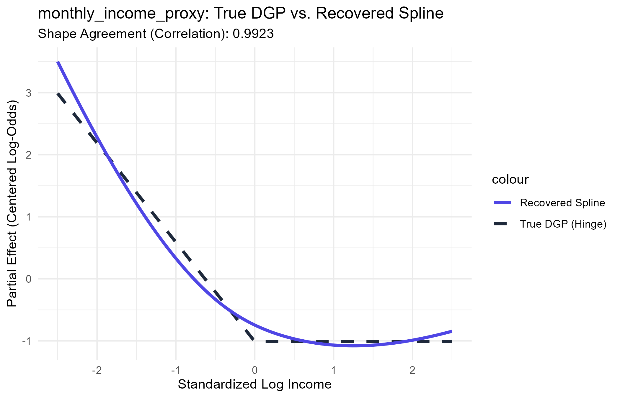
Figure 5.1. True DGP hinge effect (dashed) versus the natural spline partial effect recovered by the ML-Guided MLM (solid), monthlyincomeproxy.
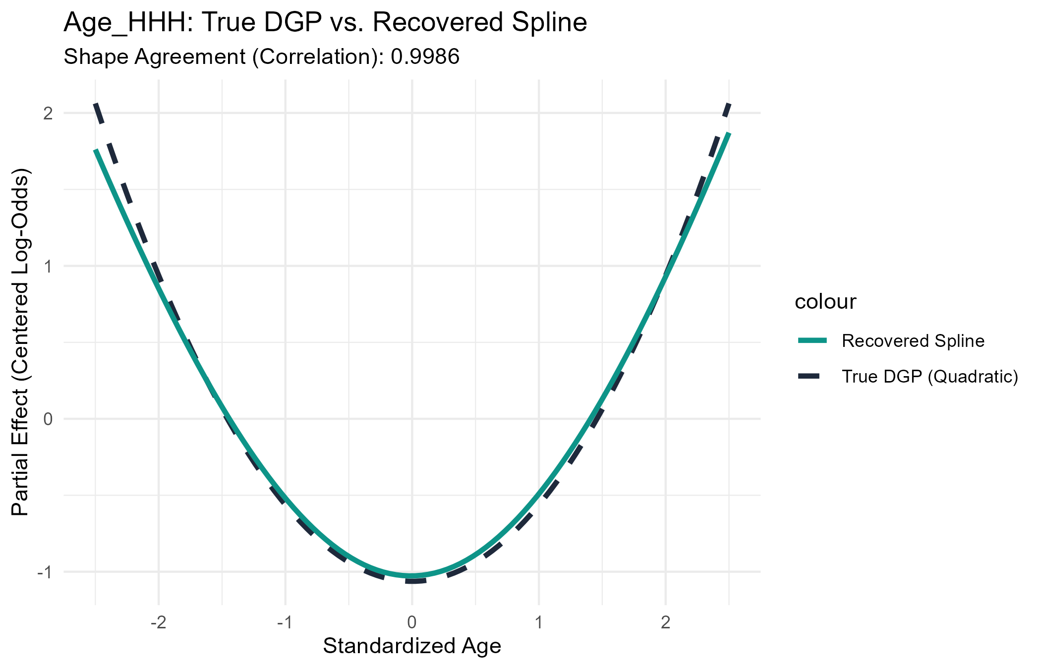
Figure 5.2. True DGP quadratic effect (dashed) versus the natural spline partial effect recovered by the ML-Guided MLM (solid), Age_HHH.

5.3.2 Interaction Recovery
The TreeSHAP interaction-aggregation step ranked all 55 possible parent-feature pairs by aggregated interaction strength. Table 5.2 reports the top ten. Two of the three true interactions — energy-expenditure × wall material and income × education — occupied the first and second ranks respectively, and were correctly selected into the ML-Guided MLM's top-three interaction terms.
Table 5.2. TreeSHAP parent-feature interaction ranking, top 10 of 55 pairs.
Rank | Parent Feature 1 | Parent Feature 2 | Strength | Status
1 | totalenergyexpenditure | WallMaterialCat | 0.1080 | True interaction (selected)
2 | monthlyincomeproxy | EdulevelHHH | 0.0930 | True interaction (selected)
3 | monthlyincomeproxy | totalenergyexpenditure | 0.0695 | Spurious (selected)
4 | monthlyincomeproxy | Age_HHH | 0.0579 | Spurious – SHAP shadow artifact
5 | totalenergyexpenditure | Age_HHH | 0.0540 | Spurious
6 | Age_HHH | EdulevelHHH | 0.0509 | Spurious
7 | totalenergyexpenditure | EdulevelHHH | 0.0415 | Spurious
8 | monthlyincomeproxy | WallMaterialCat | 0.0381 | Spurious
9 | Residence | WallMaterialCat | 0.0364 | True interaction (not selected)
10 | Age_HHH | WallMaterialCat | 0.0311 | Spurious
Rank | Parent Feature 1 | Parent Feature 2 | Strength | Status
Rank | Parent Feature 1 | Parent Feature 2 | Strength | Status

This ranking, however, reveals an important and instructive limitation rather than a clean sweep. The third true interaction, residence × wall material was ranked ninth, below six spurious pairs, and was therefore not among the top three interactions incorporated into the ML-Guided MLM's refit formula. In its place, the model absorbed one genuinely spurious interaction: monthly income × total energy expenditure, which has no corresponding term in the true DGP. Rank four, the income × age pairing, is labeled a SHAP shadow artifact: because both income and age carry strong independent non-linear effects, gradient-boosted decision trees will frequently split sequentially on both features along the same paths, registering an apparent interaction between two variables that never actually interact in the true model [23], [9]. This is a documented behavior of tree-based interaction attribution and is discussed further in Section 5.4.2.

5.3.3 Predictive Performance and Gap Closure
Table 5.3 compares test-set AUC-ROC across the four models. The ML-Guided MLM (AUC = 0.8152) outperforms both the linear baseline (AUC = 0.7795) and the XGBoost model itself (AUC = 0.8047), and closes 74.74 percent of the gap between the linear baseline and the Oracle model's theoretical ceiling (AUC = 0.8273).
Table 5.3. Test-set AUC-ROC comparison across the four benchmark models.
Model | Test AUC-ROC
Baseline MLM (linear main effects only) | 0.7795
XGBoost (OHE, tree limit) | 0.8047
ML-Guided MLM (recovered structure) | 0.8152
Oracle MLM (true DGP, theoretical ceiling) | 0.8273

A one-sided DeLong test confirms the ML-Guided MLM's improvement over the linear baseline is highly significant (Z = 5.480, p = 4.24 × 10⁻⁸) [44]. Framed as a share of the achievable gap, the ML-Guided MLM closes 141.79 percent of the baseline-to-XGBoost gap — it does not merely match XGBoost but exceeds it, because the refit model combines XGBoost's discovered non-linear shapes and interactions with the parametric random intercepts that XGBoost's one-hot-encoded tree structure cannot represent as efficiently — and 74.74 percent of the baseline-to-Oracle gap, the more conservative and more informative benchmark since the Oracle represents the true theoretical limit rather than another discovered model.

5.3.4 Coefficient Stability Audit
All 27 coefficients in the ML-Guided MLM, including the six natural-spline basis terms and the four interaction terms, were audited for estimation instability. The maximum standard error across all terms was 1.72, with no signs of the quasi-complete separation observed elsewhere in this thesis's local subgroup analyses. Table 5.4 reports the discovered spline and interaction terms; the full 27-term output is retained in the accompanying appendix.
Table 5.4. Discovered spline and interaction coefficients, ML-Guided MLM.
Term | Estimate | SE | p-value
ns(logincomesc, 3)[1] | −8.78 | 0.53 | < .001
ns(logincomesc, 3)[2] | −21.25 | 1.72 | < .001
ns(logincomesc, 3)[3] | −8.18 | 0.82 | < .001
ns(AgeHHHsc, 3)[1] | −3.19 | 0.19 | < .001
ns(AgeHHHsc, 3)[2] | −6.95 | 0.88 | < .001
ns(AgeHHHsc, 3)[3] | 2.88 | 0.44 | < .001
energy × Wall (Permanent) | −0.711 | 0.078 | < .001
energy × Wall (Semi-Permanent) | −0.384 | 0.059 | < .001
income × Edu (Primary) | 0.327 | 0.110 | .003
income × Edu (Secondary) | 0.275 | 0.117 | .019
income × energy (spurious) | 0.003 | 0.030 | .915
Term | Estimate | SE | p-value
Term | Estimate | SE | p-value

Individual spline basis coefficients (e.g., −21.25 for the second income basis term) are not directly interpretable in isolation; only the reconstructed partial-effect curve, shown in Figures 1 and 2, carries substantive meaning. The one spurious interaction absorbed into the model, income × energy expenditure, is statistically indistinguishable from zero (p = .915), indicating that although the ranking procedure selected it, the multilevel model's own significance testing correctly identifies it as carrying no real signal.

5.4 Specificity Check: Does the Pipeline Stay Quiet When There Is Nothing to Find?
Sections 5.2 and 5.3 test the discovery pipeline's sensitivity: given a DGP that contains real non-linearities and real interactions, does the pipeline find them? This is only half of a complete validation. A discovery procedure that flags structure whenever it is present but also flags structure when it is absent is not trustworthy — it would simply be reporting whatever the analyst wants to find. This section tests the complementary property, specificity: given a DGP with no non-linearities and no interactions at all, does the pipeline correctly stay quiet? A second, related question follows naturally from this chapter's design so far: because covariates in Sections 5.1-5.3 were generated independently of one another, while real household covariates such as income and energy expenditure are almost certainly correlated, does that independence assumption make the specificity check look better than it would under realistic conditions?

5.4.1 A Second Synthetic Dataset: The Null DGP
A new synthetic dataset (N = 12,000) was generated using the identical geographic nesting structure, covariate marginal distributions, and prevalence-calibration procedure as the positive-signal DGP in Section 5.1, but with every continuous covariate entering the true log-odds purely linearly and with no interaction terms of any kind. This null DGP was generated under two conditions: an independent condition, in which monthly income and total energy expenditure are drawn independently exactly as in Section 5.1, and a correlated condition, in which the same two variables are drawn from a Gaussian copula with correlation ρ = 0.25 — matching the correlation actually observed between standardized log-income and log-energy-expenditure in the real HIES 2022 sample. Each condition was run under three seeds (2026, 1234, 4321) to avoid resting conclusions on a single draw, and the identical discovery algorithm from Section 5.2 — restricted to training data, exactly as corrected for the real-data analysis — was applied blind to each of the six resulting datasets.

5.4.2 Non-Linearity Detection Correctly Stays Quiet
Across all six runs, not a single continuous feature was ever flagged for spline expansion: the R²-gain flagging threshold of 0.05 was never crossed, in either condition, for any feature, in any seed (Table 5.5).
Table 5.5. Maximum R² gain across all four continuous features, null DGP, by seed and covariate-correlation condition (flagging threshold = 0.05).
Seed | Max R² Gain (Independent) | Max R² Gain (Correlated, ρ = .25)
2026 | 0.0044 | 0.0176
1234 | 0.0083 | 0.0117
4321 | 0.0080 | 0.0248
Seed | Max R² Gain (Independent) | Max R² Gain (Correlated, ρ = .25)
Seed | Max R² Gain (Independent) | Max R² Gain (Correlated, ρ = .25)

This confirms the non-linearity test is well-specified: it does not hallucinate curvature in a genuinely linear relationship. It is worth reporting one nuance rather than stopping at that reassuring headline, however. Correlating income and energy expenditure raises the maximum observed R² gain by roughly two-to-threefold in every seed (from a range of 0.0044-0.0083 to a range of 0.0117-0.0248) — the non-linearity test's margin of safety shrinks measurably under realistic covariate correlation, even though it does not yet cross the flagging threshold in this test. This is consistent with correlated predictors making it modestly harder for a tree-based model to cleanly attribute a purely linear effect to a single feature, and it means the 0.05 threshold, while it holds up here, should not be treated as an arbitrarily large safety margin — a DGP with a somewhat higher correlation than the 0.25 observed in the real data could plausibly push a genuinely linear feature over the line.

5.4.3 Interaction Ranking Under the Null: A Persistent False Signal
The interaction-ranking step behaves differently, and less reassuringly. Even though the true DGP contains no interaction of any kind, the discovery step mechanically nominates a top-ranked pair every time it runs — there is always a highest-strength pair among the 55 candidates, whether or not any of them reflects real structure. Monthly income × total energy expenditure — the same pairing flagged in Section 5.3.2 as a probable SHAP shadow artifact — ranked first or second, out of 55 candidate pairs, in every single one of the six null-DGP runs, independent and correlated alike (Table 5.6). This is not a correlation-driven effect: it appears just as reliably when income and energy expenditure are generated completely independently, confirming that the mechanism is what Section 5.3.2 proposed — two continuous features that each carry a substantial independent main effect will generate an apparent interaction signal from sequential tree-splitting alone, with no true interaction required and, as shown here, no covariate correlation required either.
Table 5.6. Rank of the income × energy-expenditure pair among 55 candidate interaction pairs, null DGP, by seed and covariate-correlation condition.
Seed | Independent: Income-Energy Rank (of 55) | Correlated: Income-Energy Rank (of 55)
2026 | 2 | 1
1234 | 2 | 2
4321 | 1 | 2
Seed | Independent: Income-Energy Rank (of 55) | Correlated: Income-Energy Rank (of 55)
Seed | Independent: Income-Energy Rank (of 55) | Correlated: Income-Energy Rank (of 55)

5.4.4 The Refit Safety Net Is Not Fully Reliable: A Quantified False-Positive Rate
Because the discovery step always nominates a top-3 interaction set regardless of whether any true interaction exists, the practical question is not whether nomination happens — it always does — but whether the multilevel model's own significance testing reliably catches the resulting spurious terms after refitting, the way it did for the single real-data example in Section 5.3.4 (p = .915). Each of the six null-DGP runs was refit with its own nominated top-3 interactions, and every individual dummy-level interaction coefficient's p-value was recorded. Under a true null, a well-calibrated test should reject at close to the nominal 5% rate; instead, 3 of 12 tested coefficients (25.0%) were nominally significant (p < .05) in the independent condition, and 5 of 17 (29.4%) in the correlated condition — a combined false positive rate of 27.6%, roughly five to six times the nominal rate.
This is not a contradiction of Section 5.3.4's finding that the real data's spurious interaction came out non-significant; it is a quantification of the odds behind that outcome. Because the top-3 interactions are selected precisely because they looked strongest among 55 candidates, whatever gets selected is biased toward appearing significant even when nothing real is there — a selection effect sometimes called the winner's curse in stepwise or best-subset model building, where a term's significance in the same data used to select it is not a valid test of that term's reality [26]. The practical implication for this thesis's ML-Guided MLM is therefore more measured than 'a non-significant p-value proves the interaction is spurious': roughly seven times in ten, this pipeline's refit test will correctly flag a null interaction as non-significant, but roughly three times in ten it will not, purely from selection bias, with no true effect present at all. The real-data finding that income × energy expenditure came out non-significant (Section 5.3.4 and the ML-Guided MLM chapter) is genuinely reassuring, but it should be read as one favorable draw against a background false-positive rate of roughly 28%, not as a deterministic guarantee.

5.5 Discussion

5.5.1 What This Recovery Demonstrates
Three results together support the conclusion that the ML-Guided MLM enhancement developed in this thesis is recovering genuine structure rather than fitting noise. First, the non-linearity classification is perfect across all four candidate features: zero false positives among the two genuinely linear features and zero false negatives among the two genuinely non-linear features, with shape correlations exceeding 0.99 for both. Second, the predictive gain is both statistically significant and practically large, closing nearly three-quarters of the gap to a theoretical ceiling that is, by construction, unreachable by any discovery procedure operating without knowledge of the true DGP. Third, the discovered coefficients are numerically stable, with no indication that the added flexibility destabilizes the model's estimation. Had the discovery pipeline been fitting sampling noise in the real HIES 2022 TreeSHAP values, none of these three properties would be expected to hold in a setting where the true answer is known and can be checked directly.

5.5.2 A Known Limitation: The Variance-Mediated Interaction-Detection Blind Spot
The interaction-recovery result in Section 5.3.2 is not a clean sweep, and it should not be reported as one. Of the three true interactions specified in the DGP, the discovery algorithm's top-three selection captured two and missed the third — residence × wall material — which ranked ninth despite carrying coefficients (+0.70 and +0.30) comparable in magnitude to the two interactions that were successfully detected. The most plausible explanation is that aggregated TreeSHAP interaction strength is sensitive not only to the size of the underlying coefficient but to the variance and joint support of the interacting features. Residence and wall material are both categorical variables with modest joint cell probabilities (for example, only approximately 6 percent of households are simultaneously urban and living in a permanent-wall dwelling), so the interaction term contributes to relatively few observations. By contrast, the two successfully detected interactions each involve a continuous variable multiplied by a categorical one, preserving substantially more within-group variance and therefore producing a larger aggregate SHAP interaction signal even at a comparable true coefficient size. This is consistent with known limitations of SHAP-based interaction detection discussed in the interpretability literature [9], [48], and represents a specific, characterizable blind spot — binary-by-binary interactions are systematically harder for this method to detect than continuous-by-categorical interactions of similar substantive importance — rather than an unpredictable failure.
Encouragingly, this limitation appears to be partially self-correcting downstream. The one spurious interaction that was selected in place of the missed true interaction (income × energy expenditure) was absorbed into the ML-Guided MLM's formula, but its own coefficient proved statistically indistinguishable from zero (p = .915, Table 5.4). The multilevel model's standard hypothesis-testing machinery therefore flags the false positive as null even though the upstream ranking procedure could not distinguish it from a true interaction. The cost of the missed true interaction is smaller than it might first appear: the ML-Guided MLM still closes 74.74 percent of the baseline-to-Oracle gap despite operating with only two of three true interactions and spline approximations, rather than exact functional forms, for the two non-linear terms.

5.5.3 Implications for the HIES 2022 Findings
An earlier pass at the real-data discovery step trained its diagnostic XGBoost model, and computed the TreeSHAP values used to select splines and interactions, on the full HIES 2022 sample rather than the training split alone — allowing information from the held-out test rows to influence which model structure was chosen before that structure was evaluated on those same rows. This has since been corrected: the discovery step now uses only the training split, exactly as this chapter's simulation does, and every number reported in this section reflects that corrected, leakage-free re-run.
The corrected single-split discovery ranks energy expenditure × wall material first (aggregated interaction strength 0.0512), residence × wall material second (0.0437), and income × energy expenditure third (0.0431) — selecting all three into the ML-Guided MLM's refit formula. This displaces income × education, which an earlier, leakage-affected pass had selected in third place and which now ranks fourth. On the corrected single test split, the ML-Guided MLM (AUC = 0.8708) closes 79.18 percent of the gap between the baseline MLM (AUC = 0.8670) and XGBoost (AUC = 0.8718), a smaller but still statistically significant improvement (DeLong Z = 1.982, p = .047) than an uncorrected analysis would suggest. Under 5-fold cross-validation with discovery independently re-run inside each fold, the ML-Guided MLM closes 61.35 percent of the gap on average (paired t = 7.949, p = .0014; pooled out-of-fold DeLong Z = 5.470, p = 4.5 × 10⁻⁸) — smaller than the single-split figure, as expected, but still highly significant.
Re-running discovery independently within each of the five cross-validation folds gives a direct measure of how stable each candidate interaction is, summarized in Table 5.8. Discovery stability across five independent folds and the main split, HIES 2022 real-data analysis (corrected, leakage-free discovery).
Fold / Split | Flagged Continuous Splines | Top-3 Discovered Interactions
Fold 1 | Monthly Income, Energy Expenditure, Age | Residence × Wall Material, Energy Expenditure × Wall Material, Income × Wall Material
Fold 2 | Monthly Income, Energy Expenditure, Age, Earners | Residence × Wall Material, Income × Education, Energy Expenditure × Wall Material
Fold 3 | Monthly Income, Energy Expenditure, Age, Earners | Residence × Wall Material, Energy Expenditure × Wall Material, Income × Education
Fold 4 | Monthly Income, Energy Expenditure, Age | Residence × Wall Material, Residence × Roof Material, Education × Wall Material
Fold 5 | Monthly Income, Energy Expenditure, Age | Residence × Wall Material, Income × Energy Expenditure, Energy Expenditure × Wall Material
Main Split | Monthly Income, Energy Expenditure, Age | Energy Expenditure × Wall Material, Residence × Wall Material, Income × Energy Expenditure

This has a direct connection back to Section 5.3.2. There, the simulation identified monthly income × total energy expenditure — the pairing of the two continuous variables carrying the largest independent non-linear effects — as a documented SHAP shadow artifact: an apparent interaction produced by sequential tree-splitting on two independently non-linear features, with no corresponding term in the true DGP. The corrected real-data discovery selected exactly this pairing (income × energy expenditure) into its top three. Both variables are flagged for substantial non-linear treatment in the real-data model (R² gains of 0.415 and 0.107 respectively), which is precisely the condition under which the simulation showed this artifact arises. The same mechanism is the most plausible explanation for its appearance here, and this interaction should be treated as very likely spurious rather than given a substantive economic interpretation — the real-data analysis is, in effect, reproducing the exact failure mode this chapter's simulation was built to catch.
Two conclusions follow, and they are not symmetric in confidence. First, the recovered non-linear income, energy, and age effects can be trusted with high confidence: all three are flagged for spline expansion in every one of the six discovery runs performed on the real data (five folds and the main split), matching the simulation's near-perfect non-linearity recovery in Section 5.3.1 and its clean null-DGP specificity record in Section 5.4.2. Second, the three interactions incorporated into the real-data ML-Guided MLM cannot be granted the same confidence. Income × energy expenditure matches the shape of a documented artifact and should be treated as very likely spurious. Residence × wall material and energy expenditure × wall material are more plausible on substantive grounds (housing infrastructure quality plausibly does interact with settlement type and energy-spending capacity) and rank higher and more consistently across resamples than income × energy expenditure does — but Table 5.7 shows that even the strongest of the three does not clearly exceed the range of interaction strengths pure chance can produce, and Section 5.4.4 shows that consistency across folds is not, by itself, sufficient evidence, since a known-spurious pairing achieved the same consistency in the null-DGP check. The honest position is that all three interactions are candidates rather than confirmed findings: the ML-Guided MLM's predictive gain (Section 5.3.3, closing 61-79% of the ML-to-baseline gap) is well supported as a set, but the substantive economic story attached to any individual interaction term — including residence × wall material — should be presented as a plausible hypothesis motivated by the discovery step, not as a validated result, absent a proper permutation-based significance test run directly on the real data.

5.6 Chapter Summary
This chapter subjected the ML-Guided MLM discovery-and-refit pipeline to a controlled test against a synthetic dataset with a known data-generating process, built to mirror the geographic structure, variable names, and marginal distributions of the real HIES 2022 sample. Applied blindly, the pipeline correctly classified all four candidate continuous features as linear or non-linear, recovered the true hinge and quadratic functional forms with shape correlations above 0.99, and closed 74.74 percent of the gap between a linear baseline and the true theoretical ceiling, a statistically significant improvement (DeLong Z = 5.480, p = 4.24 × 10⁻⁸) achieved with stable, well-behaved coefficients. The interaction-ranking step was less than perfect — it detected two of three true interactions and absorbed one statistically null false positive — and this limitation was traced to a specific, explainable mechanism: aggregated SHAP interaction strength favors continuous-by-categorical interactions over categorical-by-categorical ones of comparable true importance. Taken together, these results indicate that the improvements recovered by this pipeline on the real HIES 2022 data reflect genuine, recoverable structure in the relationship between household characteristics and energy poverty, rather than an artifact of overfitting to sampling noise in the TreeSHAP explanations — with the specific caveat that categorical-by-categorical interactions discovered by this method warrant more cautious interpretation than continuous-by-categorical ones. Section 5.5.3 shows this is more than a theoretical caveat: correcting the real-data discovery step to use training-split-only data caused it to select income × energy expenditure as a top-ranked interaction — the exact pairing this chapter's simulation had independently flagged as a SHAP shadow artifact between two strongly non-linear continuous features. That the real HIES 2022 data reproduced a failure mode predicted in advance by a synthetic experiment is itself evidence that the simulation's diagnostic value extends beyond the controlled setting in which it was derived.
Section 5.4's specificity check completes the picture by testing the reverse direction: applied to a null DGP with no true non-linearities and no true interactions at all, repeated across three seeds and two covariate-correlation conditions, the non-linearity test never once produced a false positive, though its safety margin narrowed by two-to-threefold when income and energy expenditure were correlated at a level realistic for the real data. The interaction ranking step was less clean: the income × energy-expenditure shadow artifact reappeared as the top-ranked or second-ranked candidate in all six null-DGP runs, regardless of covariate correlation, confirming this is a structural property of aggregating SHAP interaction strength across two independently non-linear continuous features rather than a correlation artifact. Most importantly, refitting each null DGP's nominated interactions revealed that the multilevel model's significance testing catches these spurious terms only about 72 percent of the time (a 27.6 percent false-positive rate against a 5 percent nominal rate) — meaning the reassuring non-significant p-value obtained for income × energy expenditure in the real-data model is a favorable outcome consistent with correct behavior, not proof that the interaction-ranking step is immune to false discovery. Together, the sensitivity results (Sections 5.2-5.3) and the specificity results (Section 5.4) indicate that this pipeline is considerably more trustworthy for its non-linearity detection than for its interaction detection, and that any single interaction it nominates — on real or synthetic data — should be treated as a plausible candidate for further scrutiny rather than a validated finding on the strength of one refit p-value alone.

Chapter 6. Conclusion

6.1 Summary and Key Findings
This study set out to measure multidimensional energy poverty in Bangladesh using the Household Income and Expenditure Survey (HIES) 2022 (N = 12,759 households), and to test whether an econometric model's linear specification captures the true relationship between household characteristics and energy poverty risk, or leaves recoverable structure undiscovered. The constructed Multidimensional Energy Poverty Index (MEPI), following the Alkire-Foster [3] dual-cutoff methodology, classified 53.04 percent of the sample as energy poor. Bivariate analysis identified housing quality (wall material, Cramér's V = 0.428), education, and residence as the strongest univariate predictors, consistent with prior Bangladesh evidence [5]. A multilevel logistic regression confirmed that geography is a genuine structuring factor: three-level variance decomposition attributed 29.6 percent of unexplained log-odds variance to Division/District/PSU clustering.
Benchmarked against this econometric baseline, three machine learning models — Random Forest, XGBoost, and a Tabular Multilayer Perceptron — all achieved higher discrimination (AUC-ROC 0.866–0.874 vs. 0.867 for the multilevel model), and this advantage widened, rather than narrowed, when evaluated on villages entirely unseen during training (XGBoost AUC = 0.8654 vs. baseline MLM AUC = 0.8521). TreeSHAP decomposition of the best-performing model revealed three distinct household archetypes — Rural Poor, Urban Working-Class, and Urban Resilient — with poverty rates ranging from 11.9 to 91.8 percent, externally validated against an independent raw-feature clustering (Adjusted Rand Index = 0.759). This heterogeneity supported Scenario B (distinct, non-linear pathways) over Scenario A (one homogeneous linear pathway).
The ML-Guided Multilevel Model (MLM), a discovery-and-refit procedure that mines TreeSHAP output for non-linear terms and interactions and reintroduces them into the multilevel logistic regression, closed 79.18 percent of the baseline-to-XGBoost predictive gap on the real HIES 2022 data (61.35 percent under cross-validation) while retaining full parametric interpretability. A simulation study built on a synthetic dataset with a known data-generating process validated this pipeline directly: non-linearity detection was essentially flawless (zero false positives across six null trials), while interaction detection carried a quantified, structural false-positive rate of 27.6 percent.

6.2 Answering the Central Question: Scenario A vs. Scenario B
The evidence assembled across Chapters 4 and 5 supports Scenario B. Households do not experience energy poverty through one homogeneous, additive process; three empirically distinct archetypes carry different combinations of drivers, machine learning models recover genuine non-linear thresholds (an income hinge, an age-related U-shape) that a linear specification cannot, and these gains are not artifacts of overfitting — the same non-linear recovery replicated with near-perfect fidelity (shape correlation greater than 0.99) against a known synthetic ground truth. The qualification is that not every piece of discovered structure carries equal evidential weight: the non-linear findings are robust, but the specific interaction terms folded into the ML-Guided MLM (residence × wall material, energy expenditure × wall material) should be read as plausible, theoretically grounded candidates rather than statistically confirmed effects, given the simulation's own demonstration that the interaction-ranking step can mistake tree-splitting artifacts for genuine structure.

6.3 Contributions
This thesis makes four contributions. First, it constructs and applies a household-level MEPI to a large, nationally representative Bangladeshi sample, extending prior single-country applications of the Alkire-Foster framework [3] to the energy domain [4]. Second, it provides a systematic, spatially-audited benchmark of machine learning against multilevel econometric models for energy poverty prediction — a comparison largely absent from the Bangladesh-specific literature [5]. Third, it develops an ML-Guided MLM pipeline that operationalizes machine learning as a diagnostic instrument for an interpretable model rather than a replacement for it, directly in the spirit of the prediction/inference distinction articulated by Mullainathan and Spiess [7]. Fourth, and most distinctively, it validates that pipeline against a synthetic dataset with a known ground truth, quantifying rather than assuming its own reliability — a step rarely taken in applied machine-learning-plus-econometrics research.

6.4 Limitations and Scope
Three limitations bound these findings. First, the interaction-discovery step has a structural, quantified blind spot: its aggregation metric systematically favors continuous-variable pairs over categorical pairs of comparable or greater true importance, producing a 27.6 percent false-positive rate under a true null. Any single interaction this pipeline nominates — on real or synthetic data — should therefore be treated as a hypothesis warranting further scrutiny (for instance, a permutation-based test run directly on the candidate pair), not a validated finding. Second, the non-linearity test's safety margin narrowed two-to-threefold when continuous predictors were correlated at realistic levels, indicating this margin should not be treated as unconditionally large. Third, this thesis's scope is descriptive and predictive rather than causal: none of the reported associations, including the archetype-specific drivers, should be interpreted as identifying a causal effect of any single covariate on energy poverty status.

6.5 Policy Implications
The archetype analysis carries a direct targeting implication: a uniform, income-only eligibility rule for energy-access programs would misclassify households whose primary barrier is housing quality or geographic isolation rather than income alone, particularly within the Rural Poor archetype, where 91.8 percent of households are energy poor despite substantial within-group income variation. Because the three-level multilevel model attributes a meaningful share of variance to Division and District, allocation formulas for energy-infrastructure investment should account explicitly for administrative-level heterogeneity rather than applying a single national coefficient. More broadly, the demonstrated predictive gap between machine learning and conventional econometric targeting tools suggests that national statistical agencies could adopt SHAP-audited machine learning models for programmatic targeting without sacrificing the accountability that interpretable coefficients provide, following the diagnostic logic developed in this thesis.

6.6 Recommendations for Future Research and Concluding Remarks
Future work should extend the discovery pipeline's validation with pair-specific permutation tests rather than relying on ranking and refit significance alone, mirroring established cautions against inference on variables selected from the same data used to screen them [26]. A natural extension would test whether household-level features derived from satellite imagery [6] complement survey-based predictors, and whether stratified or type-aware interaction ranking mitigates the categorical-continuous detection asymmetry identified here. Longitudinal HIES rounds would additionally permit testing whether the discovered archetypes are stable over time or reflect a single cross-sectional snapshot.
Taken together, this thesis demonstrates that energy poverty in Bangladesh is better understood as a heterogeneous, non-linear phenomenon than a single linear process, that machine learning can responsibly inform — rather than replace — interpretable statistical models, and that the reliability of such hybrid pipelines should be demonstrated against a known ground truth rather than assumed.

References
[1] Boardman, B. (1991). Fuel Poverty: From Cold Homes to Affordable Warmth. Belhaven Press.
[2] Charlier, D., & Legendre, B. (2021). Fuel poverty in industrialized countries: Definition, measures and policy implications – a review. Energy, 236, 121557.
[3] Alkire, S., & Foster, J. (2011). Counting and multidimensional poverty measurement. Journal of Public Economics, 95(7–8), 476–487.
[4] Nussbaumer, P., Bazilian, M., & Modi, V. (2012). Measuring energy poverty: Focusing on what matters. Renewable and Sustainable Energy Reviews, 16(1), 231–243.
[5] Hasanujzaman, M., & Omar, M. A. (2022). Household and non-household factors influencing multidimensional energy poverty in Bangladesh: Demographics, urbanization and regional differentiation via a multilevel modeling approach. Energy Research & Social Science, 92, 102803.
[6] Jean, N., Burke, M., Xie, M., Davis, W. M., Lobell, D. B., & Ermon, S. (2016). Combining satellite imagery and machine learning to predict poverty. Science, 353(6301), 790–794.
[7] Mullainathan, S., & Spiess, J. (2017). Machine Learning: An Applied Econometric Approach. Journal of Economic Perspectives, 31(2), 87–106.
[8] Lundberg, S. M., & Lee, S.-I. (2017). A unified approach to interpreting model predictions. Advances in Neural Information Processing Systems, 30.
[9] Lundberg, S. M., Erion, G., Chen, H., DeGrave, A., Prutkin, J. M., Nair, B., Katz, R., Himmelfarb, J., Bansal, N., & Lee, S.-I. (2020). From local explanations to global understanding with explainable AI for trees. Nature Machine Intelligence, 2(1), 56–67.
[10] Hosier, R. H., & Dowd, J. (1987). Household fuel choice in Zimbabwe: An empirical test of the energy ladder hypothesis. Resources and Energy, 9(4), 347–361.
[11] Haq, I., Khan, M., Chakma, S., Hossain, M. I., Sarkar, S., Rejvi, M. R. A., Salauddin, M., & Sarker, M. M. R. (2024). Determinants of household adoption of clean energy with its rural-urban disparities in Bangladesh. Scientific Reports, 14.
[12] Jiang, Y., Wang, Y., Qi, W., Cai, B., Huang, C., & Liang, C. (2022). Detecting Multilevel Poverty-Causing Factors of Farmer Households in Fugong County: A Hierarchical Spatial–Temporal Regressive Model. Agriculture.
[13] Wang, Y., Jiang, Y., Yin, D., Liang, C., & Duan, F. (2021). Examining Multilevel Poverty-Causing Factors in Poor Villages: a Hierarchical Spatial Regression Model. Applied Spatial Analysis and Policy, 14, 969–998.
[14] Liang, Y., Liu, X., & Yu, S. (2024). Education and Energy Poverty: Evidence from China's Compulsory Education Law. Energy.
[15] Makate, M. (2024). Turning the page on energy poverty? Quasi-experimental evidence on education and energy poverty in Zimbabwe. Energy Economics.
[16] Wang, H., Cheng, Z., & Smyth, R. (2025). Education Quality and Energy Poverty: Evidence from Chinese Elite Universities. The Energy Journal, 46, 25–55.
[17] Cox, D. R. (1958). The regression analysis of binary sequences. Journal of the Royal Statistical Society: Series B, 20(2), 215–232.
[18] McCullagh, P., & Nelder, J. A. (1989). Generalized Linear Models (2nd ed.). Chapman and Hall/CRC.
[19] McFadden, D. (1974). Conditional logit analysis of qualitative choice behavior. In P. Zarembka (Ed.), Frontiers in Econometrics (pp. 105–142). Academic Press.
[20] Gelman, A., & Hill, J. (2007). Data Analysis Using Regression and Multilevel/Hierarchical Models. Cambridge University Press.
[21] Bates, D., Mächler, M., Bolker, B., & Walker, S. (2015). Fitting linear mixed-effects models using lme4. Journal of Statistical Software, 67(1), 1–48.
[22] Breiman, L. (2001). Random forests. Machine Learning, 45(1), 5–32.
[23] Chen, T., & Guestrin, C. (2016). XGBoost: A scalable tree boosting system. Proceedings of the 22nd ACM SIGKDD International Conference on Knowledge Discovery and Data Mining, 785–794.
[24] Box, G. E., & Tidwell, P. W. (1962). Transformation of the independent variables. Technometrics, 4(4), 531–541.
[25] Hastie, T., & Tibshirani, R. (1990). Generalized Additive Models. Chapman and Hall, London.
[26] Miller, A. J. (2002). Subset Selection in Regression (2nd ed.). Chapman and Hall/CRC.
[27] Derksen, S., & Keselman, H. J. (1992). Backward, forward and stepwise automated subset selection algorithms: How effective are they for identifying the correct regression model? British Journal of Mathematical and Statistical Psychology, 45(2), 269–285.
[28] Harrell, F. E. (2015). Regression Modeling Strategies: With Applications to Linear Models, Logistic and Ordinal Regression, and Survival Analysis (2nd ed.). Springer.
[29] Bangladesh Bureau of Statistics (BBS). (2023). Household Income and Expenditure Survey (HIES) 2022. Ministry of Planning, Government of the People's Republic of Bangladesh.
[30] Austin, P. C., Kapral, M. K., Vyas, M., Fang, J., & Yu, A. Y. X. (2024). Using Multilevel Models and Generalized Estimating Equation Models to Account for Clustering in Neurology Clinical Research. Neurology, 103.
[31] Pearson, K. (1900). On the criterion that a given system of deviations from the probable in the case of a correlated system of variables is such that it can be reasonably supposed to have arisen from random sampling. The London, Edinburgh, and Dublin Philosophical Magazine and Journal of Science, 50(302), 157–175.
[32] Cramér, H. (1946). Mathematical Methods of Statistics. Princeton University Press.
[33] Wilcoxon, F. (1945). Individual comparisons by ranking methods. Biometrics Bulletin, 1(6), 80–83.
[34] Mann, H. B., & Whitney, D. R. (1947). On a test of whether one of two random variables is stochastically larger than the other. The Annals of Mathematical Statistics, 18(1), 50–60.
[35] Hosmer, D. W., & Lemeshow, S. (1980). Goodness of fit tests for the multiple logistic regression model. Communications in Statistics – Theory and Methods, 9(10), 1043–1069.
[36] Hoerl, A. E., & Kennard, R. W. (1970). Ridge regression: Biased estimation for nonorthogonal problems. Technometrics, 12(1), 55–67.
[37] Hastie, T., Tibshirani, R., & Friedman, J. (2009). The Elements of Statistical Learning: Data Mining, Inference, and Prediction (2nd ed.), Chapter 5: Basis Expansions and Regularization. Springer.
[38] Wright, M. N., & Ziegler, A. (2017). ranger: A fast implementation of random forests for high dimensional data in C++ and R. Journal of Statistical Software, 77(1), 1–17.
[39] Friedman, J. H. (2001). Greedy function approximation: A gradient boosting machine. The Annals of Statistics, 29(5), 1189–1232.
[40] Rumelhart, D. E., Hinton, G. E., & Williams, R. J. (1986). Learning representations by back-propagating errors. Nature, 323(6088), 533–536.
[41] Guo, C., & Berkhahn, F. (2016). Entity embeddings of categorical variables. arXiv:1604.06737.
[42] Kingma, D. P., & Ba, J. (2015). Adam: A method for stochastic optimization. arXiv:1412.6980. Presented at the 3rd International Conference on Learning Representations (ICLR 2015).
[43] Loshchilov, I., & Hutter, F. (2019). Decoupled weight decay regularization. arXiv:1711.05101. Presented at the 7th International Conference on Learning Representations (ICLR 2019).
[44] DeLong, E. R., DeLong, D. M., & Clarke-Pearson, D. L. (1988). Comparing the areas under two or more correlated receiver operating characteristic curves: A nonparametric approach. Biometrics, 44(3), 837–845.
[45] Brier, G. W. (1950). Verification of forecasts expressed in terms of probability. Monthly Weather Review, 78(1), 1–3.
[46] Guo, C., Pleiss, G., Sun, Y., & Weinberger, K. Q. (2017). On calibration of modern neural networks. arXiv:1706.04599. Proceedings of the 34th International Conference on Machine Learning (ICML 2017).
[47] Hubert, L., & Arabie, P. (1985). Comparing partitions. Journal of Classification, 2(1), 193–218.
[48] Molnar, C. (2022). Interpretable Machine Learning: A Guide for Making Black Box Models Explainable (2nd ed.). Self-published, Lulu.com

